Environmental Engineering
and Earth Sciences

EEES Department Seminar
Plastic Waste Inputs from Land into the Ocean: Can We
Come Together to Solve this Global Problem?
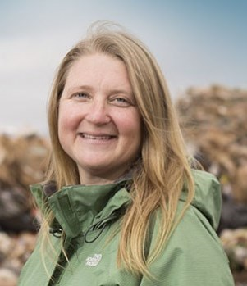
Plastic debris and its impacts in the marine environment have been widely documented, but the quantity entered the ocean from land was unknown. By linking worldwide data on solid waste, population density, and economic status, we estimated the mass of land-based plastic waste entering the ocean. We calculate that 275 million metric tons (MT) of plastic waste was generated in 192 coastal countries in 2010, with 4.8 to 12.7 million MT entering the ocean. Population size and the quality of waste management systems largely determine which countries contribute the greatest mass of uncaptured waste available to become plastic marine debris. Without waste management infrastructure improvements and other changes, the quantity of plastic waste available to enter the ocean from land is predicted to double by 2025 for a cumulative input of up to 155 million metric tons. Dr. Jambeck will discuss the methods and results, as well as potential solutions to this problem while sharing stories of integrating technology and citizen science into solutions, and crossing the Atlantic Ocean on a sailboat with thirteen other women conducting research and promoting women in STEM and other underrepresented disciplines.
Dr. Jenna R. Jambeck
Dr. Jenna jambeck is an Associate professor in the college of Engineering at the University of Georgia (UGA). She received her Ph.D. in environmental engineering from the University of Florida. She then worked for the U.S. EPA Office on Research and Development in Research Triangle Park, N.C. as an ORISE post-doc. She became a research professor at the University of New Hampshire and then moved to the University of Georgia in 2009. She has been conducting research on solid waste issues for 19 years with related projects on marine debris since 2001, especially projects related to location and spatial analysis of debris, debris quantification and characterization, and technology/mobile device usage (mapping, etc.). She also specializes in global waste management issues and plastic pollution. In November 2014 she sailed across the Atlantic Ocean with 13 other women in eXXpedition to sample land and open ocean plastic and encourage women to enter STEM disciplines. She was principal investigator of the NOAA partnership the southeast Atlantic marine Debris Initiative (SEA-MDI) and co-developer of the mobile app Marine Debris Tracker, a tool that continues to facilitate a growing global citizen science initiative. Over half a million litter and marine debris items have been logged and removed throughout the world.
More on Dr. Jambeck and her projects can be found here: http://jambeck.engr.uga.edu/. Follow her work on Twitter@JambeckResearch, @DebrisTracker or Facebook
https://www.facebook.com/jenna.jambeck, https://www.facebook.com/MarineDebrisTracker.

Friday, April 15, 2016 2:30 PM 201 Kinard Hall
Refreshments following Seminar

