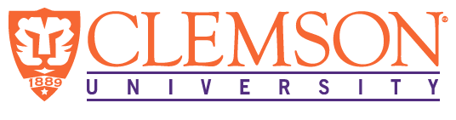
Environmental Engineering
and Earth Sciences

EEES Department Seminar

“lignocellulosic biomass utilization through a hybrid conversion platform and a new algae cultivation technology for wastewater treatment”

Speaker: Dr. Zhiyou Wen, Professor
Food Science and Human Nutrition
Iowa State University

Abstract: In this seminar, Dr. Zhiyou Wen will highlight two research and development projects in the area of biorenewables that his group at Iowa State University has been working on. The first is the lignocellulosic biomass utilization through a thermochemical-biological hybrid conversion platform; the second is the wastewater treatment using microalgae.
To convert lignocellulosic biomass to fuels and chemicals, two platforms are commonly used: (1) Thermochemical platform – Biomass is thermally processed to pyrolysis oil or synthesis gas, which is subsequently catalytically transformed into chemicals and fuels, and (2) Sugar platform – Enzymes are added to biomass to produce sugars that are fermented to industrial chemicals or fuels. The thermochemical-biological conversion process is a hybrid approach that employs both thermochemical and biological processes to transform biomass to chemicals and fuels. Depending on the thermochemical process used, this hybrid platform can either be a fast pyrolysis of biomass into pyrolytic substrates followed by microbial fermentation, or a gasification of biomass into synthesis gas (syngas) followed by syngas fermentation. My research group has been working on the biological side of this hybrid platform.
Microalgae have been widely studied to remove nutrients from wastewater but the commercial implementation of open pond as a treatment system has not happened due to high operation cost and the large footprint of these systems. My research group developed a unique culture system so called revolving algal biofilm (RAB) for solving the above problems. The RAB system has been used for municipal wastewater and food industrial effluent with superior efficiency of removing nitrogen, phosphorus and special chemicals such as selenium.

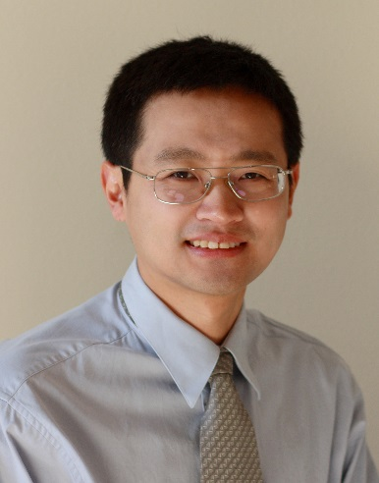
BioSketch:
Dr. Zhiyou Wen is a Professor at Food Science and Human Nutrition at Iowa State University. His background is bioprocessing engineering. He got his PhD degree from the University of Hong Kong, Postdoc training at Washington State University and Assistant Professor at Virginia Tech University before moving to Iowa State in 2010. Dr. Wen’s research focuses on microalgal wastewater treatment and value-added products, conversion of the lignocellulosic biomass to fuels and chemicals through a thermochemical-biological hybrid processing, and production of the environmental friendly biocement material for construction.

2:30 PM

Friday, October 21, 2016
L.G. Rich Auditorium Advanced Material Center
Refreshments following Seminar

