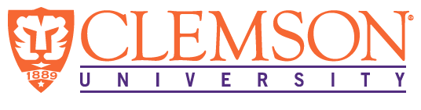

**Environmental Engineering**

**and Earth Sciences**

**EEES Department Seminar**

**“advanced materials for sustainable water purification”**

**PRESENTED**

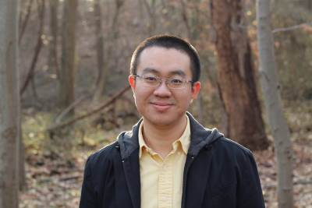

**Danmeng Shuai, Ph.D.**

**Department of Civil and Environmental Engineering**

**George Washington University**

**Abstract**: Society is currently confronting serious threats to our sustainable development including the contamination of dwindling freshwater supplies, an impending energy crisis, and resource depletion. Innovative materials-based strategies have emerged as a promising platform for sustainable water treatment with performance that can far exceed traditional approaches. Work presented herein will demonstrate the promise of several novel materials-based strategies for treatment of impaired water supplies. For example, noble metal (palladium) catalysts were proven highly effective for the reduction of a broad spectrum of EOPAA-regulated contaminants by hydrogen, providing a route by which otherwise persistent graphitic carbon nitride (g-C3N4) was developed under the guidance of molecular simulations, and fundamental science of innovative materials for water treatment, this talk will also discuss practical engineering applications of these materials in the future.

**Bio**: Dr. Danmeng Shuai graduated from Tsinghua University, P. R. China with

a Bachelor of Engineering in 2005 and a Master of Engineering in 2007, both in

Environmental Sciences and Engineering. He received a Ph.D. in Environmental Engineering from the University of Illinois at Urbana-Champaign University in 2012. H worked as a postdoctoral research associate at the University of Iowa from 2012 to2013. His research interests are in the development of novel and sustainable materials-based water treatment technologies, including advanced oxidation, reduction, and membrane processes. He has published several peer-review journal articles in *Environ. Sci. Technol., ACS appl. Mater. Interfaces, ACS Sustainable Chem. Eng., ACS Catal.*, etc. His current research is supported by NSF Environmental Engineering and Chemical and Biological Separations Program.

**2:30 PM – Friday, November 11, 2016**

**L.G. Rich Auditorium Advance Material Center**

***Refreshments following Seminar***