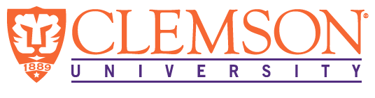
Environmental Engineering
and Earth Sciences

EEES Department Seminar

“EEES Laboratory Safety Training”
PRESENTED BY
Laura He, MS
Health and Safety Specialist
Occupational and Environmental Safety
Dear EEES Faculty, and Students,
All are required to attend the Laboratory Safety Seminar that will be held on Friday, August 28th at 2:30 PM to 3:30 PM Online via Zoom. The virtual training will be held by Laura He. She will cover topics of general laboratory safety such as PPE selection, emergency response, proper waste disposals, chemical storage, exposure control, hazard communication. We look forward to your attendance!
2:30 PM

Friday, August 28, 2020
Online via Zoom
“Attendance is mandatory for graduate students enrolled in EES 8610, EES 9610, and GEOL 8510
https://clemson.zoom.us/j/92080744835

