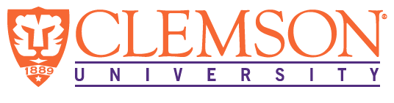
Environmental Engineering
and Earth Sciences

EEES Department Seminar

“Unique Behavior of Counter-Diffusional Biofilms”
PRESENTED BY

Robert Nerenberg
Professor
Department of Civil & Environmental Engineering & Earth Sciences
University of Notre Dame

Biofilms are complex biological structures that form on almost all moist or submerged surfaces. While biofilm treatment processes have been studied for decades, several emerging processes are based on biofilms growing on active surface that “feed” biofilm bacteria from the attachment surface. Examples include biofilms growing on O₂ or H₂-supplying membranes, elemental sulfur (Sº) surfaces, and carbon electrodes. These biofilms can be called counter diffusional, as the electron donor and acceptor substrates diffuse from opposite sides. Counter diffusion can have significant impacts on biofilm microbial community structure, morphology, density, contaminant transformation rates, and even mechanical properties. This presentation will discuss the unique behavior of counter-diffusional biofilms. A special focus will be on membrane-aerated biofilm reactors (MABRs), an emerging biofilm technology for wastewater treatment.

Bio:
Rob Nerenberg is a professor in Civil and Environmental Engineering and Earth Sciences at the University of Notre Dame. His research addresses Environmental Biotechnology, with a special focus on biofilm processes for water and wastewater treatment. Rob is a recipient of the NSF CAREER award and the Paul L. Busch Award for innovation in water research. He currently is chair of the International Water Association (IWA) Biofilms Specialist Group, and board member of the Association of Environmental Engineering and Science Professors (AEESP).

2:30 PM

Friday, September 4, 2020
Online via Zoom
“Attendance is mandatory for graduate students enrolled in EES 8610, EES 9610, and GEOL 8510
https://clemson.zoom.us/j/93141873780

