Environmental Engineering
and Earth Sciences

EEES Department Seminar

‟ Viruses in Wastewater - from CrAssphage to SARS-CoV-2”

Presented By

Dr. Kyle Bibby
Associate Professor and Wanzek Collegiate Chair
Civil and Environmental Engineering and Earth Sciences
University of Notre Dame
https://clemson.zoom.us/j/5783910968

Abstract: Protecting the public from waterborne infectious microorganisms is a primary tenant of environmental engineering. While the majority of infections from exposure to sewage-contaminated water are believed to be due to virus, which are poorly represented by currently used fecal indicator bacteria. I will begin by discussing our efforts to develop an indicator of viral fecal pollution using the newly discovered bacteriophage ‘cross-assembly phage’ (crAssphage). CrAssphage is highly enriched in sewage, potentially addressing limitations of fecal indicator bacteria for monitoring viral water quality. I will present our successful development of a crAssphage PCR assay and our evaluation of this assay both in the US and globally. In addition to posing a public health threat, the presence of pathogens in wastewater can be used to monitor for the presence of a disease within a community. I will close by discussing our efforts to monitor SARS-CoV-2 in wastewater in response to the COVID-19 pandemic, and perspectives on the future of wastewater surveillance to protect public health.

About Dr. Bibby:
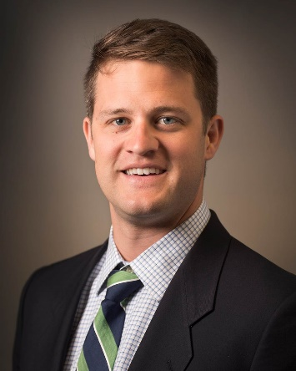
Dr. Kyle Bibby is an Associate Professor and the Wanzek Collegiate Chair at the University of Notre Dame in the Department of Civil and Environmental Engineering and Earth Sciences. He completed his BS in Civil Engineering from the University of Notre Dame and PhD in Environmental Engineering from Yale University, and was previously a faculty member at the University of Pittsburgh. He has won multiple professional awards, including the 2017 NSF CAREER award. Dr. Bibby currently leads multiple research projects centered around understanding microbiology relevant to protecting and improving human health and environmental quality.

Friday, October 30, 2020
2:30 PM
Online via Zoom
“Attendance is mandatory for graduate students enrolled in EES 8610, EES 9610, and GEOL 8510.”

