Environmental Engineering
and Earth Sciences

EEES Department Seminar

Remanufacturing – What is it and how does it fit into a Circular Economy?
Overview of the Clemson Energy Visualization and Analytics Center (CEVAC)

Dr. Mark Krystofik
Associate Director of Operations & Sustainability
Watt Family Innovation Center
Clemson University

There are many things being done to try to reduce our use of fossil fuels to mitigate impacts from climate change. In this talk, Dr. Krystofik will elaborate on two topics that support reducing greenhouse gas emissions. The first topic is Remanufacturing. Remanufacturing involves returning a previously used product to a performance level of form and function effectively equivalent to when the product was new. In some instances, remanufacturing can also provide an upgraded product, by correcting original product design flaws. The second topic provides an overview of Clemson’s Energy Visualization and Analytics Center (CEVAC). CEVAC was born by asking a question – How much energy does the Watt Center building consume? Today, CEVAC has emerged into a robust platform that shows the utility data for 70 buildings, with deep dive dashboards for 28 buildings.
Dr. Mark Krystofik is an Associate Director of Operations & Sustainability at the Watt Family Innovation Center. Dr. Krystofik works in this role to enhance embedded technology and flexibility of the facility to enable collaborative learning, applied research and innovation among students, faculty, and partner organizations. He has been in his current role since October 2019.
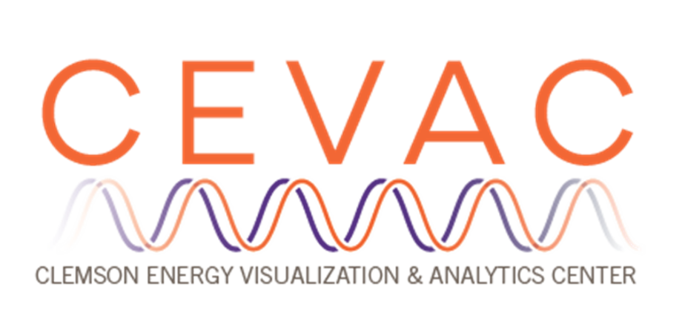
Prior to joining Clemson University, Dr. Krystofik held a research faculty role with the Rochester Institute of Technology (RIT) where he served as the Senior Program Manager for the Center of Advanced & Sustainable Manufacturing since August 2014. In this role, Mark was responsible for program management, and research and development in the areas of life cycle engineering, life cycle assessment, manufacturing process optimization, product design and sustainability, with a primary focus on assisting start-up and existing companies with product development and design for manufacturing and bringing innovation to the marketplace through research and development and industry adoption of new technologies. Prior to RIT, Mark served in engineering and manufacturing management roles for over 20 years with small to midsize firms.
Dr. Krystofik obtained his PhD in Sustainability from RIT. He also holds a MS and a BS in Industrial Engineering from SUNY at Buffalo as well as a BS in Mathematics from SUNY College at Fredonia.
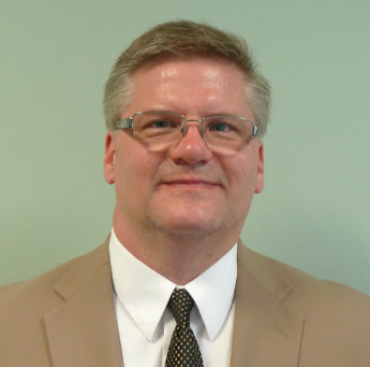

2:30 PM
Friday, April 1, 2021
Brackett Hall 100

Also available online via Zoom:
https://clemson.zoom.us/j/5783910968

In-person attendance is mandatory for graduate students enrolled in EES 8610, EES 9610, and GEOL 8510. You can join online via Zoom only if you have tested positive for COVID-19 and requested an absence or have obtained prior approval for another valid reason.

