Environmental Engineering
and Earth Sciences

EEES Department Seminar

“Tips for an Interesting Engineering Career”

PRESENTED BY
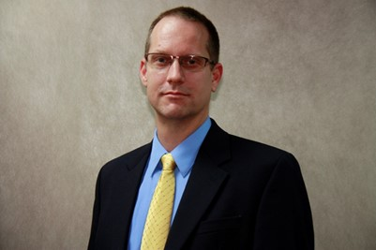
Rob Wilson

Rob Wilson is a chemical engineer, test director, and project manager with over 20 years of experience in developing, testing, integrating, and managing projects and technology development for the treatment of nuclear waste at the US Department of Energy’s Hanford, Savannah River, Fernald, and Rocky Flats sites.
Rob's experience encompasses managing process technology test programs for commercial and federal clients at bench-, engineering, and full-scale. Over the course of his career he has helped develop and mentor young engineers as a Process Engineering Manager, served as Chief Operations Officer of a small engineering and fabrication firm, and started his own consulting firm.
2:30 PM

Friday, September 20, 2019
L.G. Rich Auditorium Advanced Material Center
“Attendance is mandatory for graduate students enrolled in EES 8610, EES 9610, and GEOL 8510

Refreshments following Seminar

