

**Environmental Engineering**

**and Earth Sciences**

**EEES Department Seminar**

‟The Clemson University Chapter of Engineers without Borders – An Update on Current Projects”

**Presented By**

**Members of the Clemson Chapter of EWB**

**Abstract**: Engineers without Borders (EWB) is an international organization that applies the knowledge of engineering to the solution of international development challenges. The organization’s vision is a world in which every community has the capacity to sustainably meet their basic human needs. The USA branch of EWB was founded at the University of Colorado at Boulder in 2002. Since then, EWB-USA has grown from a handful of passionate individuals to an organization of more than 14,100 passionate members working on hundreds of engineering projects across the globe. Clemson University has an active chapter, with more than 50 undergraduate students engaged in three Creative Inquiry courses. EWB won Clemson University’s Organization of the Year Award in 2015, given to an organization that goes above and beyond in service, leadership, and academics. The current focus of CU-EWB involves a water supply project and a bridge construction project in Nicaragua and a school construction project in Uganda. The purpose of this seminar is to provide background information on EWB and describe the Clemson projects to graduate students and faculty in EEES, with the intent of involving more members of the Clemson community. The Clemson Chapter’s faculty advisor is Dr. Mark Schlautman.

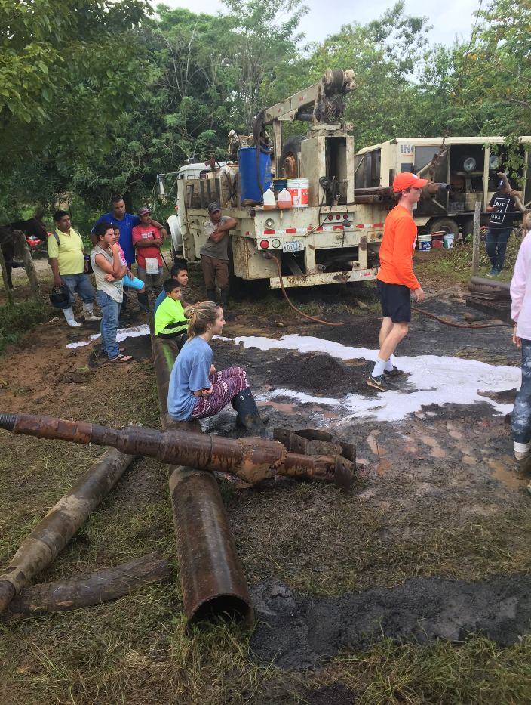

***Clemson University students work with a local contractor to install a well in El Serrano, Nicaragua.***



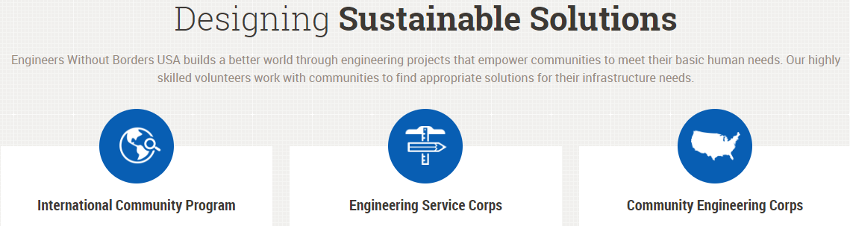

***Friday, September 6, 2019***

***2:30 PM***

***Rich Lab Auditorium***

***Refreshments following Seminar***

***“Attendance is mandatory for graduate students enrolled in EES 8610, EES 9610, and GEOL 8510.”***