Environmental Engineering
and Earth Sciences

EEES Department Seminar

‟Activated Sludge Process Milestones of the Modern Era:
A Tribute to Dr. Thomas M. Keinath”

Presented By
Dr. Glen T. Daigger, Ph.D., P.E., BCEE, NAE

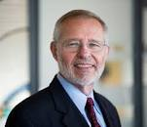
Abstract: The early 1970’s represents a transition in the design and operation of the activated sludge process from the earlier approach using empirical design and operation criteria and practices to those based much more on a fundamental understanding of process functions. This transition enabled the activated sludge process to be implemented more cost-effectively and to reliably accomplish more stringent treatment goals including biological nitrogen and phosphorus removal. Three key milestones include: (1) introduction of the solids residence time (SRT) as a fundamental design and operating parameter rather than the food-to-microorganism (F/M) ratio, (2) development of techniques to control the growth of filamentous microorganisms, and (3) development and implementation of state point analysis for the design and operation of secondary clarifiers. These three milestones will be described, along with their impacts.

Dr. Daigger’s Biography: Dr. Daigger is a member of the National Academy of Engineering. He is currently a professor in the Department of Civil and Environmental Engineering at the University of Michigan. Prior to that, Dr. Daigger was the senior vice president and chief technology officer for CH2M HILL, a global consulting firm. He was also chair of the Department of Environmental Engineering and Earth Sciences at Clemson University from 1994 to 1996.

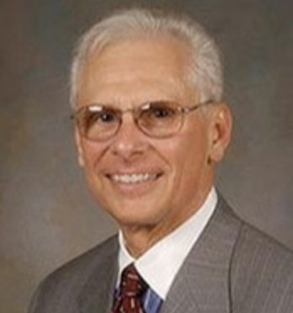
The Tribute: This year marks the 50th anniversary of when Dr. Thomas M. Keinath joined the faculty at Clemson University. Dr. Keinath rose through the ranks to become a full professor, chair of the department, and later dean of the College of Engineering and Science. Dr. Keinath made critical contributions to the field of environmental engineering through his pioneering research on sedimentation of activated sludge. He also made lasting contributions to the profession, having completed two two-year terms as president of the London-based International Water Association and as chair of its Executive Committee and Governing Board. He served the American Society of Civil Engineers as chair of its Clarifier Research Technical Committee. Dr. Keinath also led the Association of Environmental Engineering Professors as its president and he chaired the 150-member Program Committee of the Water Environment Federation for three years. He was also active on several committees and panels of the National Research Council of the National Academy of Engineering and National Academy of Sciences. Clearly, Dr. Keinath has made a lasting impact on Clemson University and the environmental engineering profession in general.

Friday, October 25, 2019
2:30 PM
Rich Lab Auditorium
Refreshments following Seminar
“Attendance is mandatory for graduate students enrolled in EES 8610, EES 9610, and GEOL 8510.”

