0
Environmental Engineering
and Earth Sciences
EEES Department Seminar

“welcome seminar”

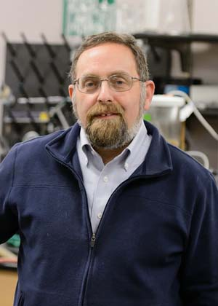

Presented By
Dr. David L. Freedman, Ph.D., BCEEM
Chair and Professor
Biological Process Engineering/Bioremediation

2:30 PM

Friday, August 23, 2019

Rich Lab Auditorium
Picnic following Seminar

