Ron Walker Leadership Program
Clemson, SC
Dates: March 29-April 3, 2026

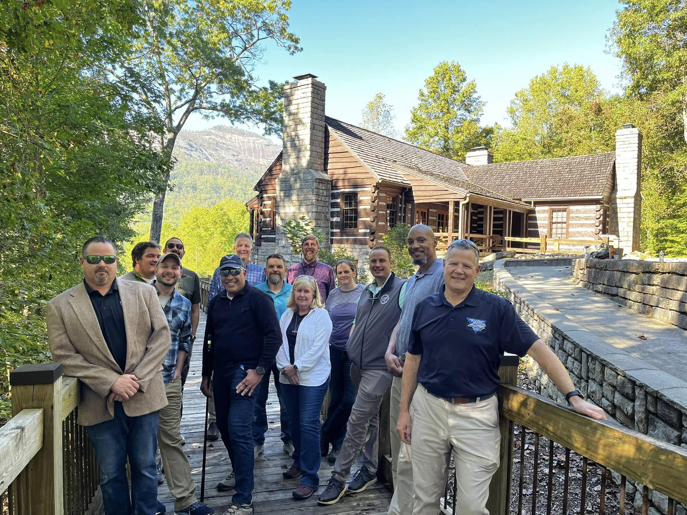

Application
The opportunity: The Institute for Parks at Clemson University announces an exciting opportunity for Park and Recreation and Public Lands professionals. The Ron Walker Leadership Program engages participants in various formats to discuss, study, and examine leadership in the everchanging world of park and public lands management. The program combines online preparatory study and experiential learning opportunities and concludes with a field-based seminar at Clemson University concurrent with the George B. Hartzog Awards and Lecture series each Spring. This program consists of approximately 45 contact hours of study that can be taken for continuing education. The program provides the perfect mix of field experiences at signature state parks in the region and the resources and beauty of the Clemson University campus.

Application Deadline is Oct. 31, 2025. Send Completed Application to Phil Gaines at spgaine@clemson.edu

First Name:
Last Name:
Email Address:
Address (Street, City, State, Zip/Post code):
Country of Residence (if outside USA):
Primary Telephone Number:
Name of Agency/Department where you are currently employed:
Title and brief job description:

Applicants Statement: Briefly describe how this opportunity will help you to attain your career/professional goals.

