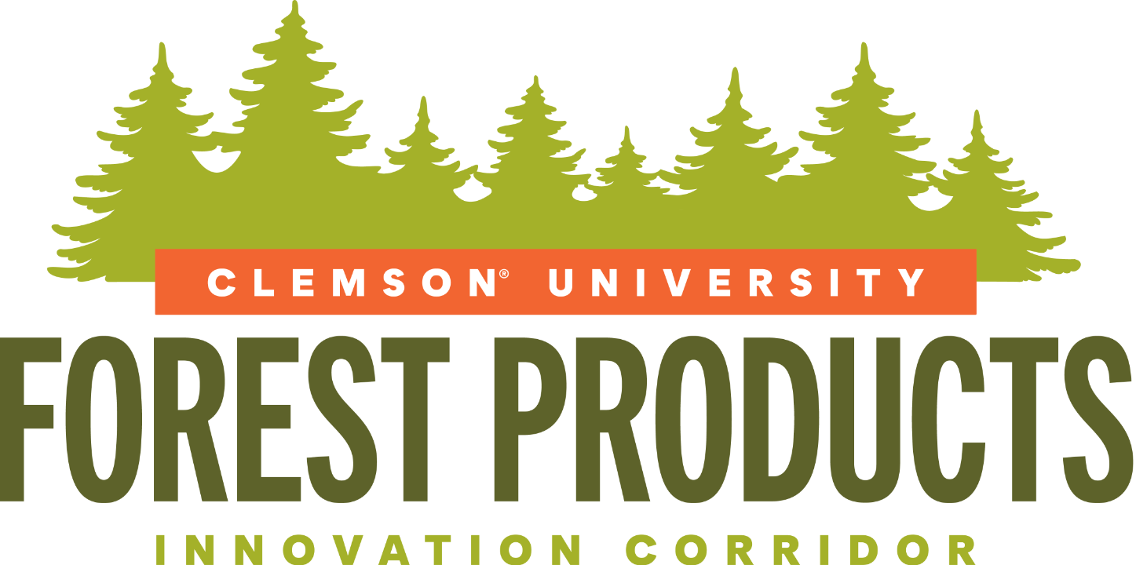

FPIC Speaker Guide
Keynote speakers and featured participants

From Forest to Market: Building the Southeast’s Bioeconomy Future
A consolidated collection of speaker headshots and biographies for conference communications and online publication.
Prepared for the Forest Products Innovation Corridor kickoff convening

Speakers
The following profiles are organized alphabetically by last name. Biographies have been lightly standardized for formatting and readability while preserving the supplied content.
• Antti Asikainen | • John Lummus
• Brian Brashaw | • Johnny Sabo
• Brunela Pollastrelli Rodrigues | • Kent Fonvielle
• Cam Crawford | • Kevin Harvell
• Cliff Holekamp | • Kristen Austin Gunter
• Daniel Hesington | • Mark Woloszyn
• David Bruce | • Masood Akhtar
• David Impson | • Matt Hestad
• Derek Ratchford | • Nick DiLuzio
• Dustin Albright | • M. Soledad Peresin
• Evan Smith | • Pete Madden
• Francis Bell “Jeep” Ford III | • Rob Baldwin
• Graham Montgomery | • Robert E. Bryan, PMP
• Guerry Green | • Sam Konduros
• Guy Sabin | • Scott P. Jones
• Jackson Morrill | • Scott Phillips
• Jared Coffin | • Stefan France
• J. Todd Petty | • Thomas W. Marrero
• Jerrold Miller | • Tim Lowrimore
• Jingxin Wang | • Trip Chavis
• Joey Espinosa | • Troy Harris
• John Hatcher | • Tyler Burkholder

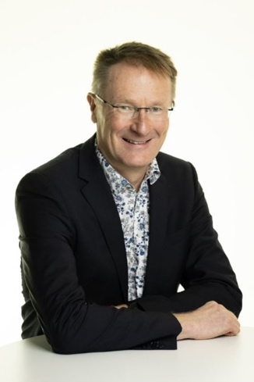

Antti Asikainen
Antti Asikainen is the executive vice president for research Natural Resources Institute Finland. He also is a research professor of forest technology and operations. His areas of expertise include forest technology, wood sourcing and forest management and climate interaction, bioenergy and logistics. Asikainen acts as the chairman of the Finnish Forest Bioeconomy Science Panel. He has contributed to the national and EU level forest and science policy programmes.
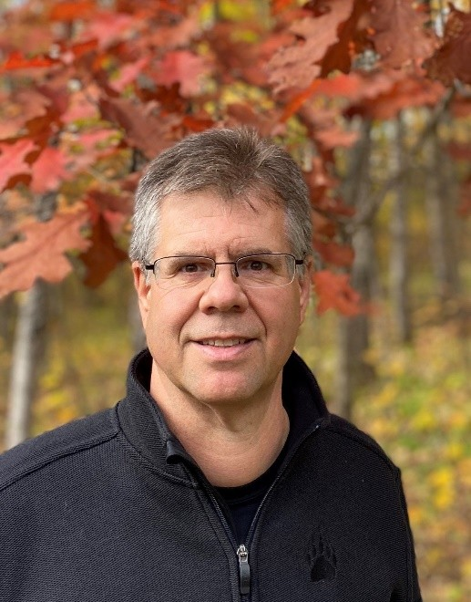

Brian Brashaw
Assistant Director, Wood Innovations
USDA Forest Service, National Headquarters
Biography: Brian Brashaw is the Assistant Director for the USDA Forest Service Wood Innovations Program. The Wood Innovations Program supports the development of wood products and wood energy markets and production facilities to reduce wildfire risk and enhance long-term, sustainable management for federal, state, tribal and private landowners. Wood Innovations is focused on mass timber, biochar, innovative wood products and renewable wood energy through both grants and technical assistance. For over 35 years, Brian has focused on supporting the connection between forestry and forest products, helping support and advance wood products through research, market development and outreach. Brian earned a BS degree in Forestry from the University of Wisconsin-Stevens Point, a MS degree in Wood Materials Engineering from Washington State University, and a PhD in Forest Resources from Mississippi State University.
Forest Service Social Media:
Website - https://www.fs.usda.gov/science-technology/energy-forest-products/wood-innovation
Instagram - https://www.instagram.com/u.s.forestservice/
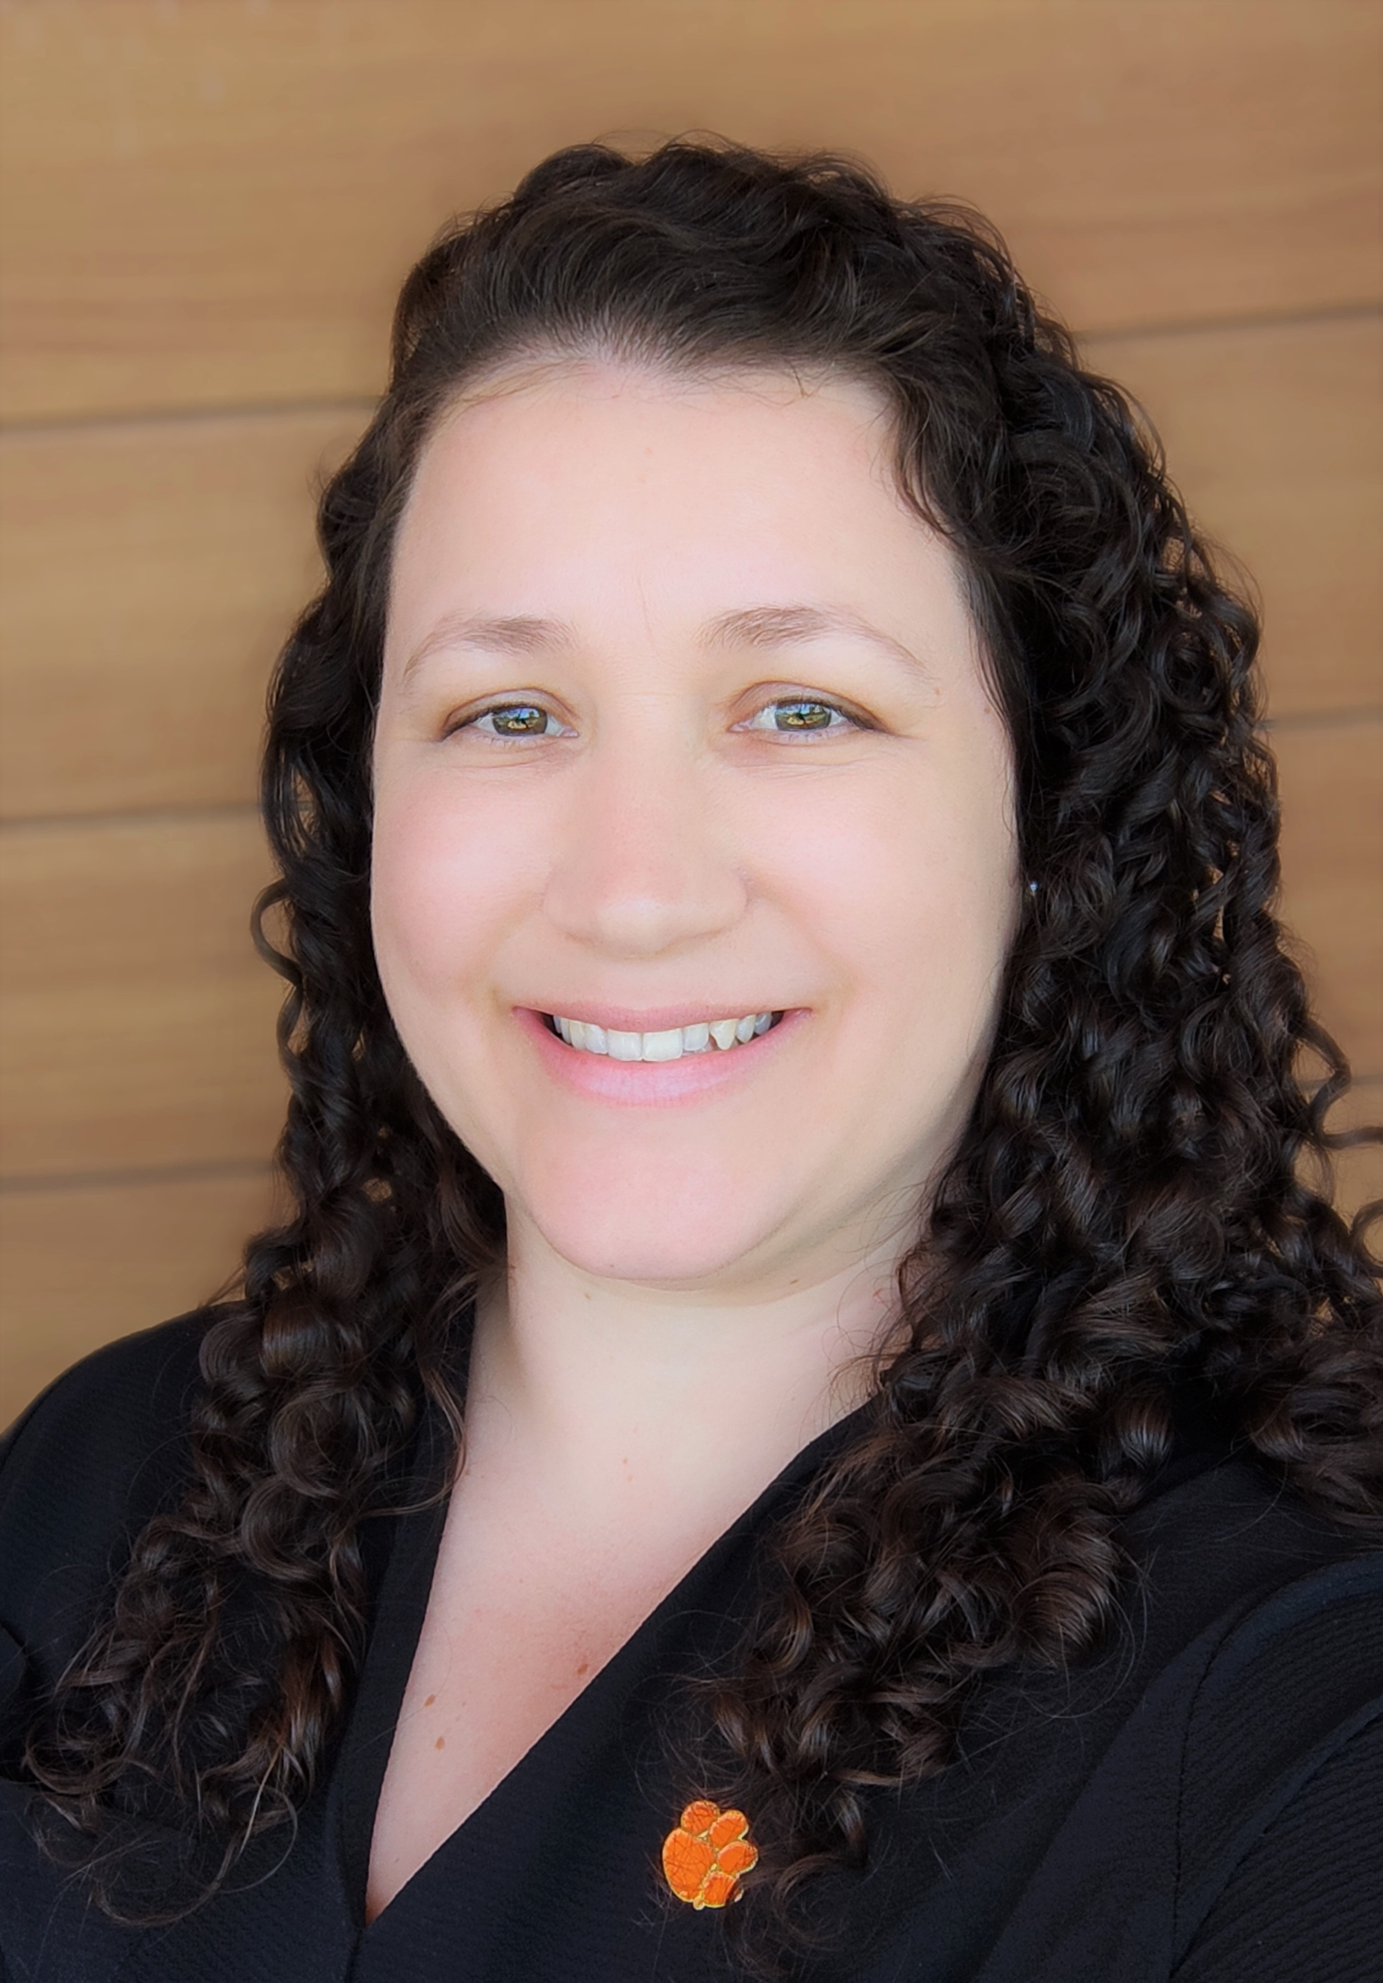

Brunela Pollastrelli Rodrigues
Dr. Brunela Pollastrelli Rodrigues is an Assistant Professor of Wood Utilization and Biomaterials in the Department of Forestry and Environmental Conservation and a faculty member of the Wood Utilization + Design Institute at Clemson University. Before joining Clemson, she worked as a Postdoctoral Associate in the Department of Sustainable Bioproducts at Mississippi State University and as a visiting scholar in the USDA Forest Products Lab. At Clemson University, she teaches Forest Biology, Wood Identification, Forest Products Summer Camp, Wood and Paper Products, and Applied Wood Quality. Her research work covers a broad range of projects, including assessing the condition and performance of timber piles in SC rural bridges, enhancing fire performance in mass timber products, and advancing the utilization of thermally modified wood in the USA. Through her work, she supports innovation, stakeholders’ education, and contributes to preparing the next generation of South Carolina foresters and forest products professionals.
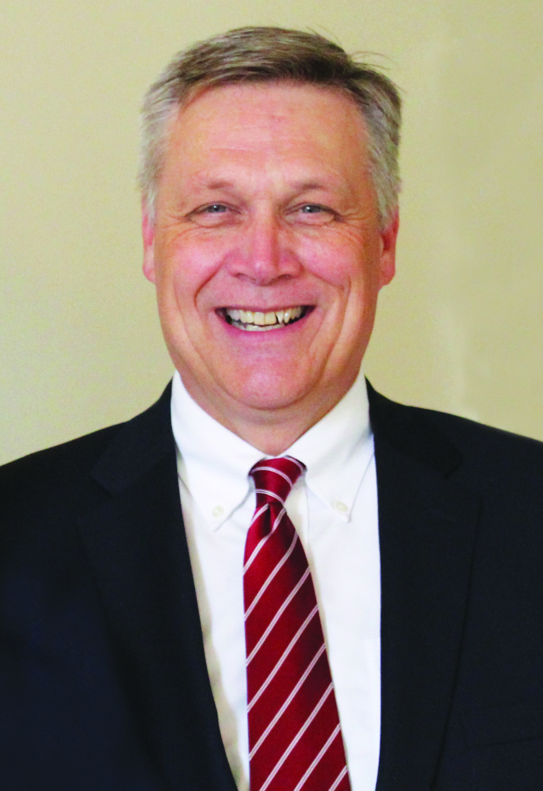

Cam Crawford
On June 1, 2011, Cam Crawford became the president and CEO of the Forestry Association of South Carolina. Cam serves as the Co-Chair of the South Carolina Forest Recovery Task Force and is a member of the WaterSC Water Resources Working Group established by Governor Henry McMaster. In the past, he has served as Chairman of the Palmetto Agribusiness Council, served as Chairman of the Forest Industry Associations Council, on the Board of Directors for the National Alliance of Forest Owners, served as the Forestry Advisor to the South Carolina House of Representatives COVID-19 Agriculture and Natural Resources Committee, and as a member of the American Forest Foundation’s Woodland Operating Committee. In 1989, Cam was appointed as the youngest Magistrate in South Carolina, taking office as a Lexington County Magistrate at the age of 23.
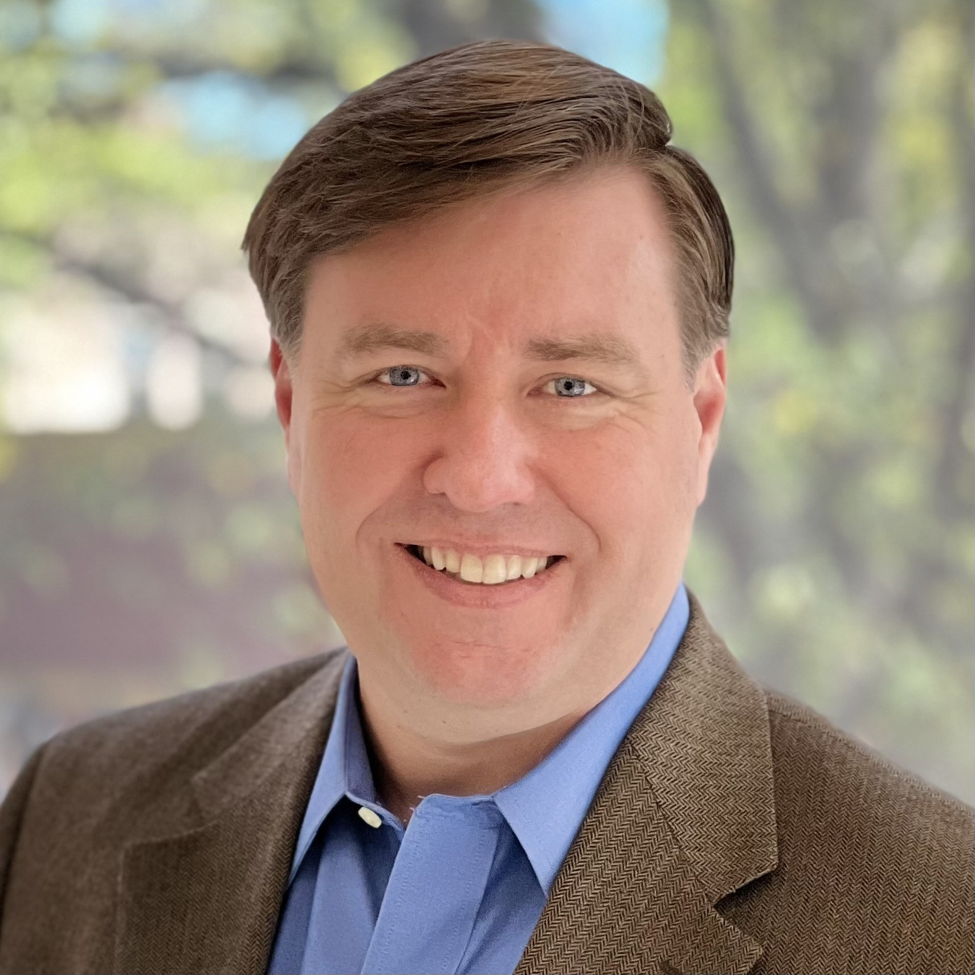

Cliff Holekamp
Cliff Holekamp is the Cofounder and Managing Director of Cultivation Capital, an early-stage venture capital firm expanding its focus into the forestry sector. Cliff has been named to the Business Insider Seed 100 Best Early Stage Investors and was named the Top Startup Investor in South Carolina. He was previously the Professor of Practice and Academic Director for Entreprenuership at Washington University in St. Louis where he led the program to a number one world ranking for entrepreneurship. In addition to serving on the boards of Cultivation Capital portfolio companies, Cliff serves on the Board of Trustees for Washington & Lee University and for Christ Church Episcopal School, and serves of the Board of Directors for the Clemson University Research Foundation.
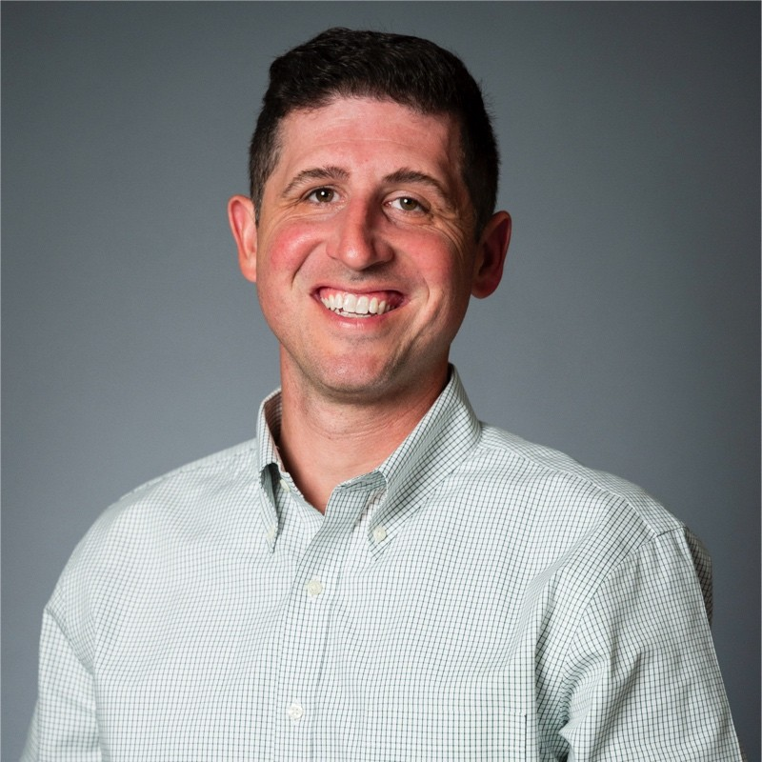

Daniel Hesington
Daniel is a Branch Engineer for the Southeast region of the U.S. In this role, Daniel provides engineering support, tests products, creates literature and presents to Simpson Strong-Tie customers, specifiers, and internal employees for a wide range of Simpson Strong-Tie products with a focus on their Mass Timber solutions. Prior to joining Simpson Strong-Tie in 2023, Daniel was practicing consulting structural engineer for 13 years. He worked on many different structures including mid-rise medical office buildings, hospitals, multi-family apartments and condos, K-12 and higher education facilities, military, and municipal projects.
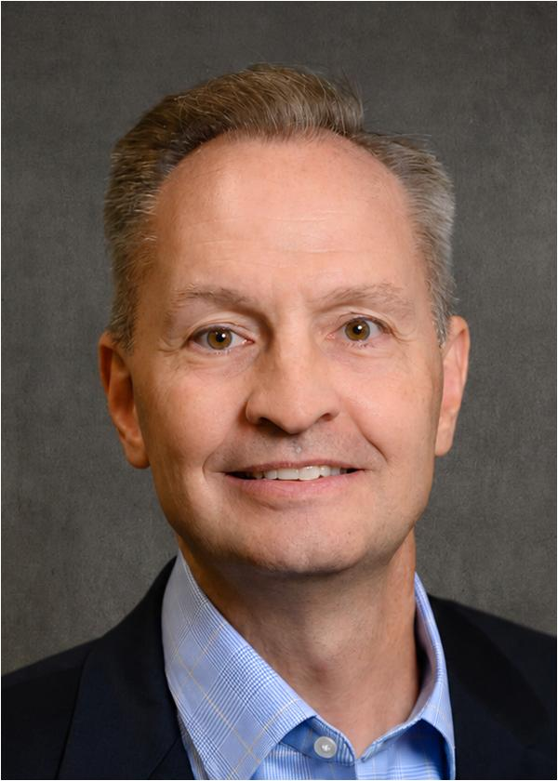

David Bruce
David Bruce, Professor and Chair of the Chemical and Biomolecular Engineering Department, has been a faculty member at Clemson for 28 years. Professor Bruce's principal research interests are in the areas of catalysis, kinetics, mass transfer, and molecular modeling, with a particular interest in the selective conversion of lignin and cellulose-based sugars into high-value chemicals, the prediction and measurement of diffusion phenomena in polymers and catalysts, and syngas conversion to alcohols.
Clemson URSAA Award for being an author on a paper with over 1,000 citations
Coordinator for simulation efforts for the Center for Atomic-Level Catalyst Design, funded with $12.5 million from the U.S. Department of Energy
Taught 15 different undergraduate and graduate courses, graduated 26 Ph.D. and M.S. students, and mentored 4 postdoctoral research associates at Clemson
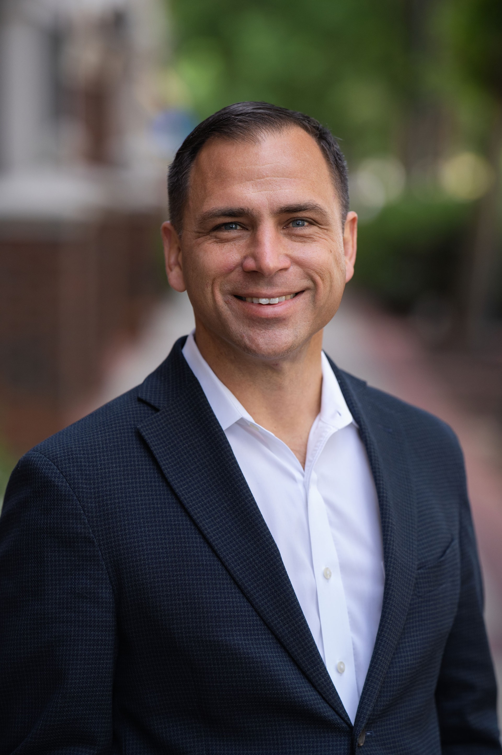

David Impson
David Impson is a structural engineer with BPA specializing in innovative and efficient structural systems, with particular expertise in mass timber design. His experience spans office, commercial, institutional, parking, and housing projects throughout the Southeast and across the United States. David is actively involved in advancing mass timber through project design, education, and industry outreach, helping architects and owners evaluate structural solutions that balance constructability, cost, sustainability, and architectural goals.
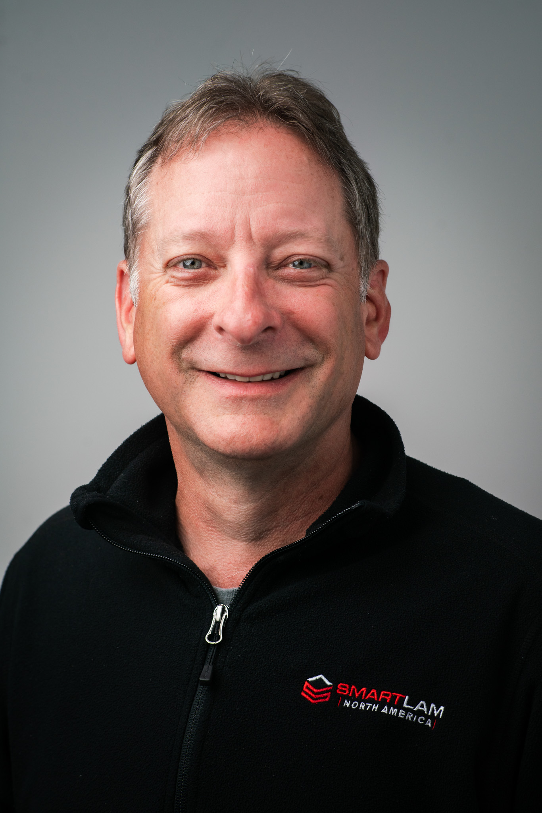

Derek Ratchford
As CEO of Smartlam North America, Derek Ratchford leads a team who continually work to improve the mass timber industry through technological advances. Derek excels at building functional teams to manage the operational processes so our people can succeed, and projects effectively meet budgets and timelines. He inspires his team to trust their own judgment and make decisions that best fit with the needs of the clients. For 30 years, Derek has thrived in the rapidly changing world of Engineered Wood Products. Derek began his career with Trus Joist MacMillan working in the I-joist/LVL business. He spent 15 years working with Anthony Forest Products/Canfor managing their I-Joist/Glulam operations and one sawmill. Derek served two years as Tolko’s VP of US Operations and has been CEO of Smartlam North America since 2021. His academic credentials and technical expertise in structural wood products, along with his enthusiasm for the mass timber building revolution, drive his desire to provide the best engineered wood products in the US.
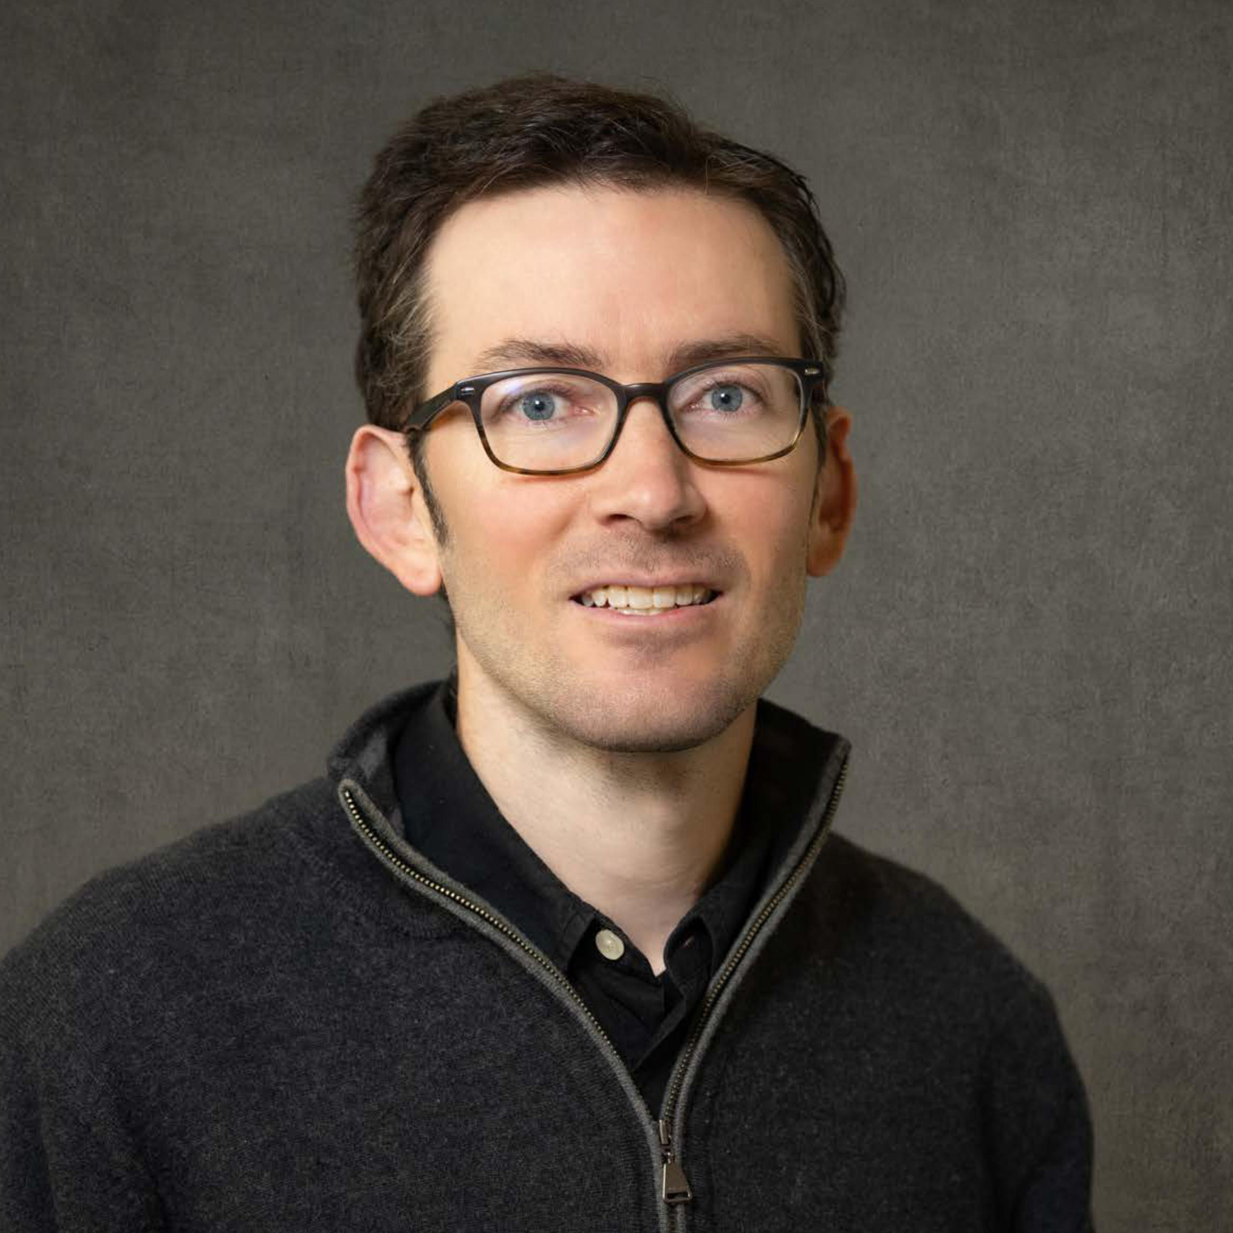

Dustin Albright
Dustin Albright, AIA, is Associate Professor and Assistant Director in the McMahan School of Architecture at Clemson University. He leads design studios and teaches structures seminars while drawing on his dual background in Architecture and Civil Engineering. His teaching and research revolve around the materials, systems and processes of high-performance buildings with low embodied carbon. This includes his work with advanced wood and timber systems at a range of scales. He is a founding faculty fellow in Clemson’s Wood Utilization + Design Institute. In addition to his academic work, he practices professionally with Hanbury, a multidisciplinary design firm with offices in Virginia and the Carolinas, among other locations.
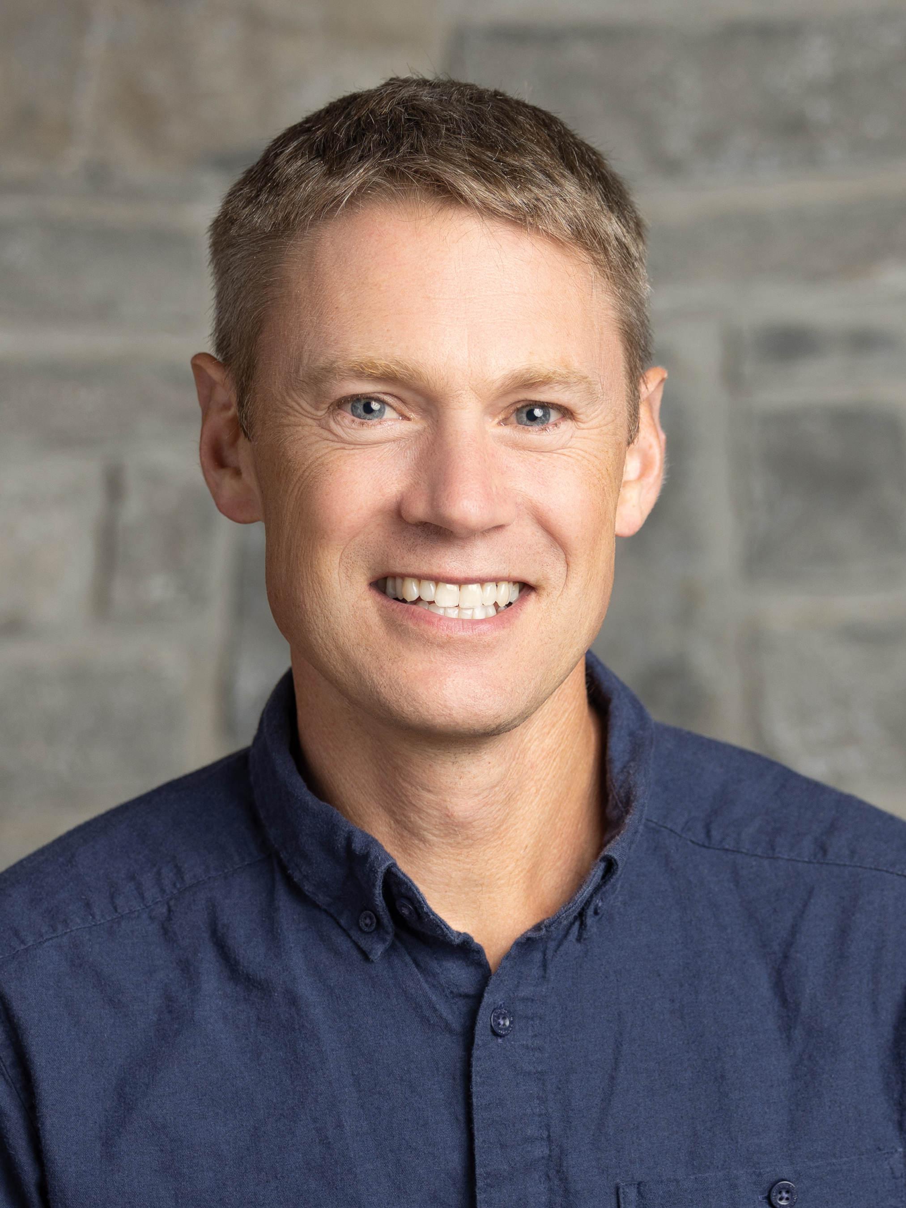

Evan Smith
Evan Smith, Senior Vice President of Conservation Ventures at The Conservation Fund, oversees programs that invest in communities and working forests to generate both economic and environmental return. Since joining the Fund in 1995, Evan, a trained forester, has worked to demonstrate that nonprofits can successfully acquire and sustainably manage large tracts of forestland, most recently through launch of the Working Forest Fund, including signature projects in all regions of the U.S. He serves on the boards of directors for the Center for Diversity & the Environment and Starker Forests, Inc. Among other affiliations, he previously served eight years on the Investment Committee and Board of Directors for Natural Capital Investment Fund, now known as Partner Community Capital, a certified Community Development Financial Institution. Originally based out of TCF’s D.C. headquarters for the first seven years, then establishing a Portland OR office for 15 years, he moved to Los Angeles with his family in 2018. He holds B.S. in Geology and Master of Forestry degrees from Yale University.
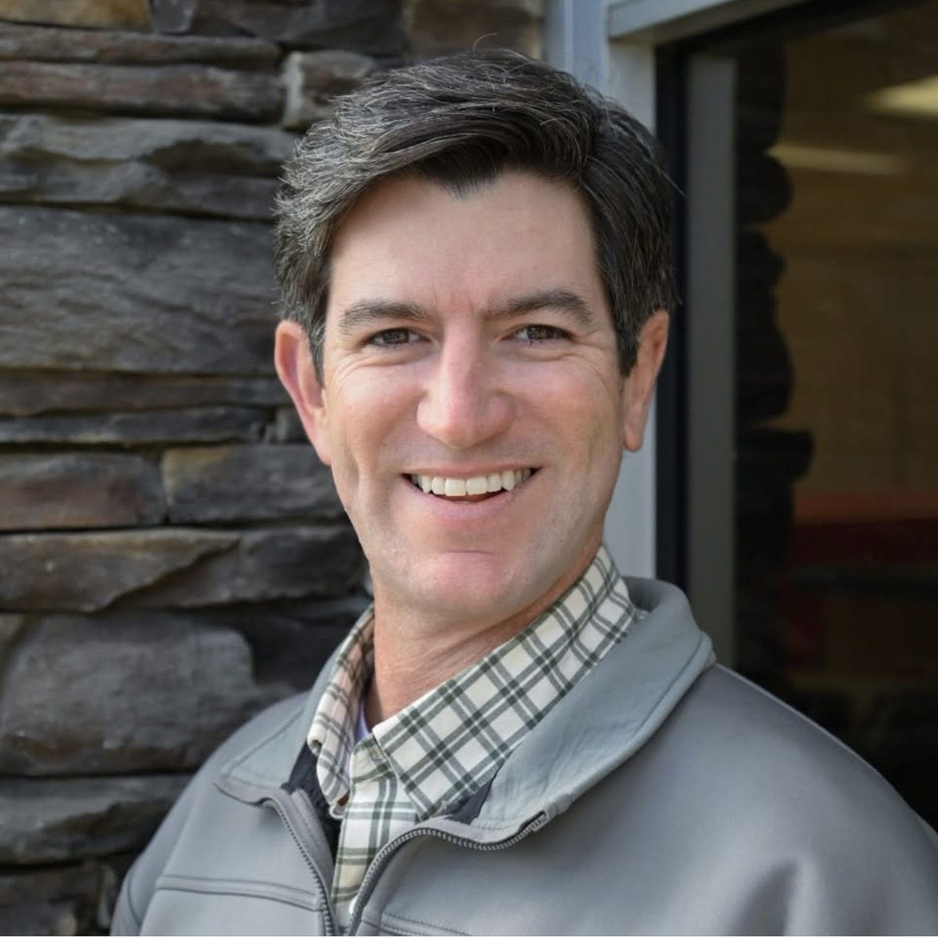

Francis Bell “Jeep” Ford III
Jeep brings valuable expertise and leadership with 25+ years in multiple industries and business ventures across South Carolina. Originally from Georgetown, currently residing in Greenville, SC, one of Jeep's primary passions is for revitalizing rural SC towns through technology, education, and job growth. The Ford family has been in the SC timber business since the early 1800s which provides him unique experience and institutional knowledge. In addition, Jeep has been in the alternative and renewable energy industry for almost 20 years, involved with natural gas brokerage and the development of sites across SC for national companies. Jeep has worked with SC trucking companies towards conversion to sustainable fuels, worked with rural communities, businesses and utility providers to promote on grid solar solutions, and has been identifying emerging technologies to solve critical issues around waste management and energy production. Jeep has also worked with the State of South Carolina, State Universities and school systems to establish and promote programs around clean energy and emerging technologies. With an extensive background in putting the right client together with the right project, Jeep has helped to create a network of growing opportunities throughout the energy sector.
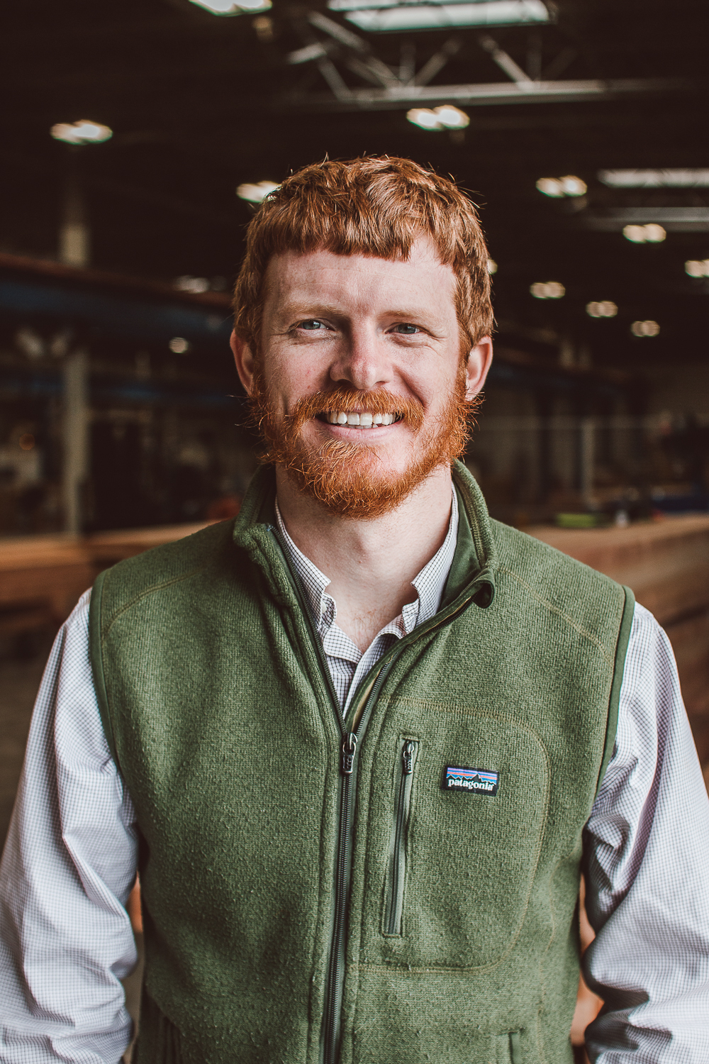

Graham Montgomery
Graham Montgomery serves as Vice President and Director of Preconstruction at Timberlab and is based out of the company’s East Coast mass timber office and fabrication facility in Greenville. A licensed structural engineer, Montgomery focuses on project-driven, efficient design while advancing mass timber through ongoing research, testing and industry collaboration.


Guerry Green
Guerry Green leads strategy and finance across Screen Tight and Green Eagle, his family’s South Carolina-based building products and advanced materials businesses. He is currently helping develop and commercialize Natura, a natural fiber insulation platform focused on creating a high-performing line of building products from Southern wood. Before joining the family businesses, Guerry worked in investment banking at Jefferies and commercial banking at Truist. He earned his undergraduate degree in Financial Management from Clemson University, graduating summa cum laude from the Calhoun Honors College, and later earned his MBA from UNC Kenan-Flagler Business School. Guerry is a native of Pawleys Island, South Carolina.
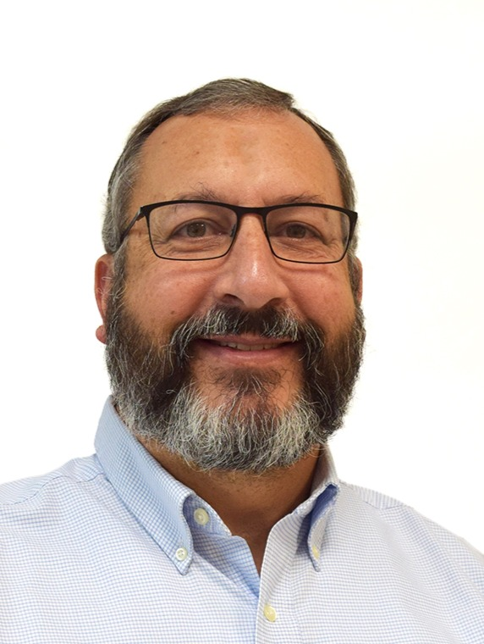

Guy Sabin
Guy Sabin joined the SC Forestry Commission’s Resource Development Section in November 2025, which includes Forest Inventory and Analysis, Timber Product Output, Forest Markets, and Economic Development. Sabin previously served as Vice President of the Forestry Association of SC, is a Registered Forester in SC, and has over 30 years of experience as a professional forester in South Carolina, Virginia, and Washington State. He has a BS in Biology from The Citadel and MS in Forestry from Clemson University.
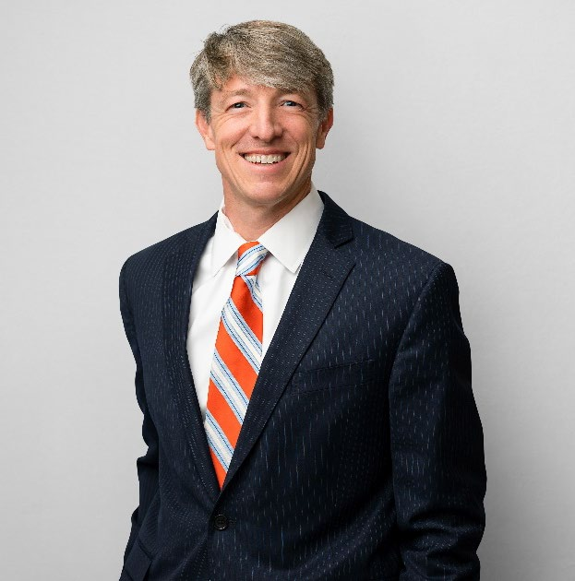

Jackson Morrill
Jackson Morrill, President & CEO American Wood Council Jackson has over 20 years of experience
working as a lawyer and trade association representative. He was previously the President of the Composite Panel Association, which represents manufacturers of composite wood panels. He also worked at the American Chemistry Council, practiced environmental law at Beveridge & Diamond, and served as an environmental law consultant at the World Bank. He is a graduate of the University of Virginia and Tulane Law School and is admitted to the Maryland and District of Columbia bars.
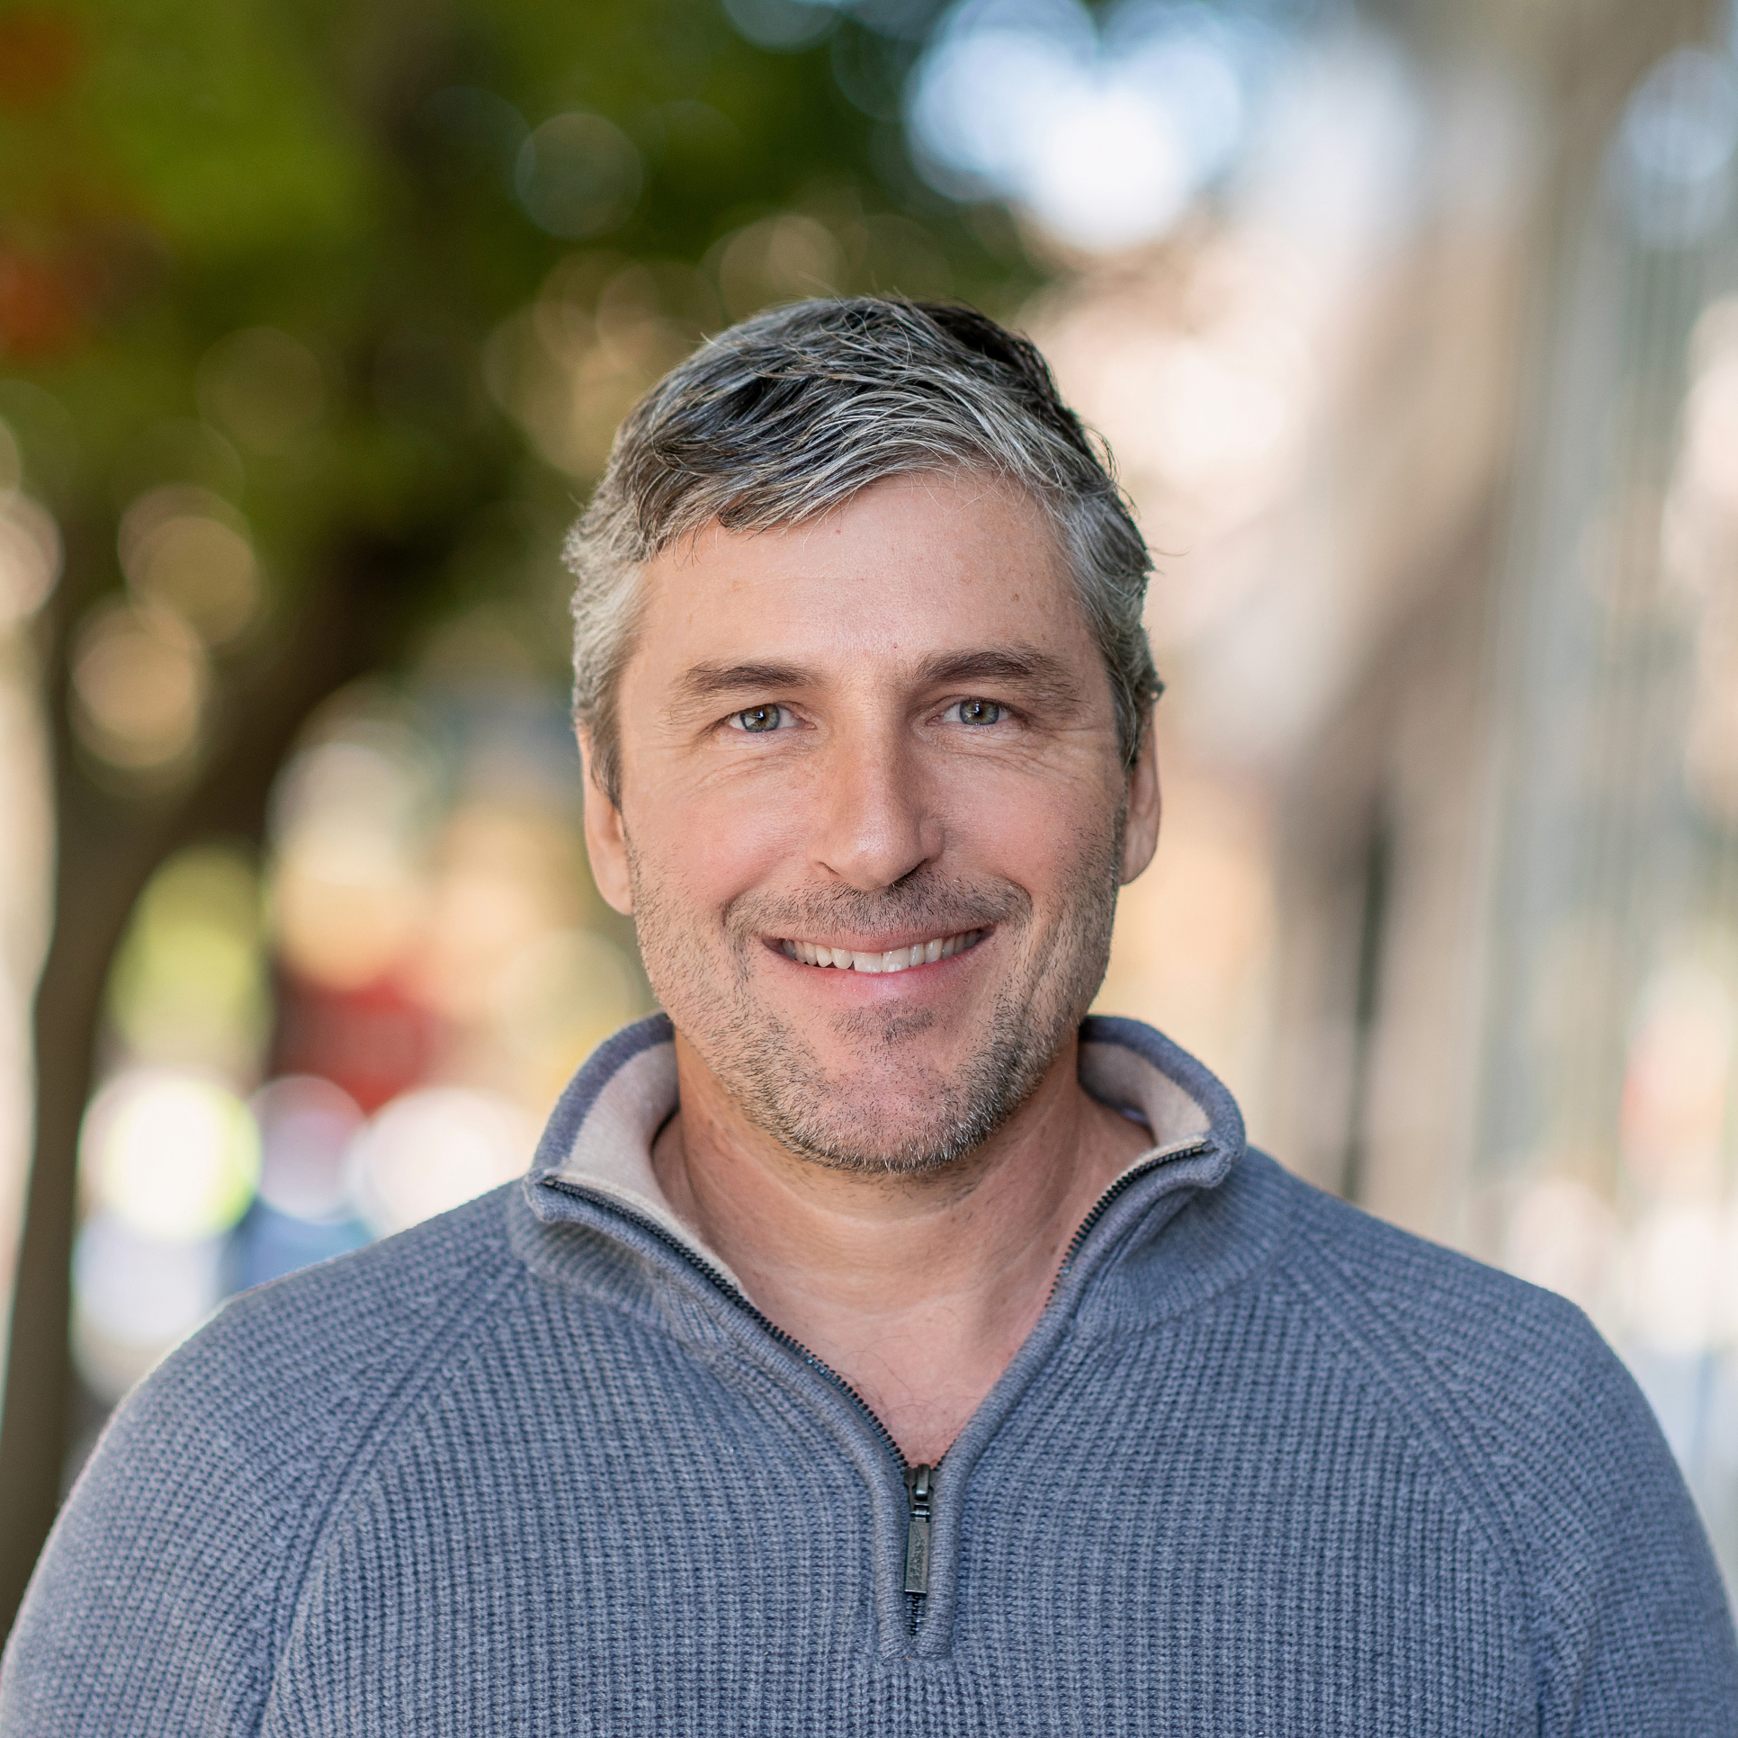

Jared Coffin
Jared is an experienced architect with over 35 years of practice, leading student-focused projects that emphasize well-being and purpose-driven design. A key focus of his work is advancing the use of mass timber, and he has maintained a strong relationship with Clemson University’s Wood Utilization + Design Institute (WU+DI) since 2017, supporting innovation in sustainable materials and construction.
He founded Hanbury’s Clemson office to strengthen the connection between practice and academia, creating a pipeline for students to gain real world experience while enabling firm leadership to engage in teaching. He is also deeply committed to mentorship, helping shape the firm’s long standing talent development programs.
Through his leadership and engagement with Clemson’s architecture studios, Jared has expanded Hanbury’s impact into surrounding communities, using design to promote revitalization, sustainability, and student success.
Jared Coffin | www.hanbury.design | 864.448.0464
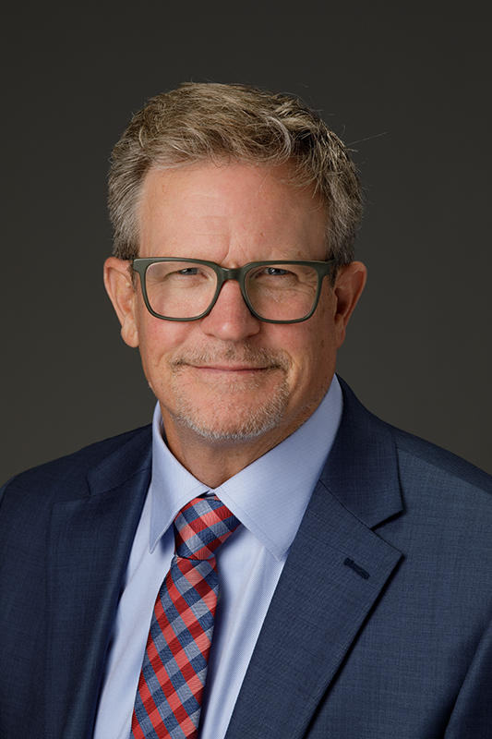

J. Todd Petty
Dr. Todd Petty currently serves as Dean of the Warnell School of Forestry and Natural Resources at the University of Georgia, the oldest forestry school in the US south. Prior to UGA, Dr. Petty was a professor and chair of the department of Forestry and Environmental Conservation at Clemson University where he was closely involved in design of the newly opened forestry building, which is a state-of-the-art research and teaching facility constructed fully from mass-timber. Dr. Petty spent the bulk of his career as a professor in the school of natural resources at West Virginia University, where he taught and conducted research in the areas of river, watershed, and fisheries science. While at WVU, Dr. Petty also served five years as the associate dean for academic affairs in the Davis College of Agriculture, Natural Resources and Design. Dr. Petty earned a bachelor’s degree from the University of Virginia and an MS and PhD from the Warnell School at UGA.
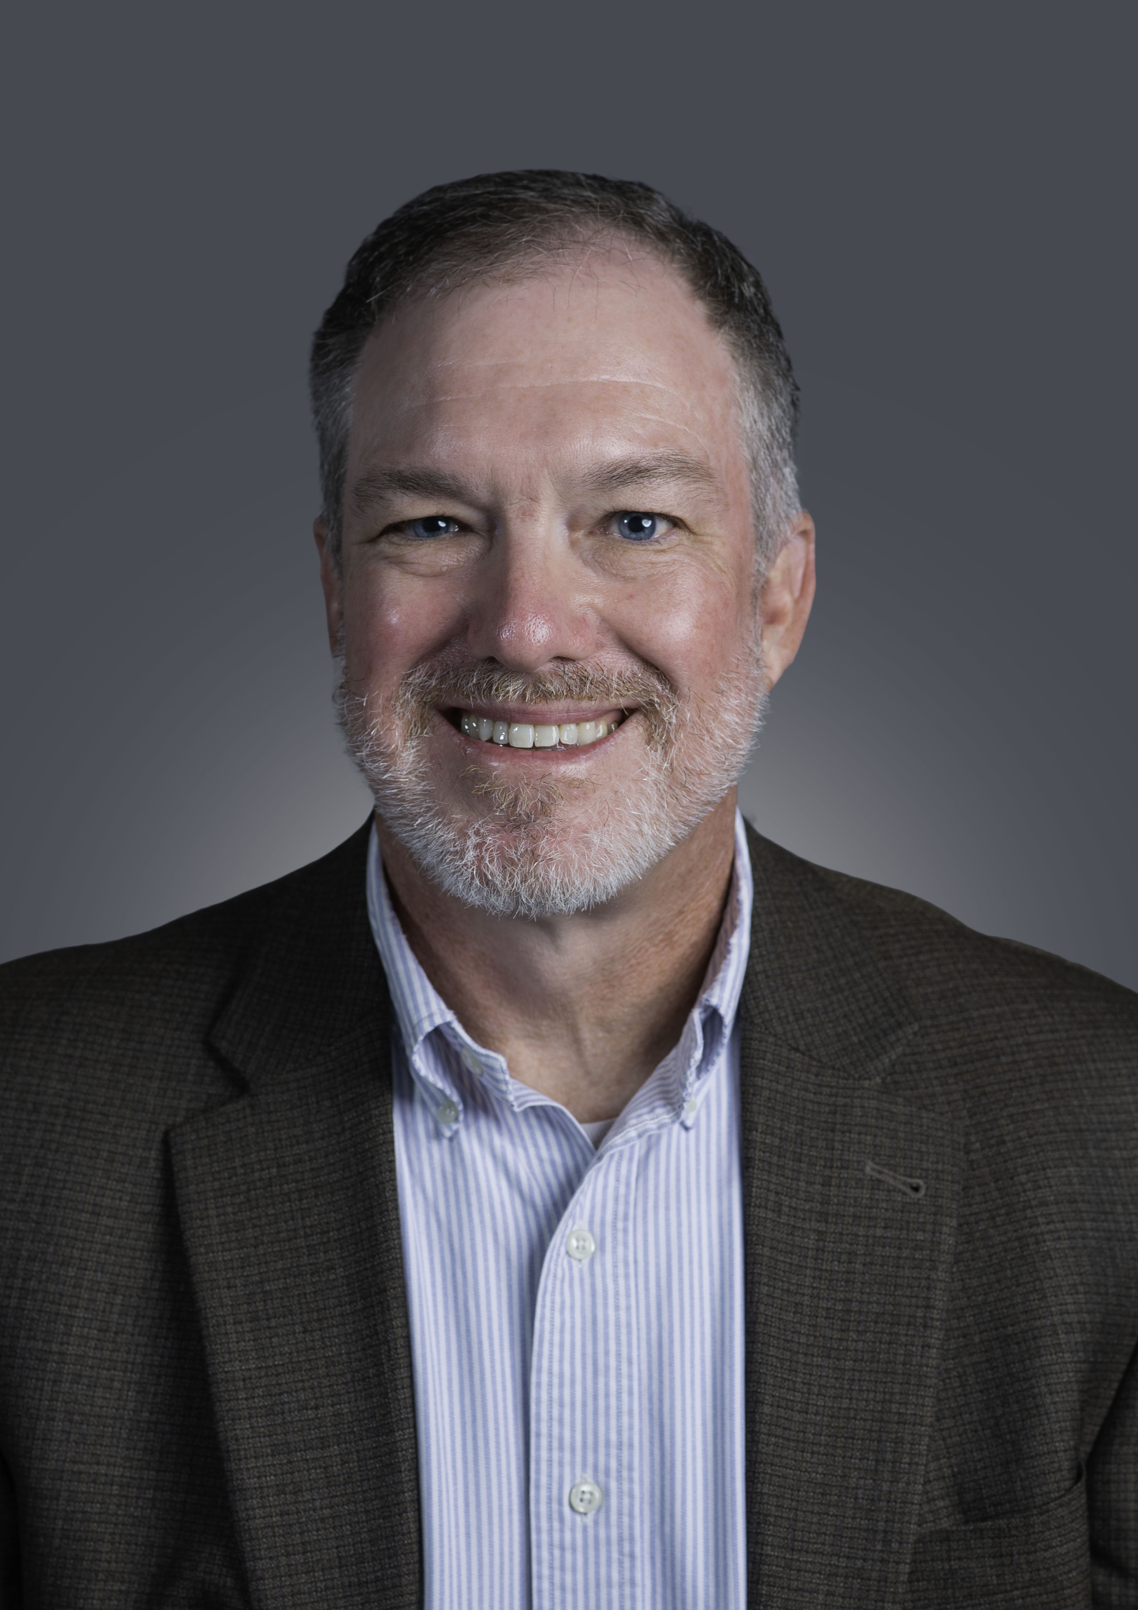

Jerrold Miller
Jerrold Miller has been with Kraton Pine Chemicals for 25 years and is the Global Technical Director leading the Product Development and Scale Up team based in Savannah Georgia. He is passionate about bringing new products to the market which add value for the customer, the market and the environment. Other passions include anything outdoors, especially camping, fishing, and hiking (in our beautiful forests in the southeast), golf, tennis, and cycling.
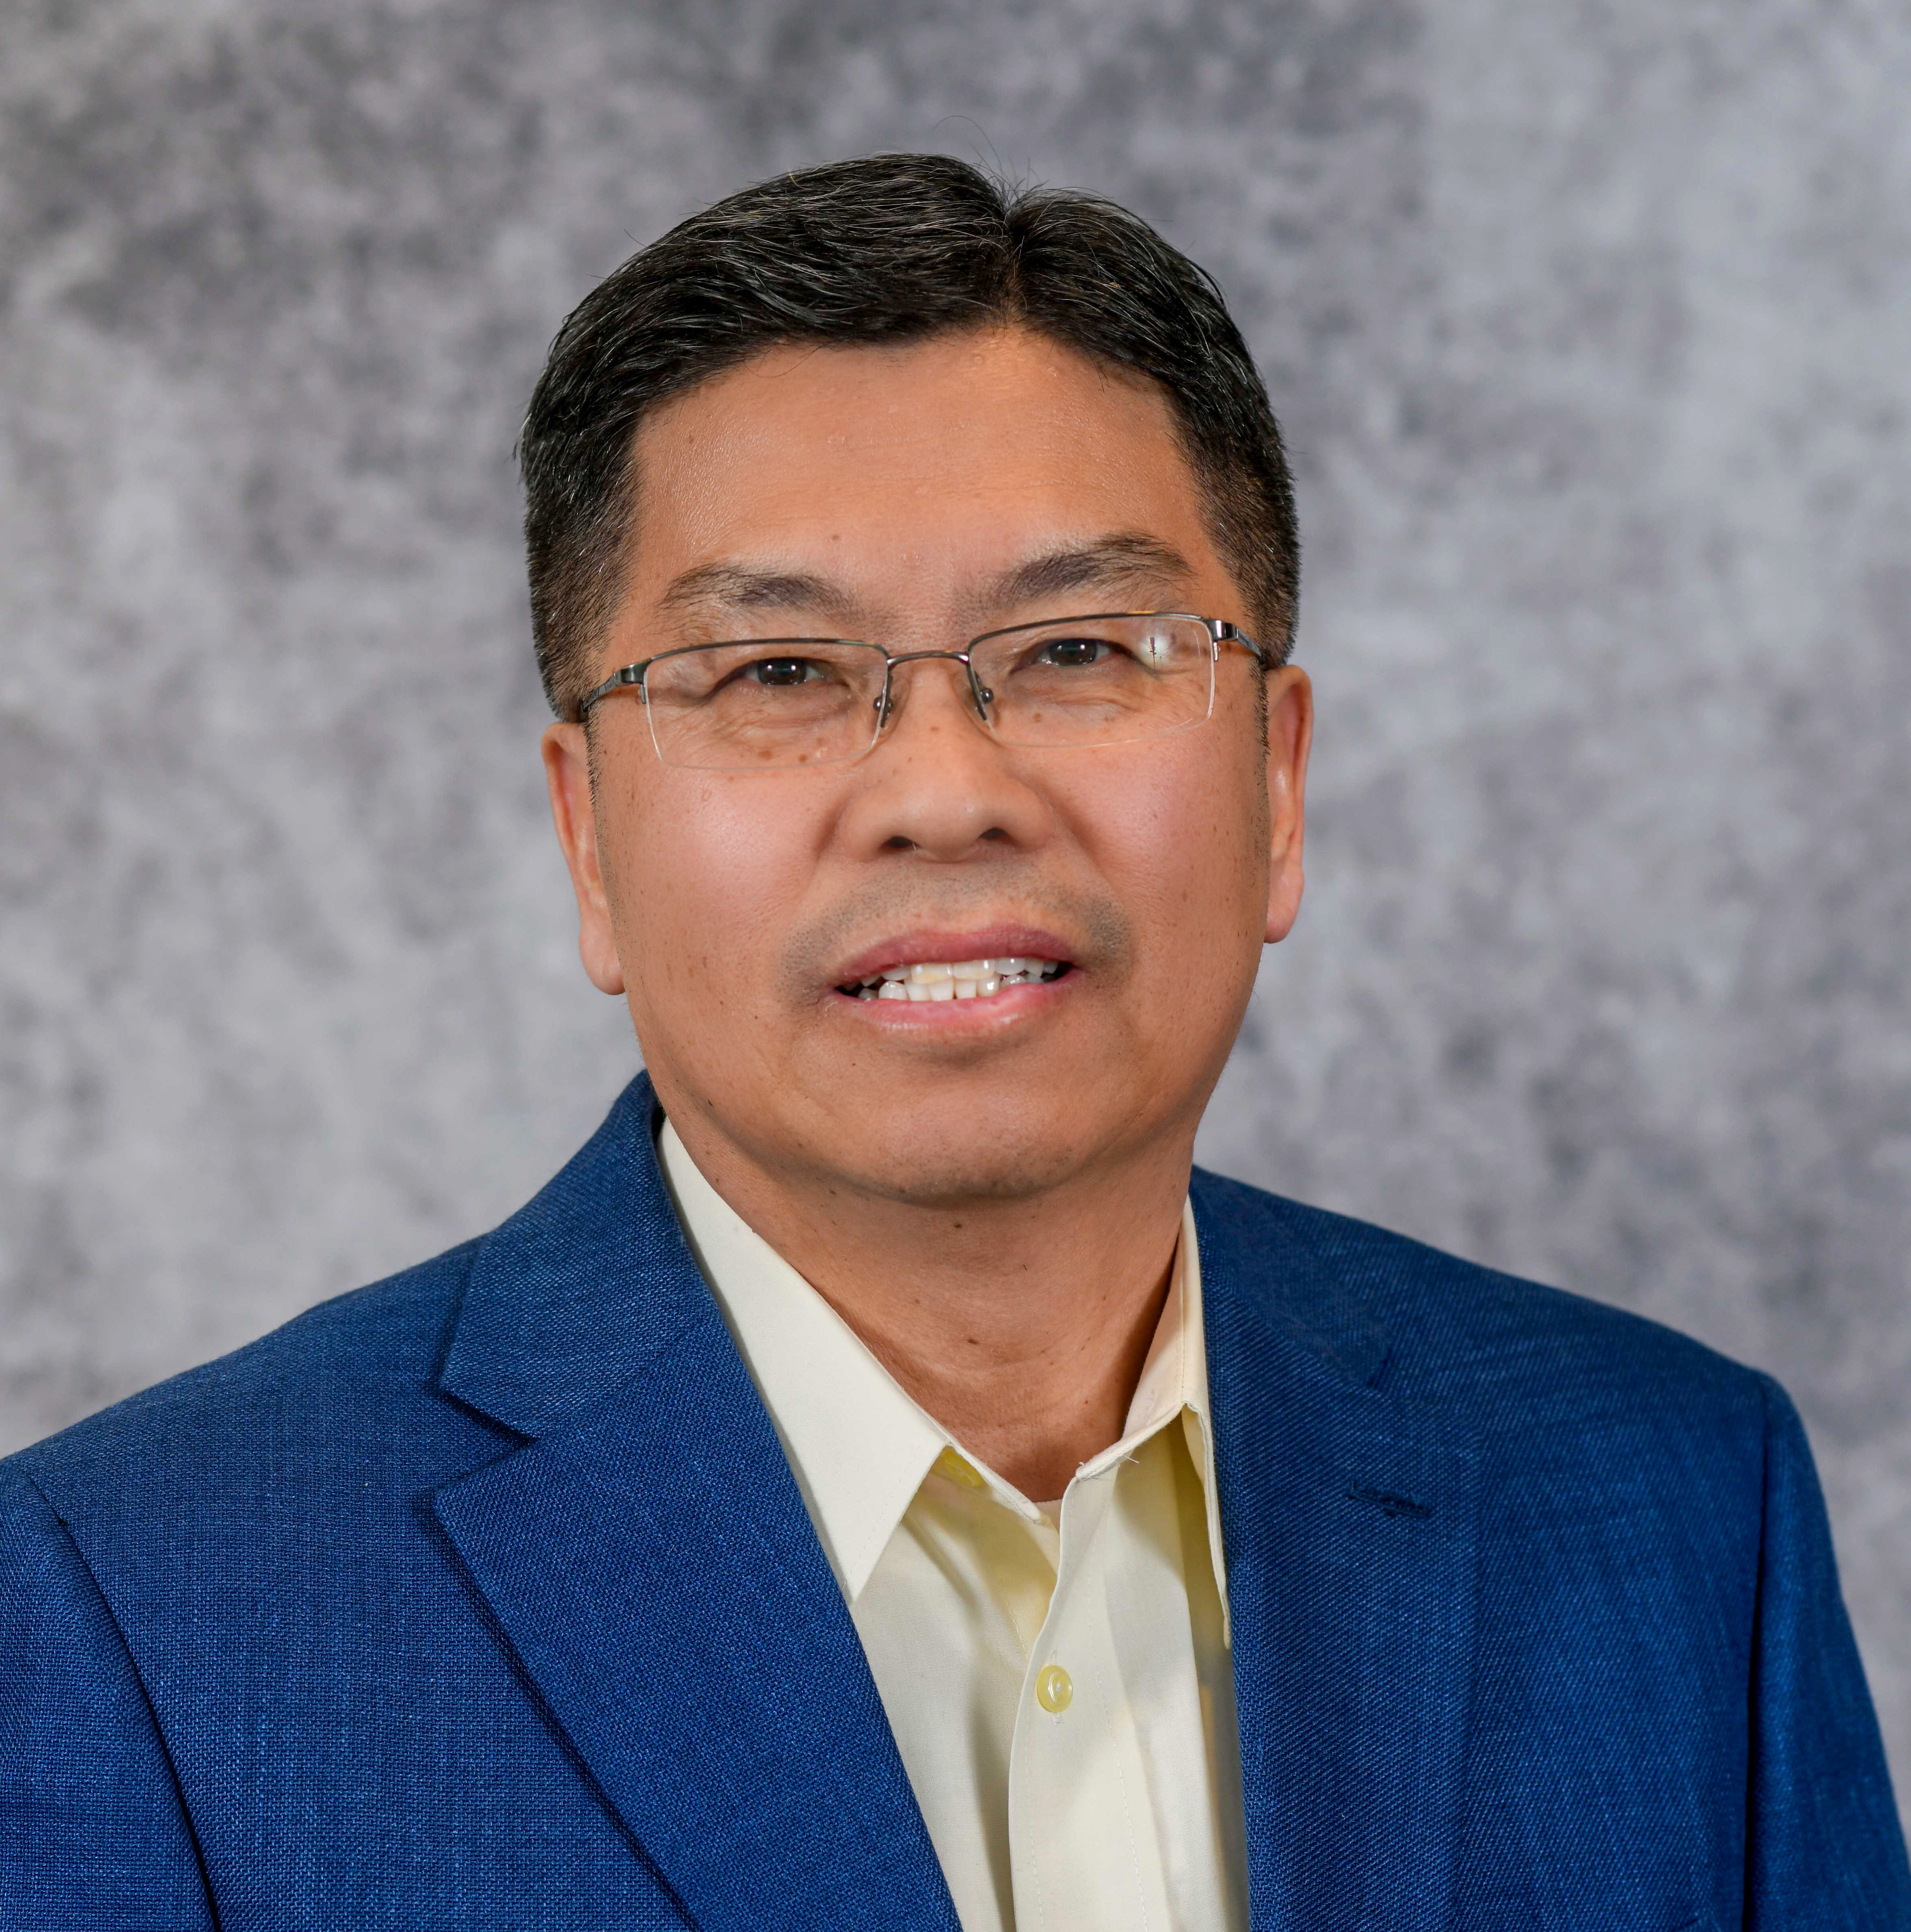

Jingxin Wang
Dr. Jingxin Wang is Head and Reuben B. Robertson Professor of the Department of Forest Biomaterials at North Carolina State University in Raleigh, North Carolina, USA. Before joining NC State, he was the Benedum Distinguished Scholar, Davis Michael Professor of Forestry and Natural Resources, and the Director of Sustainable Biomaterials & Bioenergy at West Virginia University, USA. He received his degrees in Forest/Mechanical Engineering from Northeast Forestry University, China. He received a M.S. in Computer Science from West Virginia University, and a Ph.D. in Forest Resource Management from the University of Georgia, USA. He has taught forest and biomass harvesting logistics and analysis, computing applications in forest and natural resources for both undergraduate and graduate students for more than 20 years. His research interests include biomass energy and bioproducts, forest carbon management and supply chain management, computer simulation and system modeling, and data science and Applied AI. Dr. Wang has authored or coauthored more than 200 refereed papers, and 12 books or book chapters. He is a leading PI for several USDA and USDOE funded biomass energy and bioproducts projects. He has served as an editorial board member and associate editor for four international journals. He is an active member of six international professional societies.
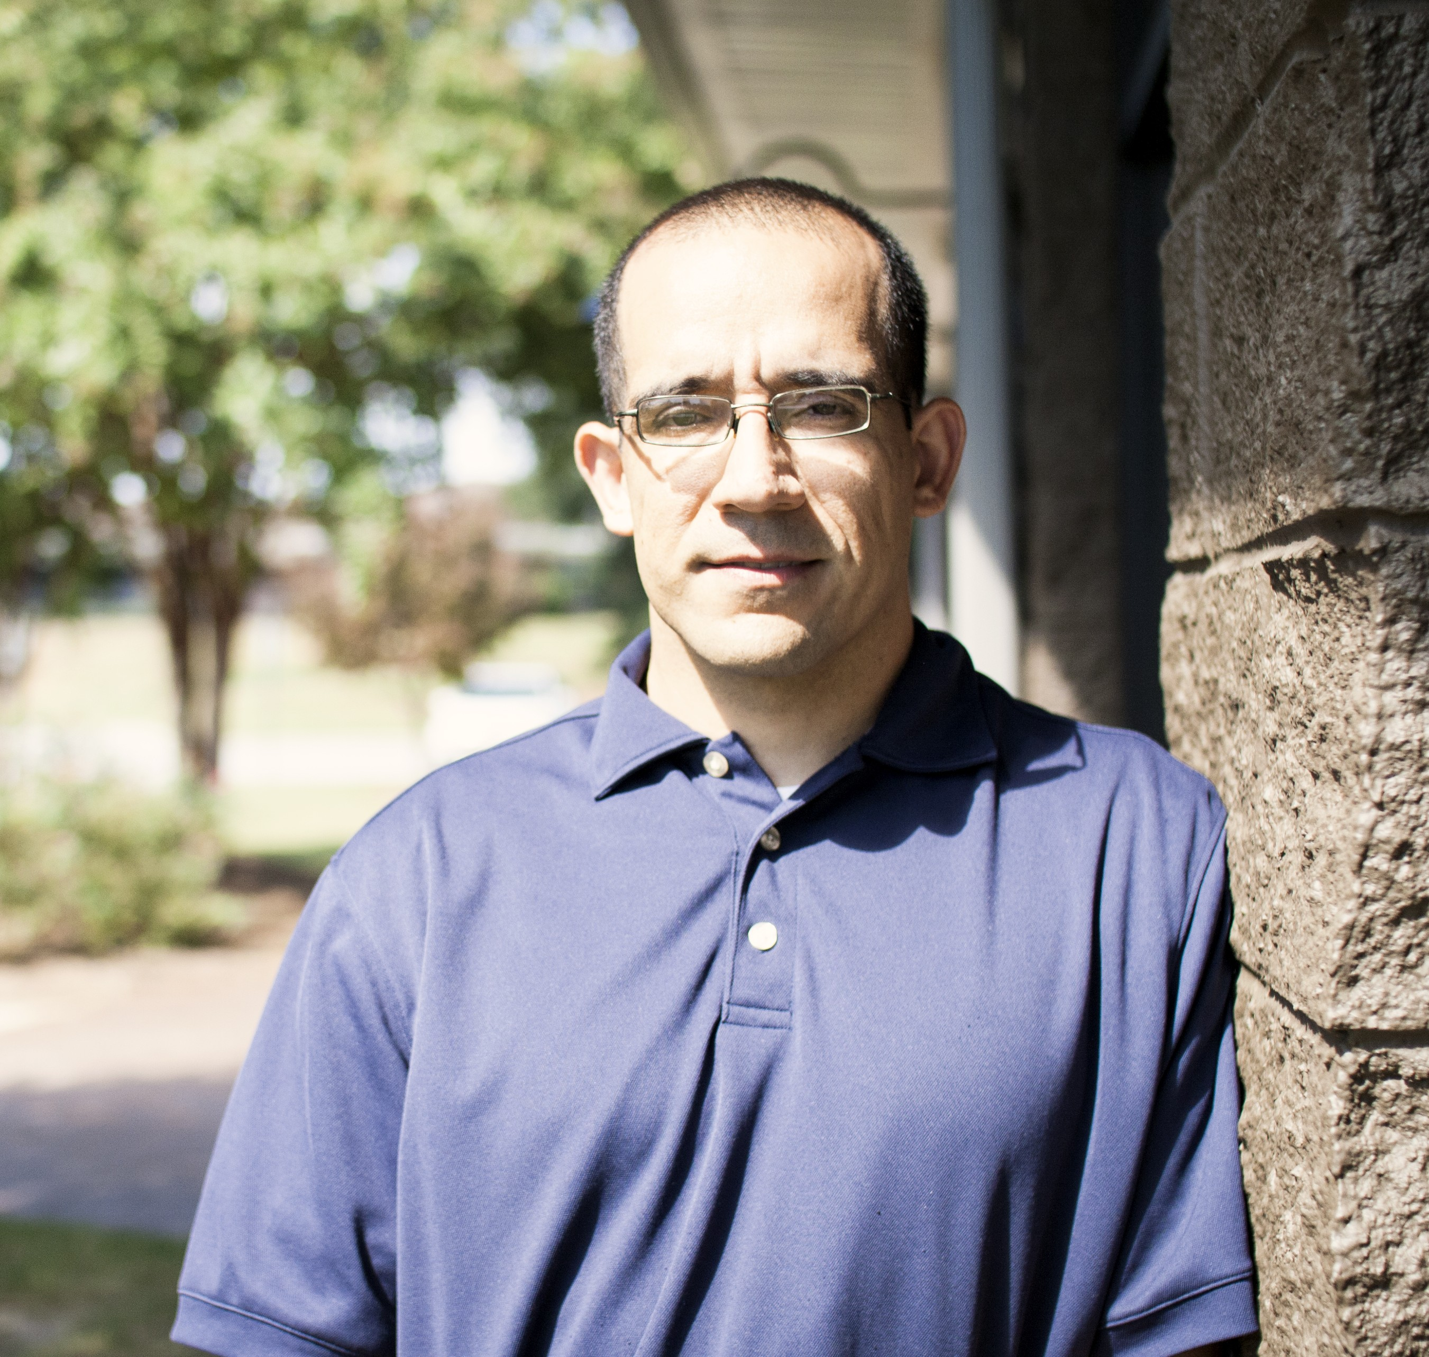

Joey Espinosa
Joey grew up in a small rural area in South Carolina and came to Greenville to attend Furman University. After receiving his Bachelor's and master’s degrees in chemistry from Furman, Joey worked as an organic and analytical chemist for almost 10 years, before working in the non-profit field for 14 years. Joey returned to his chemistry roots, leading research and sustainability for Mosaic Color & Additives for the last 6 years.
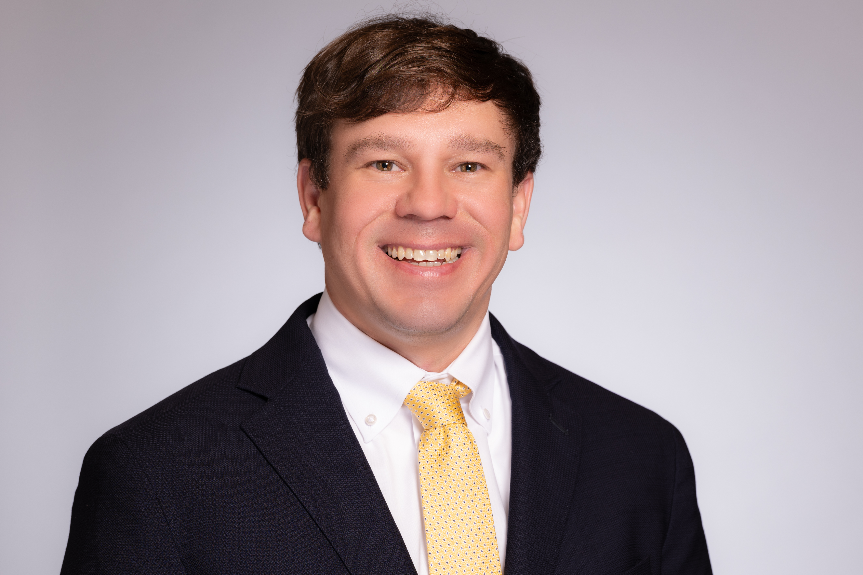

John Hatcher
Dr. John Hatcher, a certified forester and executive director, leads the North Carolina Forestry Association’s advocacy efforts with the North Carolina General Assembly as well as interacting with federal and state regulatory agencies on issues that affect forestry and the forest products industry. Prior to joining the NCFA, Hatcher spent three years with Compass South, Inc. in Walterboro, SC as a forest economist. He was involved in all facets of timberland and agricultural land evaluations and appraisals. Hatcher holds a Doctorate of Philosophy in Forestry Resources, a Master of Science in Applied Economics and Statistics, and a Bachelor of Science in Wildlife Fisheries Biology from Clemson University.

John Lummus
John Lummus serves as the President and CEO for the Upstate SC Alliance. In this role, he is responsible for overseeing the direction of the Alliance as well as running the day-to-day operations. Prior to his current position at the Upstate SC Alliance, Lummus served as vice president of Economic and Institutional Advancement at Tri-County Technical College, a position he held for eight years. Lummus also served as director of the Anderson County Office of Economic Development and worked to recruit new industry while supporting existing industry throughout the county. A native of Anderson, John is a graduate of Wake Forest University and received his master’s degree in Public Administration from the University of South Carolina (USC). He is also a graduate of the South Carolina Economic Developer’s School, USC’s Higher Education Leadership Program, and the national Executive Leadership Institute conducted by the League for Innovation in Community Colleges. In May of 2015, John received his SCCED (South Carolina Certified Economic Developer) certification.
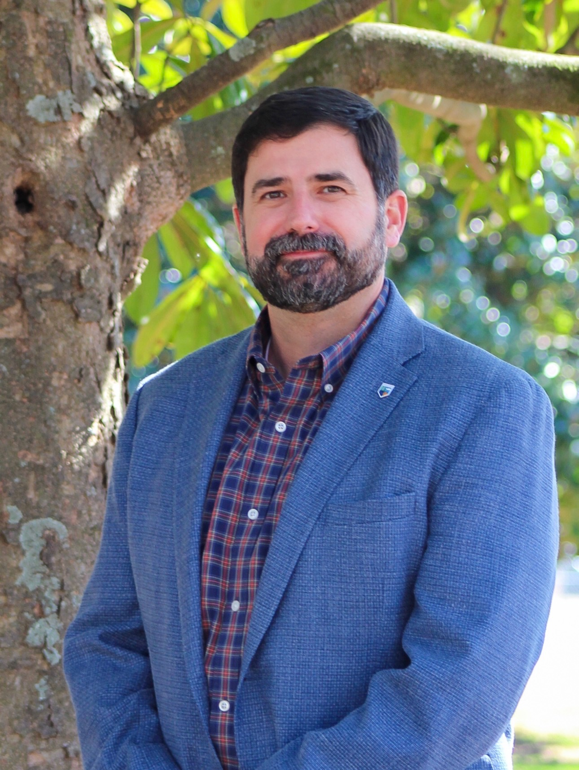

Johnny Sabo
Johnny Sabo was appointed Director and State Forester of the Georgia Forestry Commission (GFC) in September 2024. Since taking on the role, he has led the agency through an unprecedented period of challenges, including Hurricane Helene response and recovery, significant Southern Pine Beetle outbreaks, devastating wildfires, and major shifts within Georgia's forestry industry. Governor Brian Kemp appointed Johnny to lead the Governor's Forestry Task Force in fall 2025. The Task Force brought together leaders from government, industry, and academia to develop strategies to strengthen Georgia's forestry economy. One of the Task Force’s key outcomes was the establishment of the Georgia Forestry Innovation Initiative, a partnership between the Georgia Forestry Commission and the Georgia Institute of Technology focused on advancing innovation, research, and economic opportunities for Georgia's forest products industry. Johnny also serves as Treasurer of the National Association of State Foresters Foundation and is a member of the National Association of State Foresters Wildland Fire Committee, the Georgia Forestry Foundation Board of Trustees, the Georgia Sentinel Landscape Executive Committee, the University of Georgia Warnell School of Forestry Dean’s Advisory Board, and the Georgia Outdoor Stewardship Board of Trustees. He holds a bachelor's degree in Forest Resource Management from Clemson University. Johnny and his wife, Christina, have one son and reside in Macon, Georgia.
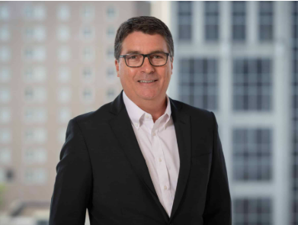

Kent Fonvielle
Co-Head & Chief Operations Officer, Power & Infrastructure
Kent Fonvielle is Co-Head and Chief Operations Officer of Pacolet Milliken’s Power & Infrastructure Division. Kent is responsible for Operations of the Division’s operating subsidiaries, including Piedmont Green Power, Bushy Park, Hydera, and Lockhart Power. He also has responsibility for Pacolet’s renewable energy asset portfolio across the country Prior to Pacolet, he was an executive with MISO, a regional transmission grid operator, responsible for its South Region. Before joining MISO, Kent held various roles at Duke Energy, from engineering and operations to regulatory affairs. Kent received his Bachelor’s degree in Civil Engineering from NC State and his Master of Business Administration from University of North Carolina - Wilmington.
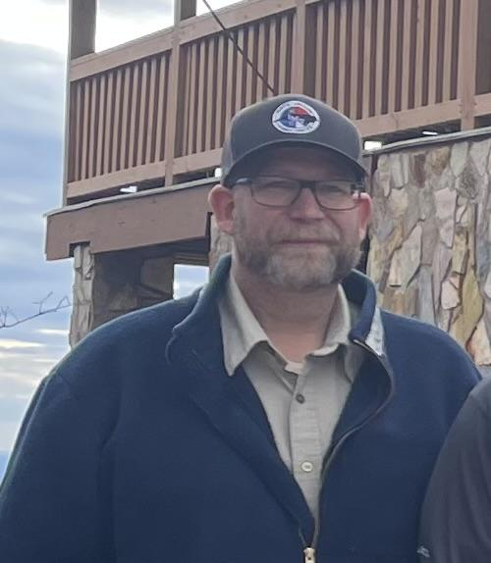

Kevin Harvell
Deputy State Forester
Kevin Harvell has worked for the North Carolina Forest Service for 30 years and is currently serving as the Deputy State Forester. He has been in this role since February of 2025 where he supervises Field Operations, Aviation Operations, Forest Protection and the Forest Management Divisions. Programs and services provided by the agency include wildland fire/emergency response, wildfire mitigation and prevention, technical assistance to forest landowners, cost-share administration, forest health monitoring, water quality monitoring / protection, urban forestry and nursery management to name a few. Harvell is originally from Guilford County and is a 1996 graduate of North Carolina State University with a BS in Forest Management.
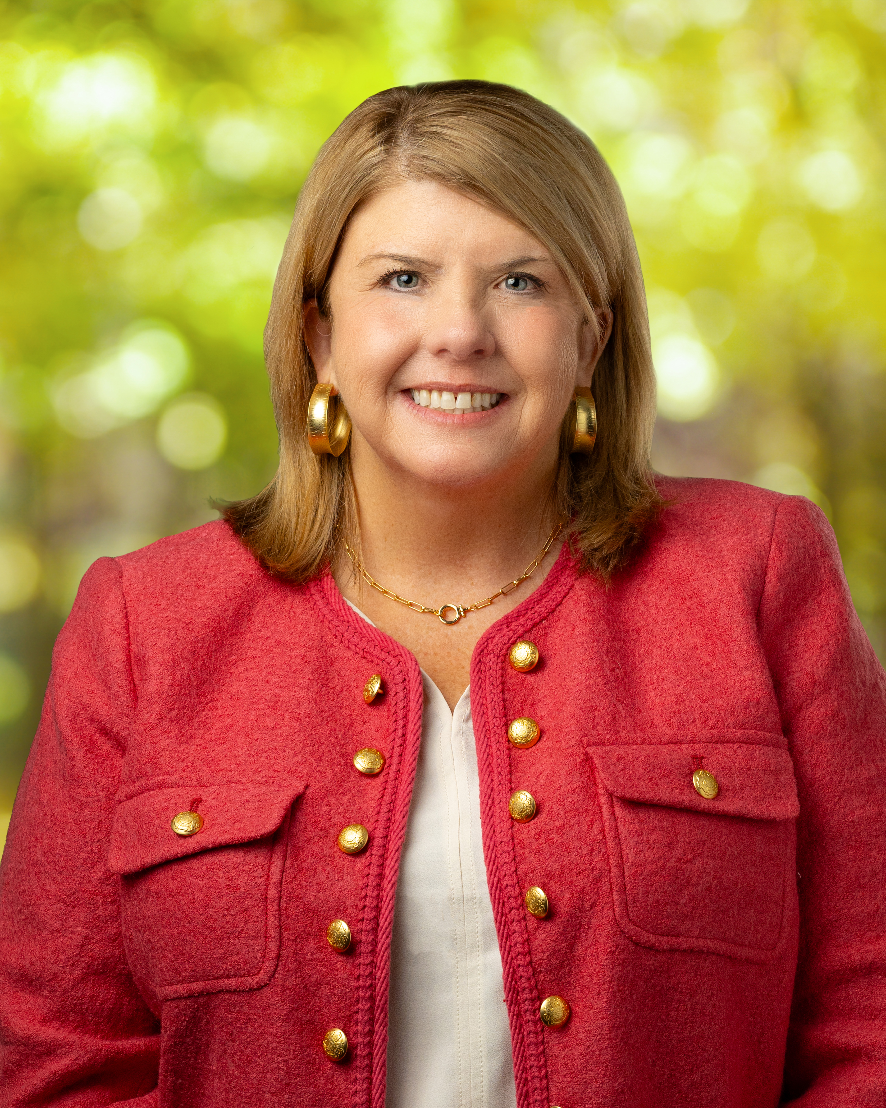

Kristen Austin Gunter
Kristen knows the value of bringing together diverse groups to create solutions for people and the environment. In her role as Senior Vice President for Conservation, Kristen works with key stakeholders and partners to help fulfill Sustain SC’s mission. She oversees Sustain SC’s work in energy, and resilience and conservation. Most recently she has re-launched the Land and Water Action Platform, one of the primary sources of corporate funding for land conservation across the state. Prior to joining Sustain SC, Kristen spent more than 25 years with The Nature Conservancy where she built conservation programs in the Midwest, South Carolina, and the Southern Appalachians. During this time Kristen learned how to create change through real-world solutions, policy expertise, sustainable financing, and collaborative partnerships. Believing strongly that the key to success is trusted relationships, Kristen’s depth of experience includes negotiating complex land transactions to expand public lands and managing natural resources in partnership with agencies, non-profits, and public utilities. Kristen has called Greenville home for twenty years and enjoys engaging in and giving back to her community. She was appointed by Greenville City Council to serve on their Sustainability Committee and is a graduate of Leadership Greenville and the Urban Land Institute’s Sustainable Leadership Program. Kristen’s alma mater, University of Tennessee, is located in the shadow of the Smoky Mountains where she grew up, and where her love of conservation was fostered.
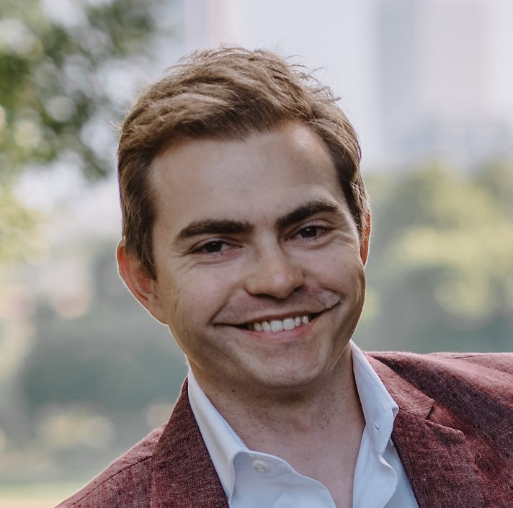

Mark Woloszyn
Mark wants to help build the sustainable U.S. bioeconomy, turning the nation's underused forest biomass into domestic industrial materials at scale. He is Director of Investment Strategy and Analytics at Resource Management Service (RMS), where he supports the day-to-day management of roughly $5.8 billion in timberland investments, leads the firm's AI Center of Excellence, and helps drive the evolution of its technology systems. His attention goes to the unglamorous middle of commercialization, where promising forest technologies usually stall: feedstock logistics, customer discovery, industrial partnerships, and capital assembled from public, philanthropic, and private sources. He holds a Master of Forestry from Yale, where he also co-founded an agroforestry startup accepted into the university's incubator. Prior to his shift into forestry, he worked in investment banking and corporate development. He follows companies like Stora Enso and Metsä for what a mature, higher-value forest-materials ecosystem can look like, and is most interested in what the US's own version should be.
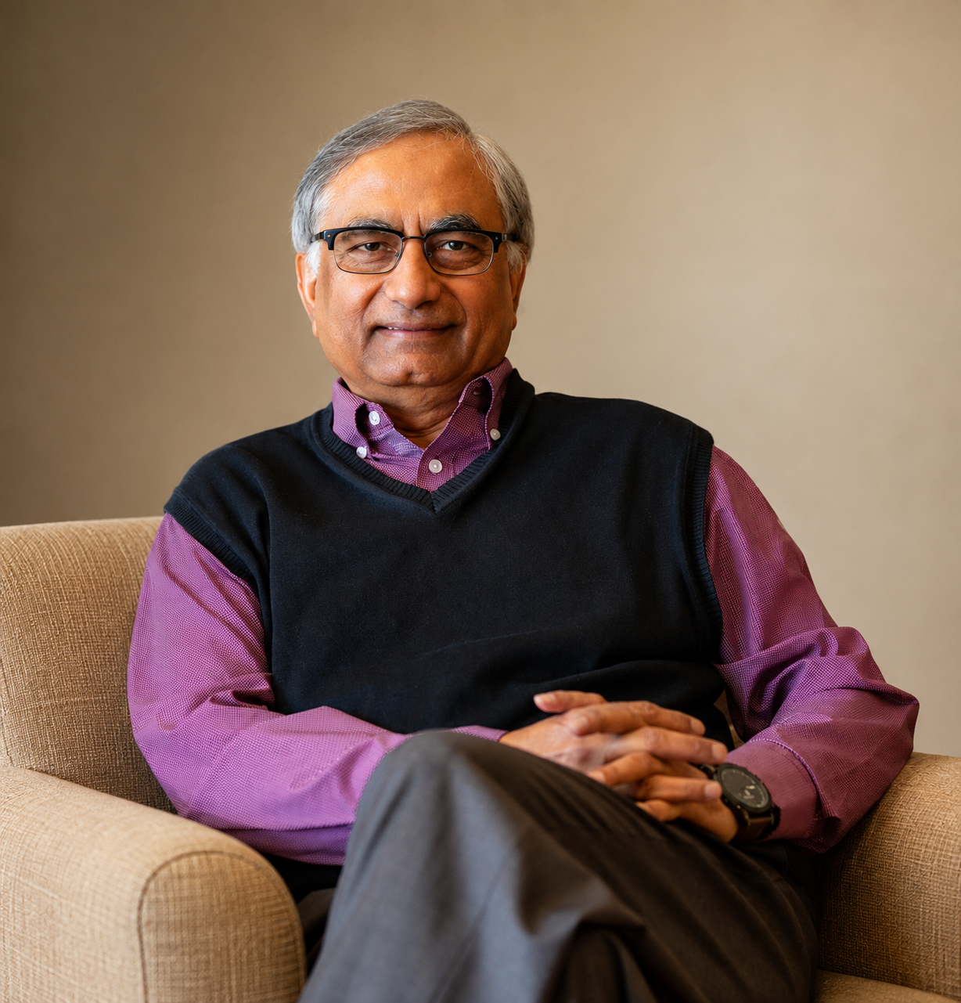

Masood Akhtar
Masood Akhtar, Ph.D., is a nationally recognized leader in energy efficiency, renewable energy, advanced biofuels, bioproducts, and sustainability, with more than 35 years of experience in research, commercialization, investment, technology transfer, investment, and public policy.
A serial entrepreneur and President and Co-Founder of the Biorenewable Deployment Consortium, Masood has pioneered transformative energy and biorefinery initiatives and secured hundreds of millions of dollars for innovative projects. His achievements include many awards, including the USDA Honor Award and Forest Service Chief’s Awards. His leadership has earned appointments by Wisconsin governors, USDA, and the U.S. Congress. He established the Wisconsin Bipartisan Paper Caucus to revitalize Wisconsin’s pulp and paper industry, the nation’s largest. Today, Masood advises industry leaders and global investment groups, advancing decarbonization, innovation, investment, and bipartisan solutions for America’s energy future.
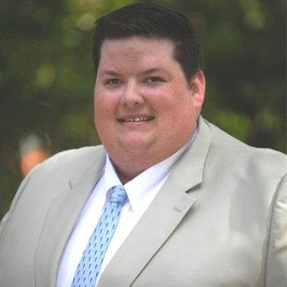

Matt Hestad
Matt Hestad serves as Senior Vice President of the Georgia Forestry Association and Foundation, leading Foundation operations and administration and helping advance initiatives across Education & Leadership, Environmental Sustainability, and Economic Competitiveness. He also provides strategic guidance and management for communications and engagement efforts for the Georgia Forestry Association and Foundation. Previously, Matt served as Vice President of Engagement, overseeing communications, marketing, brand management, and stakeholder engagement focused on elevating Georgia’s forestry sector. Before joining GFA full-time, he spent seven years with HL Strategy, an Atlanta-based communications consultancy, leading communications strategies and campaigns for nonprofit, natural resources, and manufacturing clients. Raised in a family cattle and cutting horse business, Matt has a deep connection to Georgia’s rural communities and working forests. He holds a bachelor’s degree in Agricultural Communications from the University of Georgia and an associate degree from Abraham Baldwin Agricultural College (ABAC). He is also a graduate of Leadership Newton and the UGA Advancing Georgia's Leaders in Agriculture and Forestry program. Matt, his wife Bianca and son Boomer live in Covington, Georgia.

Nick DiLuzio
Nick is Vice President of Business Development for Forisk Consulting, a market research and analysis firm serving the North American forest products industry. Forisk provides firms in the timberland and forest products sectors with actionable data and insights across the supply chain, from the woods to the mill gate. Prior to Forisk, Nick worked for the Georgia Forestry Association, where he led the Georgia Forestry Foundation. He holds a B.S. in Biology from Davidson College, Masters degrees in Environmental Management and Forestry from Duke University, and he is a Certified Forester through the Society of American Foresters.
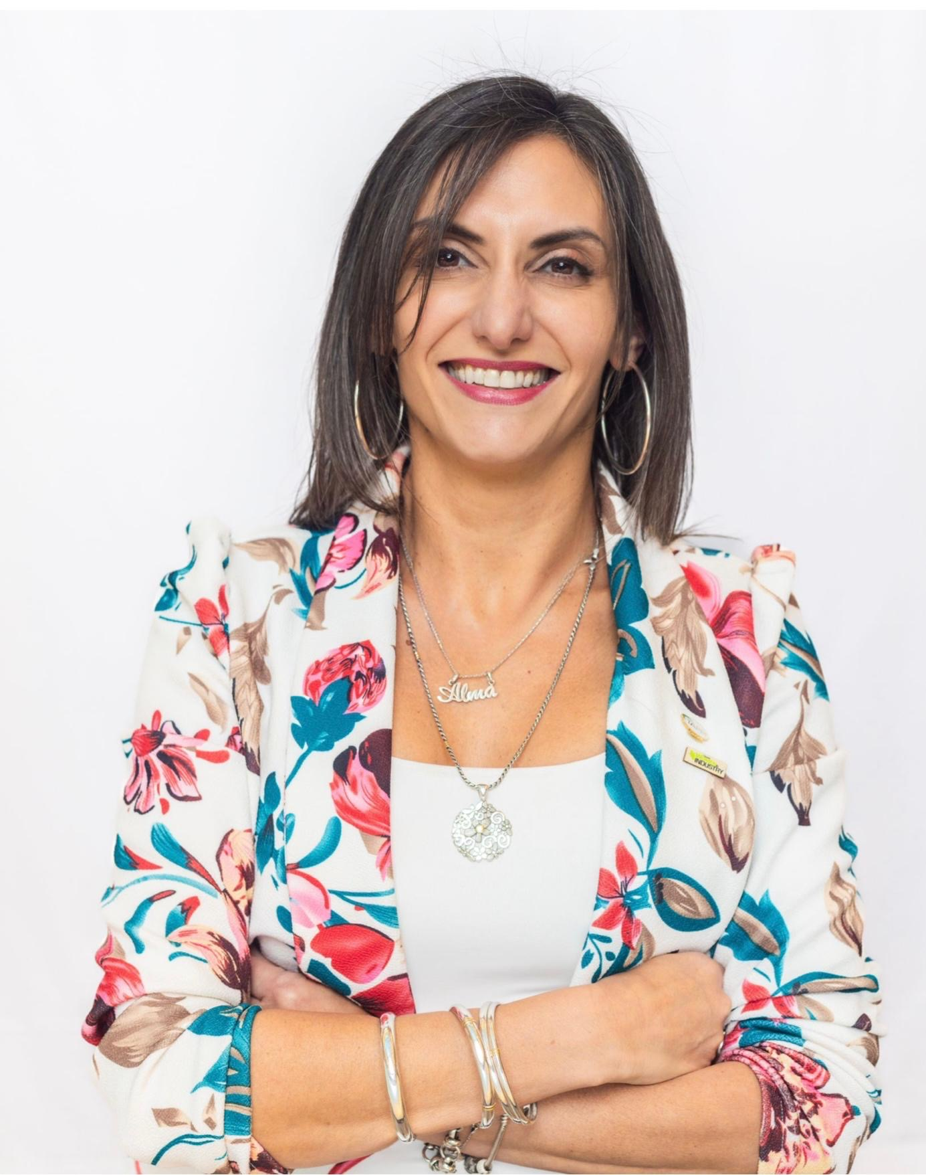

M. Soledad Peresin
Dr. M. Soledad Peresin is the Patricia “Pat” Layton Endowed Director of the Wood Utilization + Design Institute (WU+DI) at Clemson University and a Professor with joint appointments in Forestry & Environmental Conservation and Materials Science & Engineering. A chemist and materials scientist by training, she brings more than 20 years of academic and industry experience focused on transforming lignocellulosic biomass into high-value, sustainable materials for applications including construction, packaging, and advanced manufacturing. Prior to joining Clemson, Dr. Peresin was a faculty member at Auburn University, where she founded the Sustainable Bio-Based Materials Lab, and a Senior Scientist at VTT Technical Research Centre of Finland. She is a recipient of the NSF CAREER Award and has authored more than 90 scientific publications.
Dr. Peresin is also an active leader in the forest products and renewable materials community. She serves on the TAPPI Board of Directors, is Associate Editor of TAPPI Journal, chairs TAPPI’s Advanced Renewable Materials (ARM) Division, and serves as an elected Councilor of the American Chemical Society’s Cellulose and Renewable Materials Division. Through her research, professional leadership, and work at WU+DI, she advances collaboration among academia, industry, and government to accelerate innovation in sustainable biomaterials and strengthen the circular forest bioeconomy.
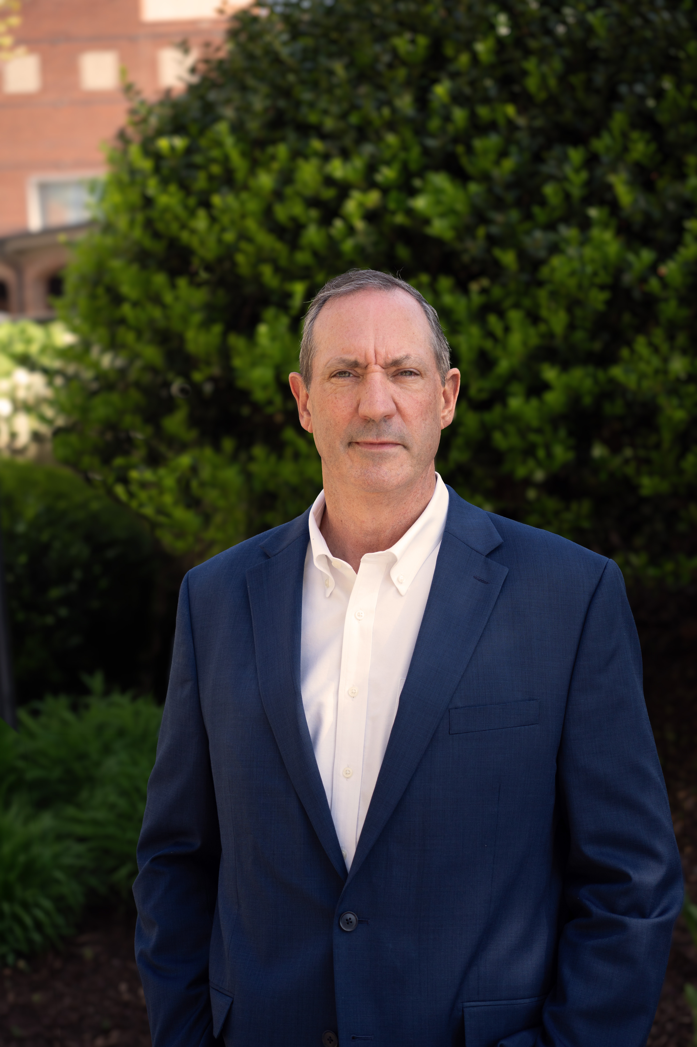

Pete Madden
Pete Madden currently serves as President and Chief Executive Officer of the U.S. Endowment for Forestry and Communities in Greenville SC. He has worked in the forest industry for over 30 years in land management, procurement, business development, finance, acquisitions & divestitures, renewable energy, and supply chain logistics. His previous roles include President and Chief Executive Officer of Drax Biomass Inc., Operations Management and Senior Financial Analyst at Georgia-Pacific Corporation, several key positions at Plum Creek Timber Company including Vice President of Renewable Energy and Supply Chain, and a Forest Technician at Westvaco Corporation. Pete graduated in 1988 with a Bachelor of Arts degree from Marlboro College in Vermont. He also earned a Master of Science in Forestry and a Master of Business Administration degree from the University of New Hampshire.
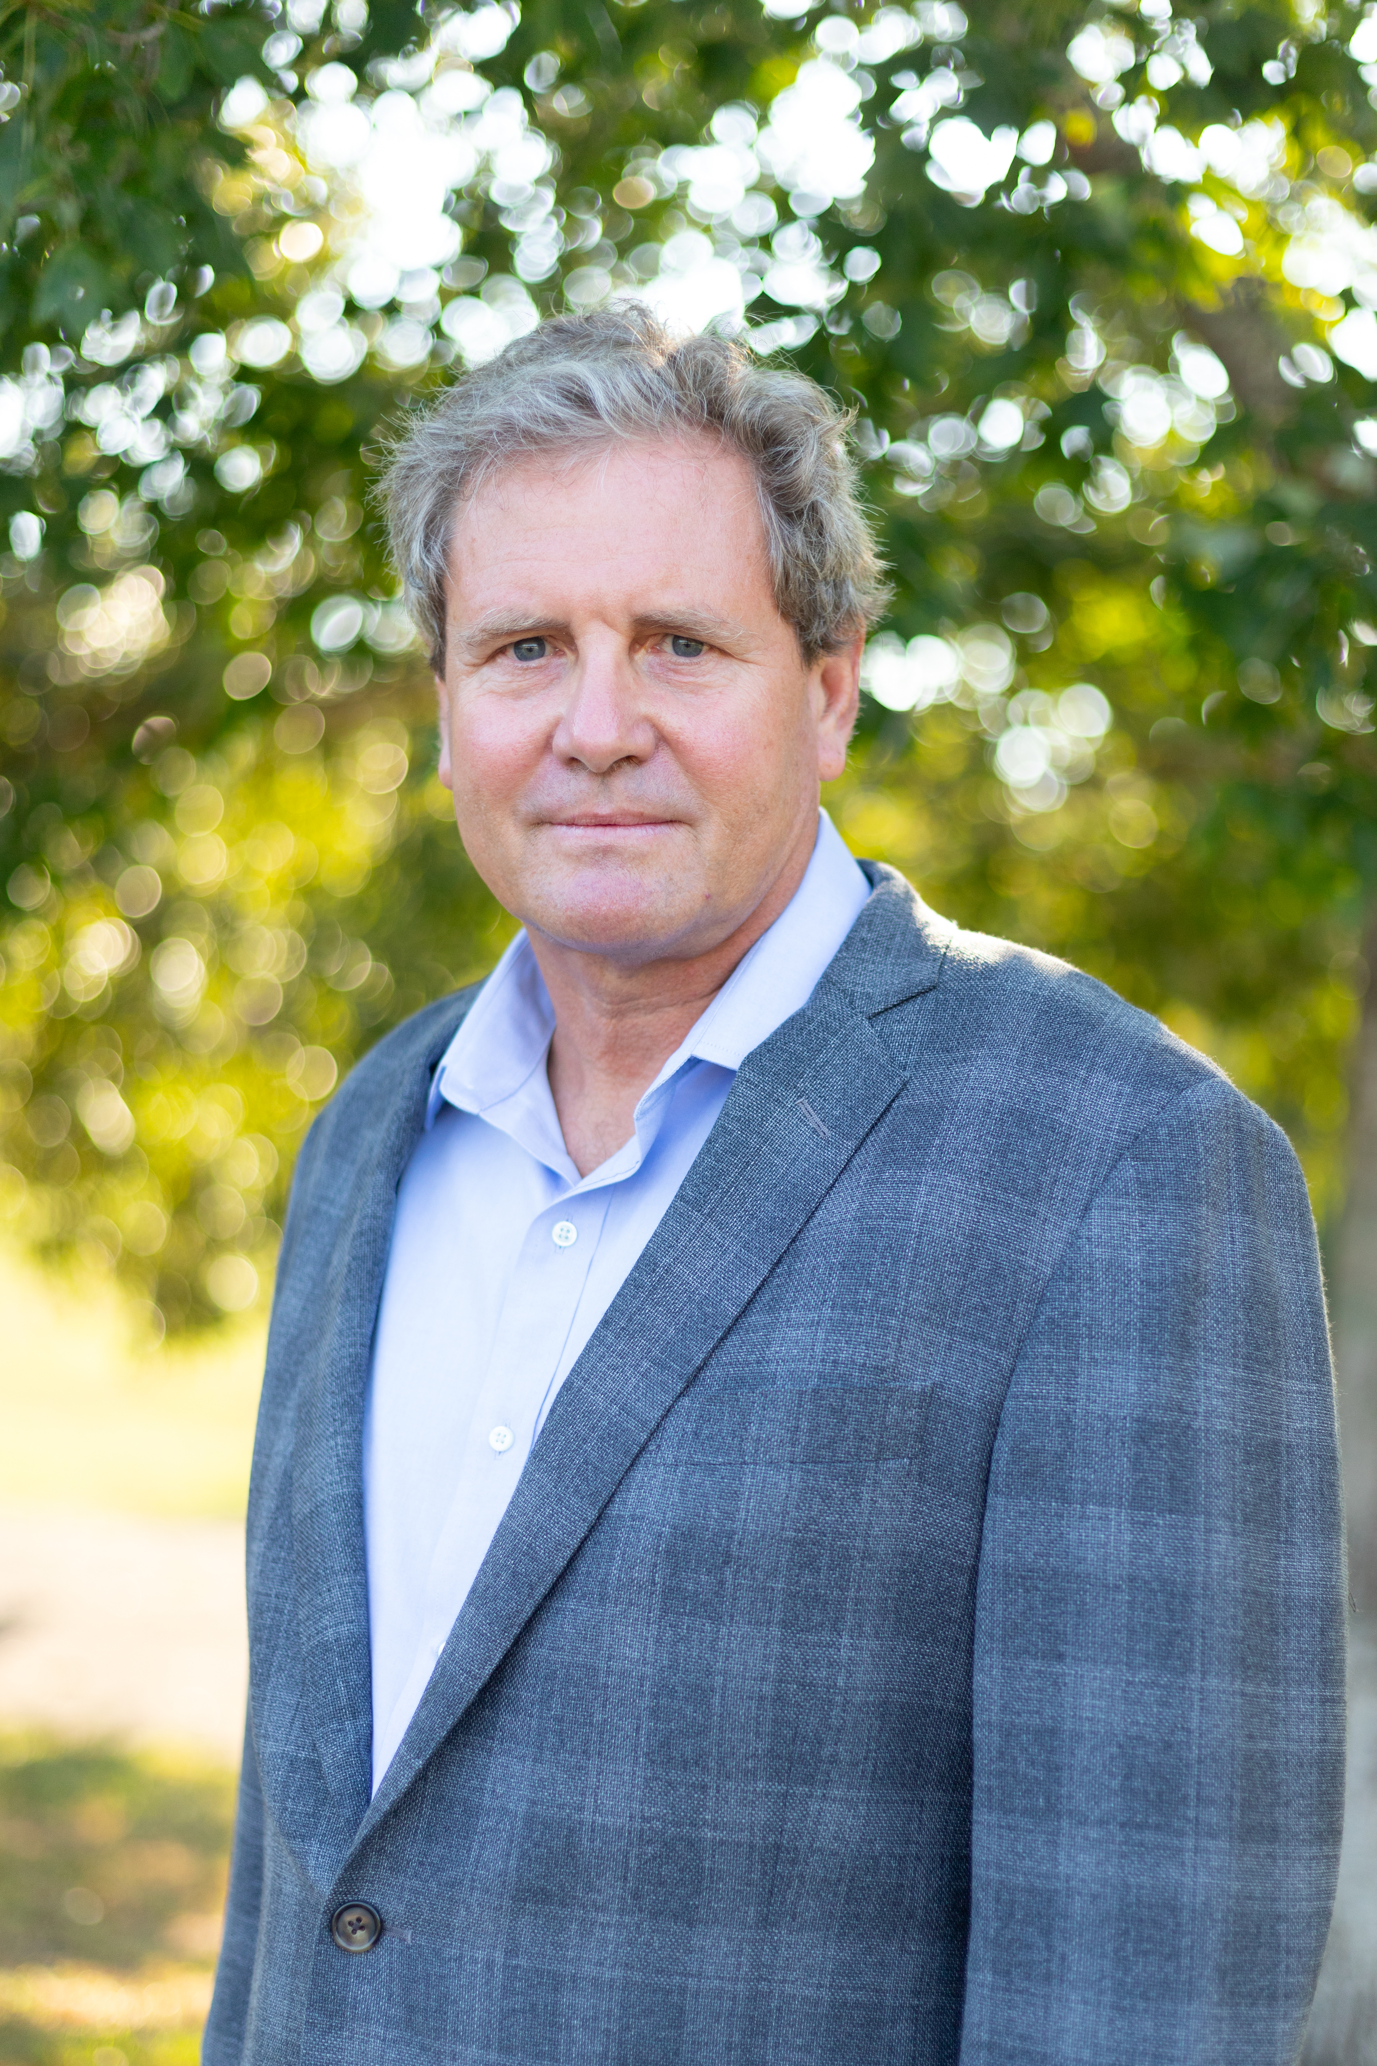

Rob Baldwin
Rob Baldwin is a professor and holds the Margaret Lloyd Chair of Conservation Ecology in the Department of Forestry and Environmental Conservation, and serves the Dean of CAFLS as the Executive Director of the Clemson University Forest. He received his PhD from the University of Maine, where he contributed to the understanding of spatial aspects of conserving forested wetlands in urbanizing landscapes. He came to Clemson in 2006 and developed a research career including collaborations for wildlife conservation in Southeastern forests. In addition to the Clemson University Forest he oversees a research and teaching property - the Hardscramble Preserve - in the Sandhills portion of the State. In 2024 he was honored by Clemson University with the Class of ’39 award for Excellence.
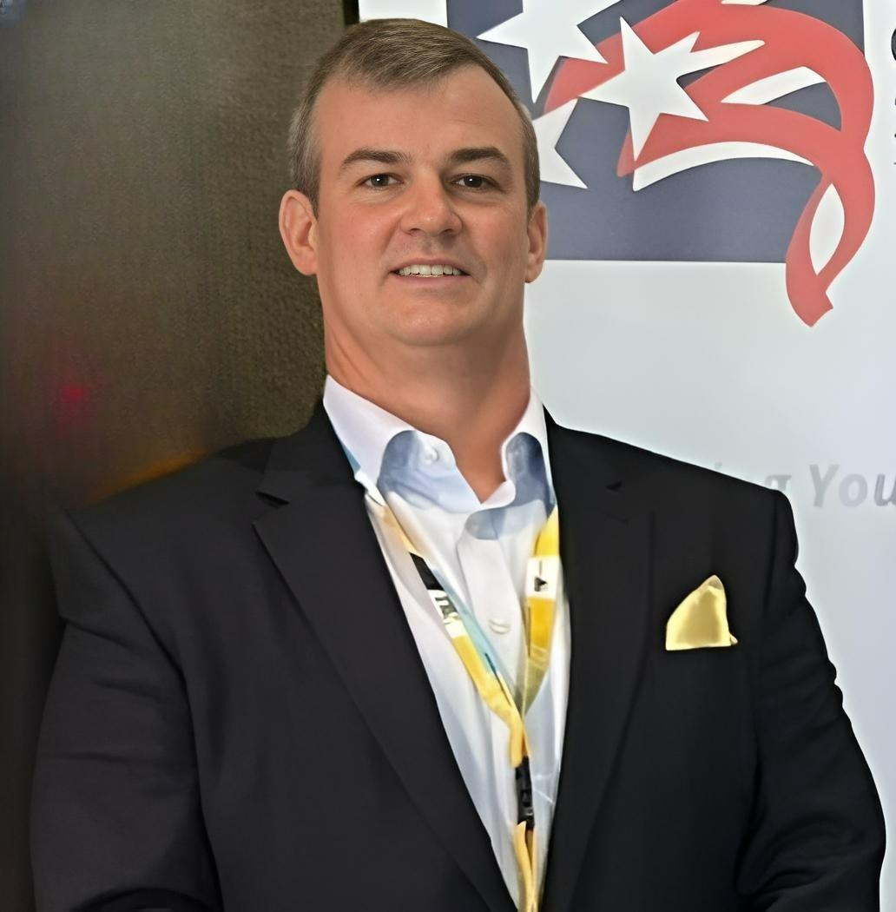

Robert E. Bryan, PMP
Robert E Bryan, PMP is a 30 plus year veteran of the Electric Utilities industry, a graduate of Clemson University, and earned his PMP in 2011. A leader of substation, transmission, lighting, vegetation, solar, wind and distribution construction and maintenance, planning, project, and program estimating and construction and project management. With experience working with and for construction and engineering firms, IOU’s, COOP’s, governments, and municipalities. Responsible for the planning and leadership of multiple programs and projects, large mixed teams of engineers and construction personnel, storm preparation and restoration efforts nationally and internationally, and the training/mentoring of personnel. Starting CCCP, in late 2023, was instrumental in his ability to learn about the SC forestry industry and its current issues. That gave rise to Carolina Renewable Products and its solution for South Carolina’s Forestry industry woes and to create energy independence. A champion for process improvements and education in safety, sustainability, and environmental compliance. A father and avid outdoorsman, he donates his time to coaching youth sports, Special Olympics, and leadership in environmental and conservation organizations.
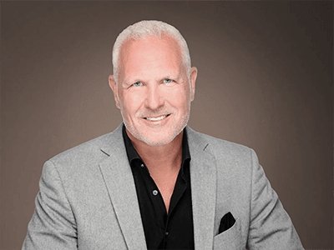

Sam Konduros
Sam Konduros, President & CEO of the Greenville City EDC, guides business recruitment, investor relations and collaboration with economic development partners. Konduros, who describes himself as “mission-driven” and an “entrepreneur at heart,” is a licensed attorney, certified economic developer and realtor. He has held multiple business leadership roles regionally and statewide including President/CEO of Upstate SC Alliance and President/CEO of SCBio (South Carolina Biotechnology Industry Organization). Konduros began his career at the SC Department of Commerce, helping recruit a wave of international companies to the state. A graduate of Clemson University and the University of South Carolina School of Law, Sam was designated as a “Knowledge Economist” by South Carolina Research Authority (SCRA) and was awarded the Governor's Order of the Palmetto in 2018."
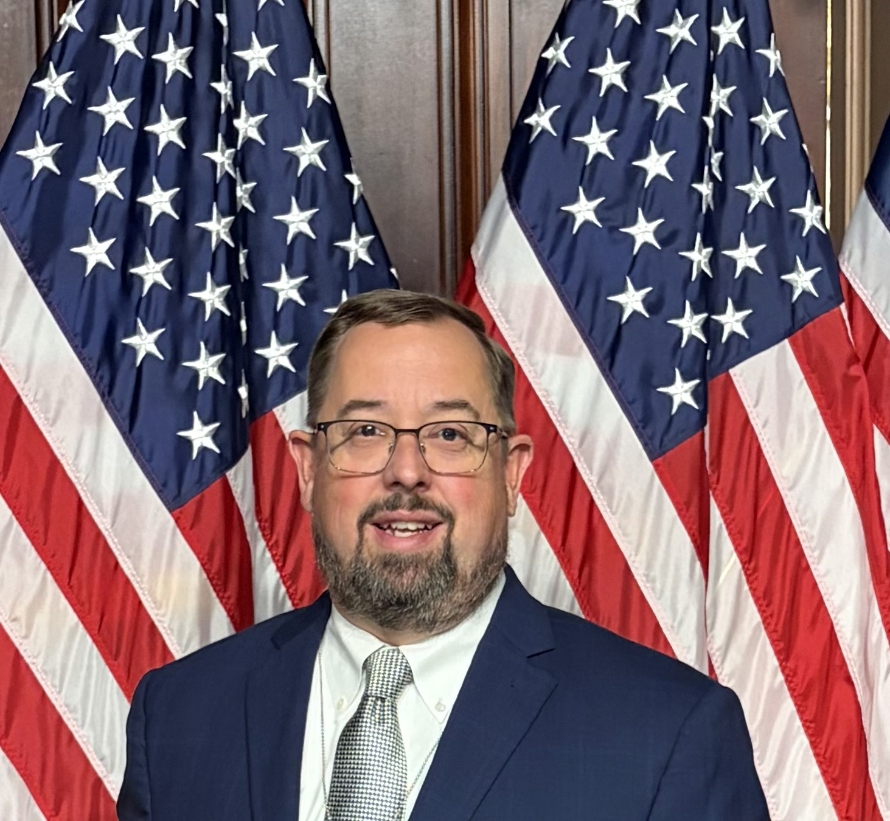

Scott P. Jones
Scott Jones joined the Forest Landowners Association in 2003 and has a Bachelor of Science in forest resources from UGA. Scott brings a diverse background of forest land management, ownership, and advocacy at the state, national and international levels and has served as the Chair of the Civil Society on the Standards Committee for Sustainable Biomass Program and is a member of the Advisory Committee on Sustainable Forest-Based Industries of the FAO of the UN. Scott is well versed in advocating on behalf of private forest landowners to ensure certainty and preserve property rights to sustain the next generation of forest landowners.

Scott Phillips
Scott Phillips is the State Forester of South Carolina and executive director of the South Carolina Forestry Commission. Appointed in 2018, he provides strategic leadership for statewide forestry, wildfire response, forest health, conservation, and forest-based economic development programs, working closely with a nine-member board appointed by the Governor. He represents South Carolina’s forestry interests at the state, national, and international levels. A career forester with more than 25 years of experience, Phillips began his career in field forestry and wildfire operations, serving on Incident Management Teams during complex emergency responses-experience that continues to shape his leadership approach. He has led the agency through significant organizational transformation, major wildfire seasons, and large-scale conservation and economic initiatives. Phillips is a past president of the National Association of State Foresters and currently serves as Co-Chair of South Carolina’s Forest Recovery Task Force. He holds degrees from the University of Georgia and Clemson University and is a Registered Forester in South Carolina.

Stefan France
Stefan France is a Professor in the School of Chemistry and Biochemistry at the Georgia Institute of Technology, where he serves as Associate Chair for Graduate Programs. His research program focuses on developing innovative synthetic methods and strategies for constructing structurally complex, biologically relevant molecules, with particular interests in catalysis, reaction development, and natural product synthesis. Prof. France is committed to integrating research, education, and mentorship to prepare the next generation of scientists and research leaders. As Associate Chair, he provides leadership for graduate education, student development, recruitment, and initiatives that strengthen the graduate student experience. He also serves on the Executive Board of the GT Center for a Renewables-based Economy from Wood (ReWOOD), contributing to interdisciplinary efforts focused on advancing research and innovation in renewable and sustainable wood- based materials and technologies. Across his research, educational, and leadership activities, Prof. France works to foster collaborative scientiﬁc environments and create opportunities that connect fundamental chemistry with broader societal and technological challenges.

Thomas W. Marrero
Thomas W. Marrero, PhD, is President and CEO of Wakefield BioChar. A former FBI Special Agent, Army officer, and research chemist, he leads the company's efforts to commercialize biochar for agriculture, carbon removal, and environmental sustainability. He holds a PhD in Analytical Chemistry from the University of Missouri.
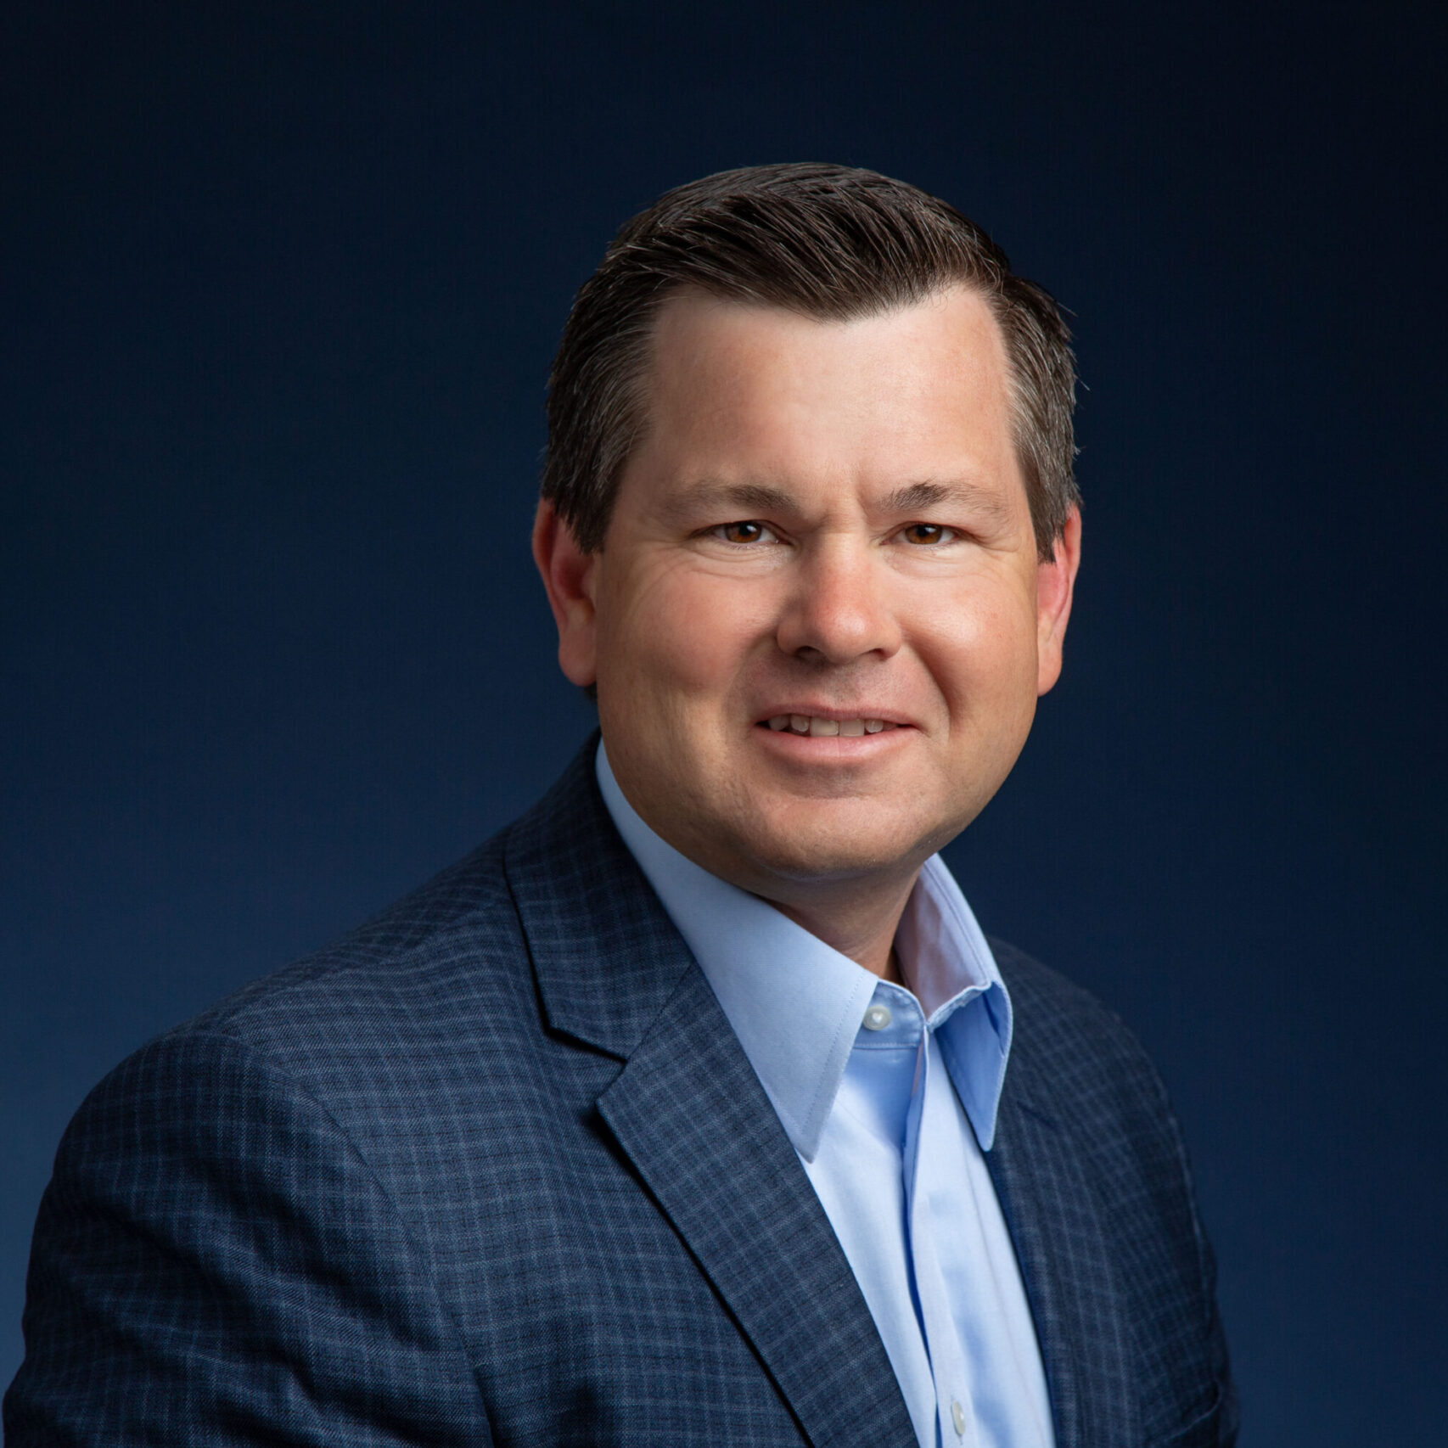

Tim Lowrimore
Tim Lowrimore is President and CEO of the Georgia Forestry Association and Georgia Forestry Foundation. A registered forester, Lowrimore’s career spans the forestry supply chain and includes experience working with forest landowners, manufacturers, policymakers, state agencies, and economic-development leaders. Before joining GFA and GFF, he served as Director and State Forester of the Georgia Forestry Commission, where he led the agency’s statewide work in forest management, wildfire response, landowner services, and industry support. His combination of public-sector leadership, policy experience, and private-sector engagement gives him a unique perspective on how states can align government, research institutions, industry, and capital to strengthen markets for working forests. Tim has been recognized by Georgia Trend as one of Georgia’s Top 100 Influential Georgians, strengthening his voice and influence on behalf of forestry advocacy.
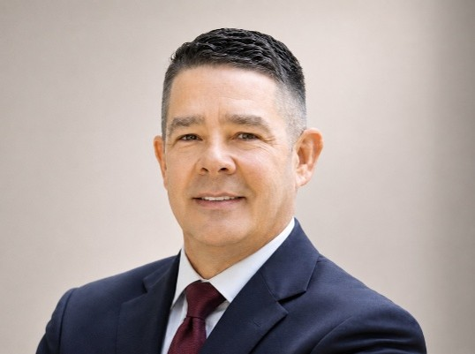

Trip Chavis
Trip began his career with Milliken in 1994 as a forest technician before founding Global Mapping Solutions, LLC, where he provided GPS and GIS services for utility infrastructure across the United States. He returned to Milliken in 2003, leading technological advancements and innovative timber inventory solutions, and was promoted to Vice President of Operations in 2010 before being named Chief Executive Officer in 2014. Trip earned a Bachelor of Science in Forest Resource Management from Clemson University and is actively involved in professional and civic leadership, including past service as Chairman of the South Carolina Association of Consulting Foresters and Chairman of the Congaree Land Trust. Trip is currently Vice Chair of Sustain SC, a trustee for The Nature Conservancy South Carolina a board member for the Longleaf Alliance and a founding board member of the South Carolina Forest Landowners Advocacy Guild. Trip is also a Fellow of the Shi Institute Sustainability Leadership Initiative. He serves as an active Elder at Unity Church of Lake Murray and resides in Little Mountain, South Carolina with his wife, Melissa.
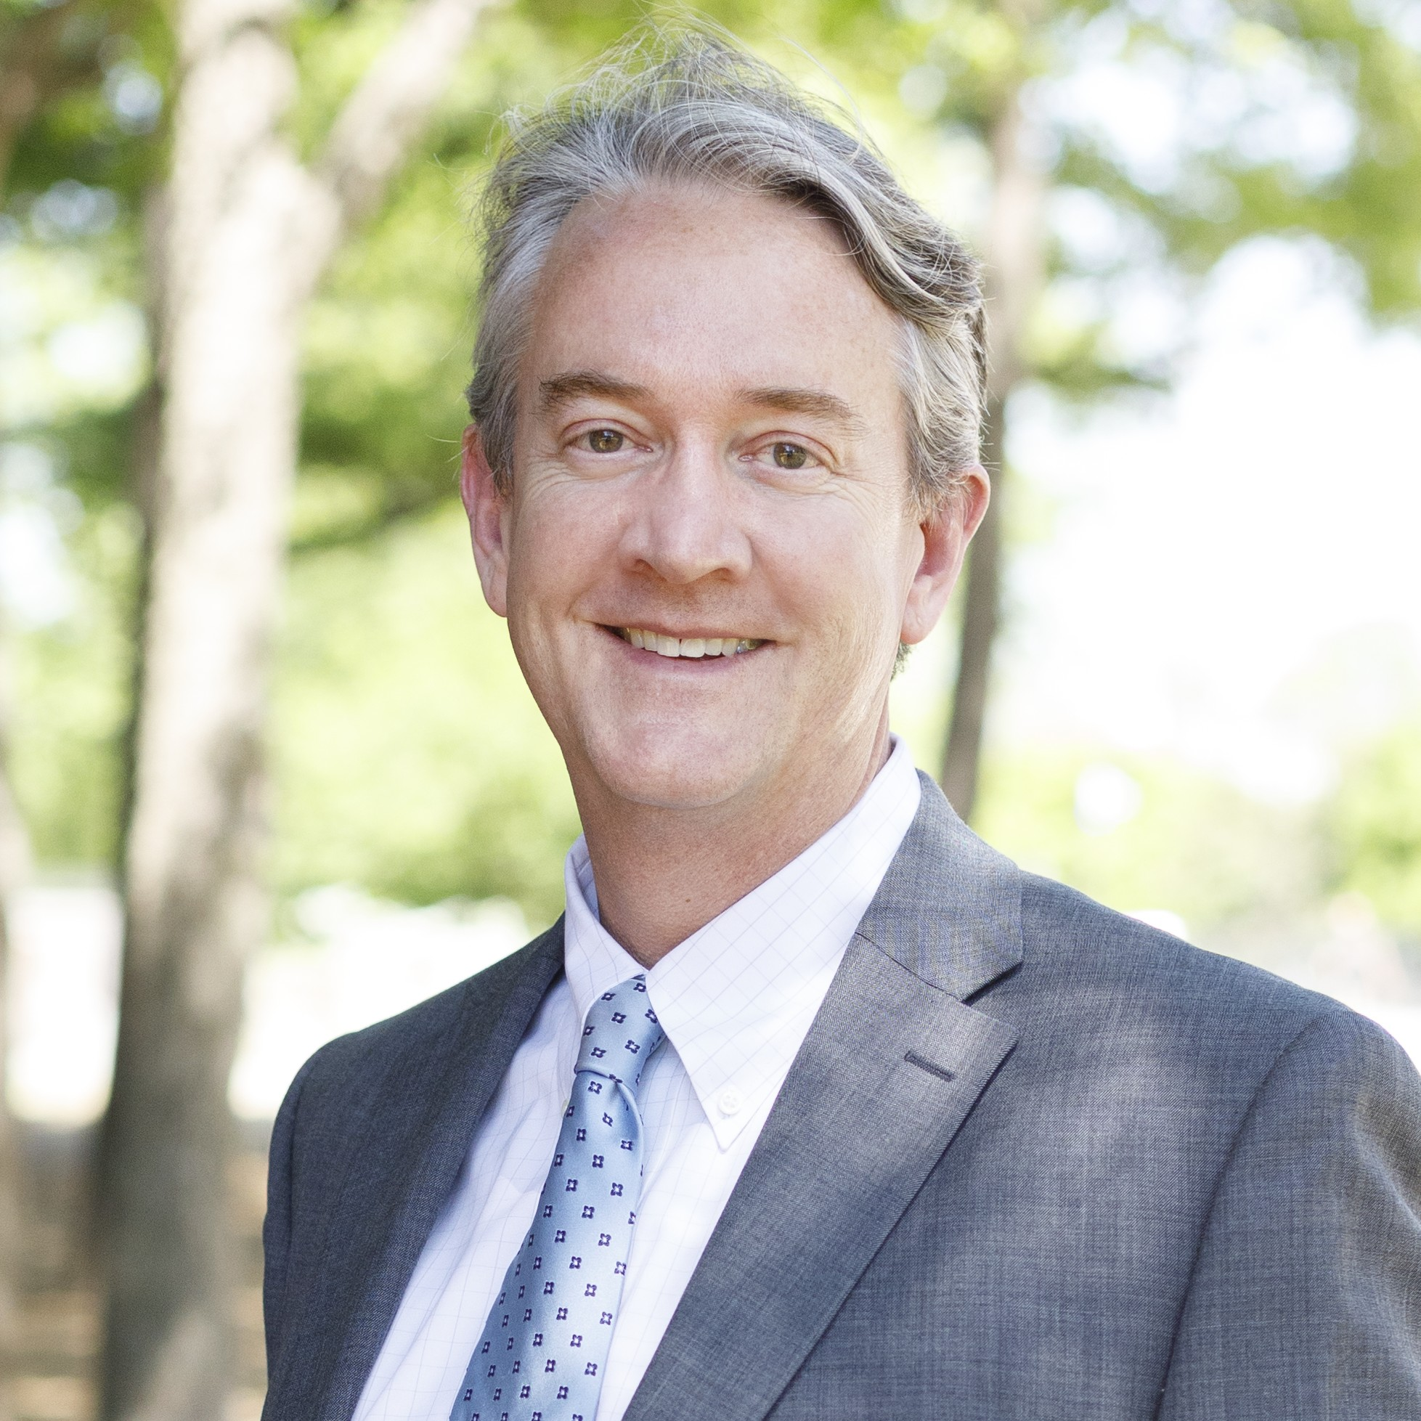

Troy Harris
Troy Harris is the Founder of Boundary Stone and a leading national expert in timberland portfolio management, natural-capital strategy, and mass-timber market development. With nearly 35 years of experience across U.S. forest regions, Troy works at the intersection of biological systems, long-duration capital, and the built environment. His leadership was instrumental in developing 619 Ponce in Atlanta-the first "Georgia Grown," farm-to-table mass timber commercial building. Appointed by the U.S. Department of Agriculture as the first public member of the Softwood Lumber Board, Troy also serves on the boards of the National Alliance of Forest Owners, the Forest Landowners Association, the Georgia Forestry Association, and the Georgia Forestry Foundation. He holds a B.S. in Forest Management from Auburn University and an MBA from the University of Georgia, serving on the Dean’s Advisory Board for both institutions.

Tyler Burkholder
Tyler Burkholder, CEO of Bio-Derivatives. Bio-Derivatives converts forestry and timber resources into wood vinegar and related pyrolysis products, targeting new offtake markets for Southern forest residuals. Tyler's background includes six and a half years as a nuclear chemist in the U.S. Navy, before moving into program management and now the timber industry, where he focuses on improving forest utilization across the Southeast.

