Blackberries
In fall of 2023, Extension Agents throughout South Carolina surveyed growers on specialty crop acreage for the year. The goal was to identify what counties it was grown, acreage, and observable market prices for the year.

Total Number of Farms: 25
Total Number of Counties: 20
Total Acreage: 96.10
Highest Acreage: Spartanburg County
Organic Acreage: 0.25
Processing Acreage: 2.5

Estimated Value:
Observed Prices: $25.00 – $42.00 per flat ($2.50 - $4.20 per lb.)
Estimated Yield: 8,000 lbs. per acre
Total Yield: 96.10 x 8,000 lbs. per acre
x $3.00 per lb. = $2,306,400 total value

County | Acreage
Abbeville* | 1.0
Allendale | 10
Beaufort  Berkeley | 0.6  1.0
Charleston | 0.5
Cherokee* | 1.0
Chester* | 1.0
Chesterfield | 15.0
Greenville* | 13.0
Greenwood* | 1.0
Laurens* | 5.0
Lexington | 0.5
McCormick* | 1.0
Newberry | 0.25
Pickens | 2.75
Richland | 2.0
Spartanburg* | 37.0
Sumter | 1.5
Union* | 1.0
York* | 1.0

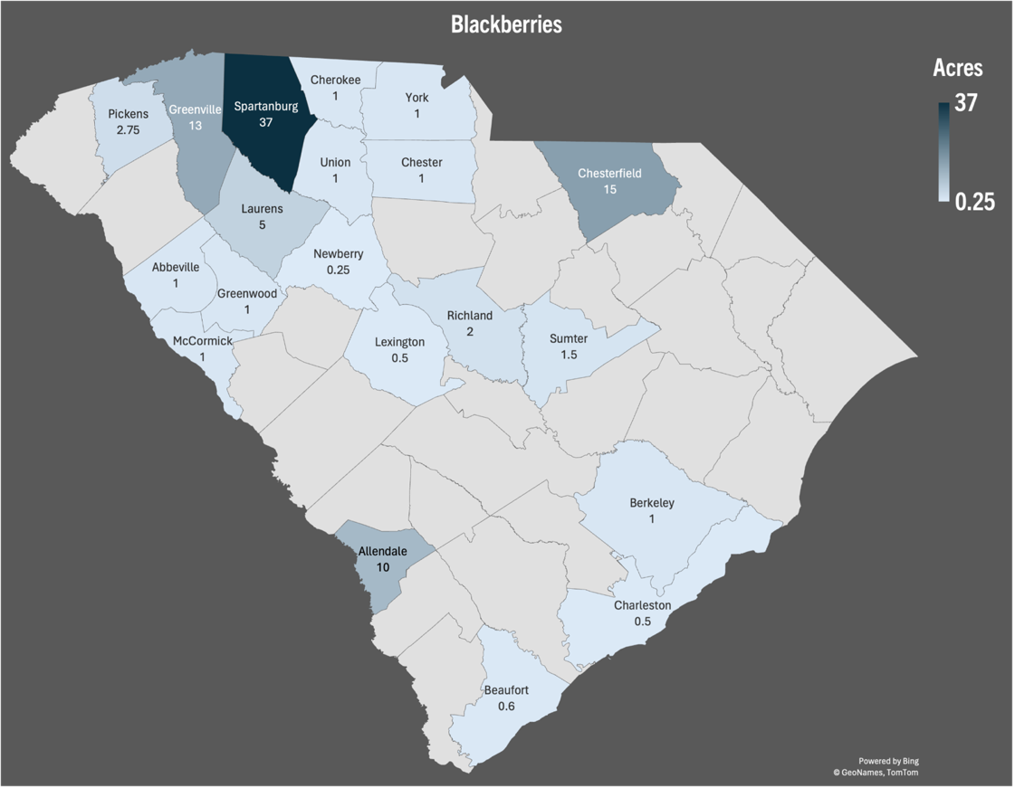

Figure 1: Cumulative acres per county

* = Data retrieved from USDA or FSA.
If you are aware of missing acreage, please contact your
local horticulture extension agent or email kburke5@clemson.edu.

This is a collaborative project between Clemson Extension Horticulture and Agribusiness teams.

