# Muscadines

In fall of 2024, Extension Agents throughout South Carolina surveyed growers on specialty crop acreage for the year. The goal was to identify the counties of production, acreage, and observable market prices for the year.

Total Number of Counties: **23**

Total Acreage: **252.0**

Highest Acreage: **Lexington County**

Organic Acreage: **33.4**

Processing Acreage: **80.41**

## Estimated Value:

Observed Prices: $28.00 - $42.00 per ½ bushel

Estimated Yield: 550 ½ bushels (22 lbs.) per acre

Total Yield: 252.0 x 550 ½ bushels per acre  
x $32.00 per ½ bushel = $4,435,200 total value

|  |  |
| --- | --- |
| **County** | **Acreage** |
| Anderson | 1.5 |
| Beaufort | 0.1 |
| Berkeley | 0.2 |
| Calhoun | 1.0 |
| Charleston | 4.3 |
| Cherokee* | 2.9 |
| Chester* | 5.0 |
| Chesterfield | 10.0 |
| Darlington | 3.0 |
| Edgefield | 53.0 |
| Greenville* | 4.4 |
| Horry | 17.5 |
| Laurens* | 25.0 |
| Lexington | 56.4 |
| Marion | 20.0 |
| Oconee | 2.3 |
| Orangeburg | 3.0 |
| Pickens | 2.1 |
| Richland | 11.0 |
| Spartanburg* | 16.8 |
| Sumter | 0.5 |
| Williamsburg | 5.0 |
| York* | 7.0 |
|  |  |

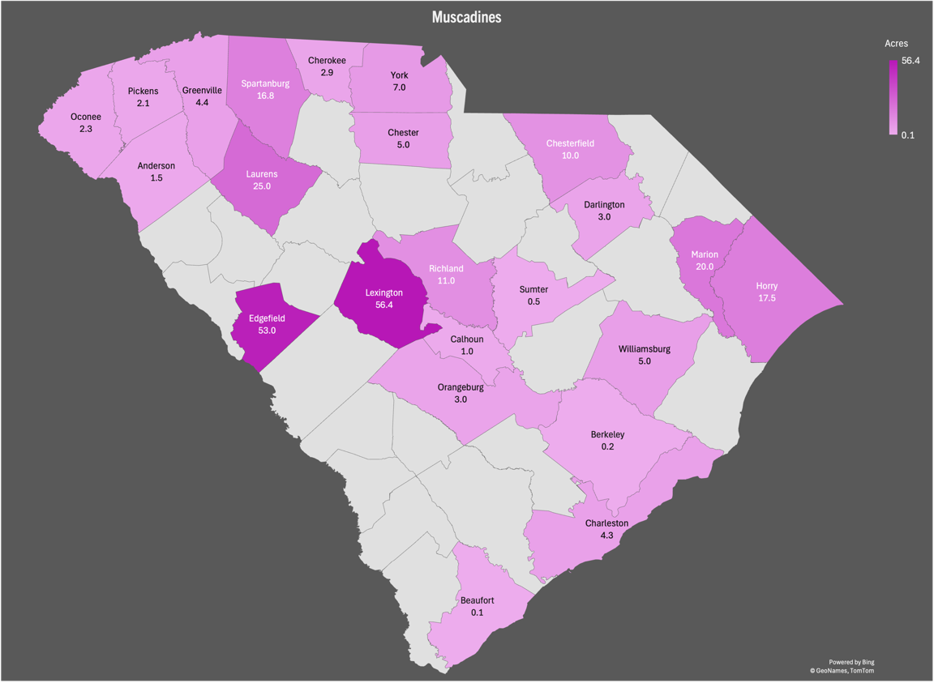

Figure 1: Cumulative acres per county

* = Data retrieved from USDA or FSA.  
If you are aware of missing acreage, please contact your   
[local horticulture extension agent](https://www.clemson.edu/extension/horticulture/team.html) or email [kburke5@clemson.edu](mailto:kburke5@clemson.edu).

This is a collaborative project between Clemson Extension [Horticulture](https://www.clemson.edu/extension/horticulture/index.html) and [Agribusiness](https://www.clemson.edu/extension/agribusiness/index.html) teams.