Clemson CPE Canvas
Continuing & Professional Education

H O W D O I A C C E S S M Y C O U R S E ?
- On the first day of your course, please go to https://clemsoncpe.instructure.com/login/canvas. Tip: Bookmark your Canvas Dashboard to easily access your course.
- Log in using the email and password you created when registering for your course in Catalog.

- If you do not remember your account information, click “Forgot Password?” to reset it. It may take up to 30 minutes to receive your password reset email.
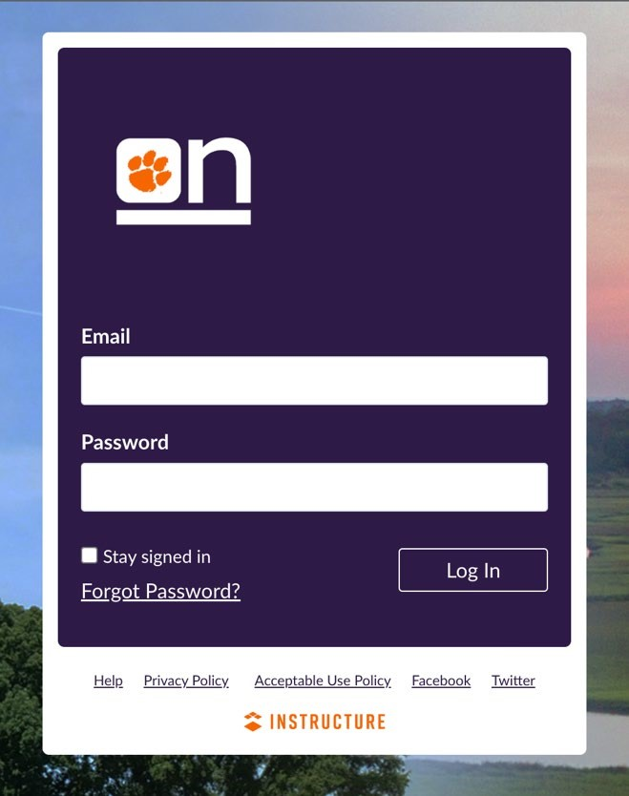
For the best course experience, the use of a laptop or computer is recommended.
To access Canvas on a mobile device, download the Android or iOS Canvas Student app from your app store.
N E E D H E L P ?
If you need technical assistance, please contact Clemson Online at onlineplus@clemson.edu.
Our support email is monitored Monday-Friday from 8:00 AM -4:30 PM EST. If you contact us in the evening or on the weekend, we will help you during the next business day. Please do not contact CCIT for support; instead, reach out to Clemson Online so that we can assist you.

C L E M S O N O N L I N E
502 Lebanon Rd, Pendleton, SC 29670 | 864-656-9320 | clemson.edu/online 1

