Simple Zoom Meeting Instructions
Bryan Smith

This quick, simple instruction sheet is to help you connect to the CAMM Zoom meetings we will be offering for the CAMM recertification program this spring.

- The Eventbrite receipt emailed to you will have a Zoom link provided near the bottom of the receipt in the “Additional Information” section. This should take you directly to the Zoom meeting registration, and will look something like this (notice from a trial meeting below):

Thank you for registering for the CAMM Recertification Trial to be held at 11:00 am on March 25, 2020. Click on the following link any time after 10:30 am to enter the training:

https://clemson.zoom.us/meeting/register/xxXXxxx_xx(xxX

You will be required to enter your name and email address before entering the training. The letter announcing the trainings provided instructions - if you have any questions contact Bryan Smith at xxxx@xxxx.xxx or 864-xxx-xxxx.

- If you have never used Zoom before, when you click on the link the screen will prompt you to download the Zoom software. (You may also go to the Zoom website instead at
https://zoom.us/download#client_4meeting to download the software before the meeting.)

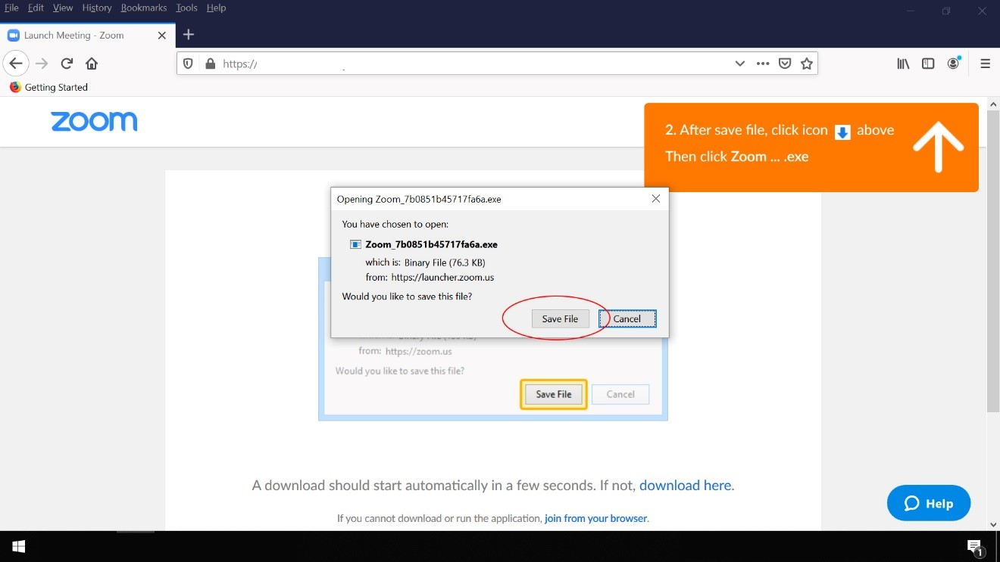

Click on the “Save File” button circled. In some Browsers, like Chrome or Edge, the file may automatically install. In Firefox it only saves the file to your computer and you must complete another step. Click on the small “download arrow” in the upper right corner of the screen, then click on the Zoom file name in the box that appears to load the program:

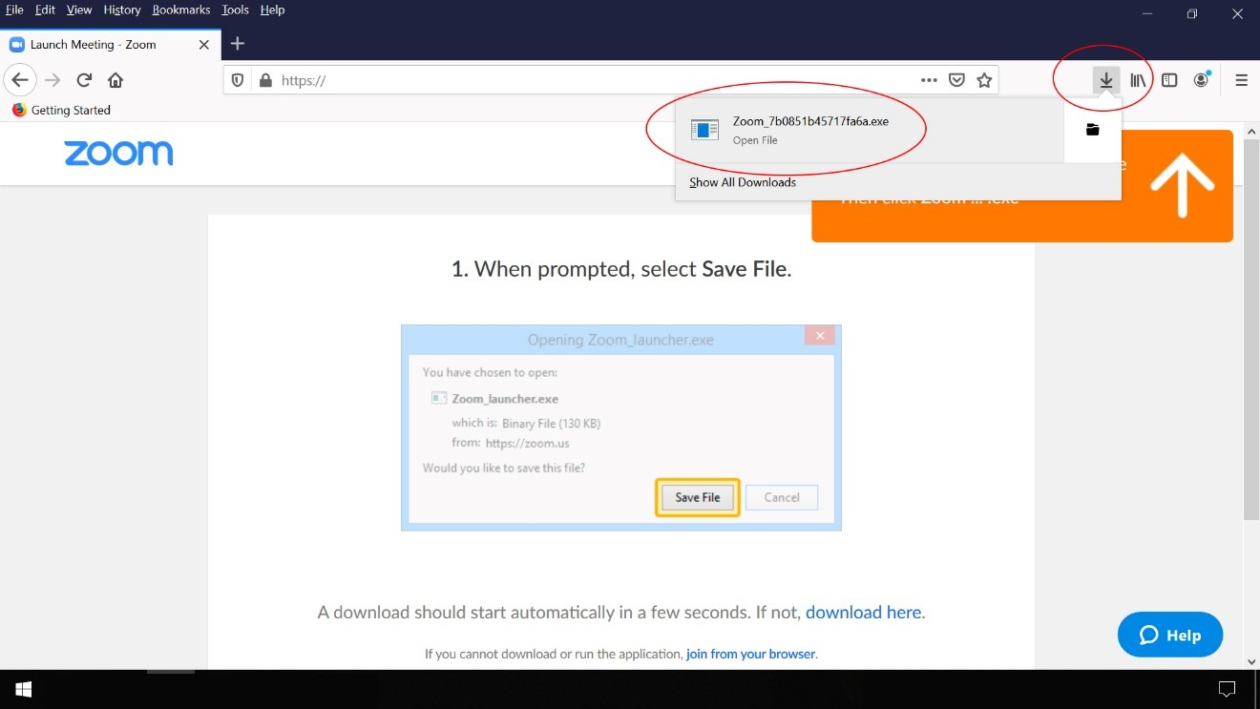

- A new web page will open. It will first give Zoom’s privacy policy – you must click the “Accept” button to continue:

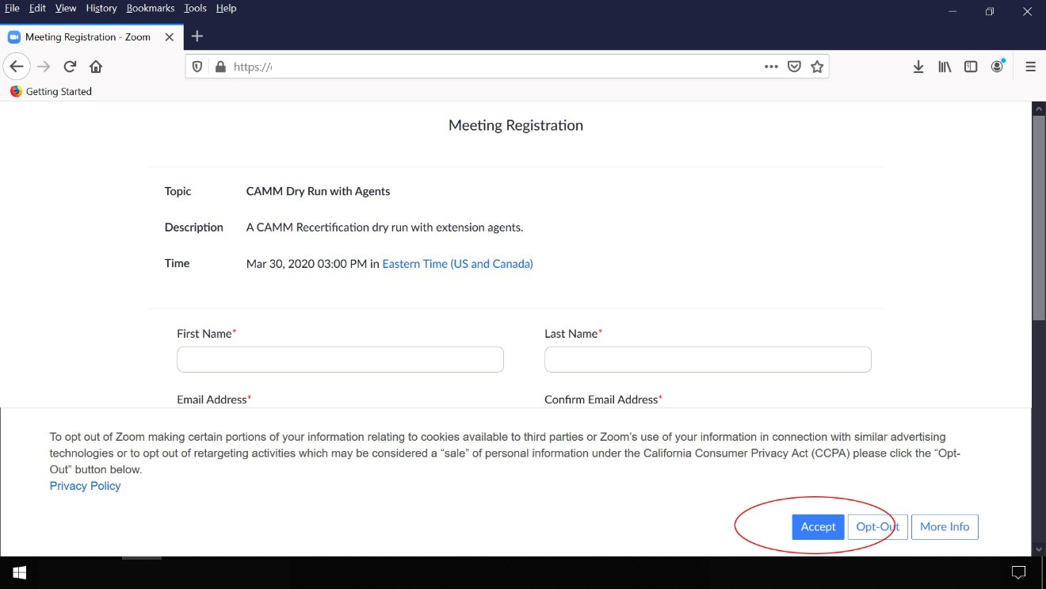

- Since registration is required for CAMM Zoom programs, a screen will now show. Enter your name and email address. Click on the “I’m not a robot” check box (it may ask you to select some images containing a traffic light or something similar), the click on the “Register” button:

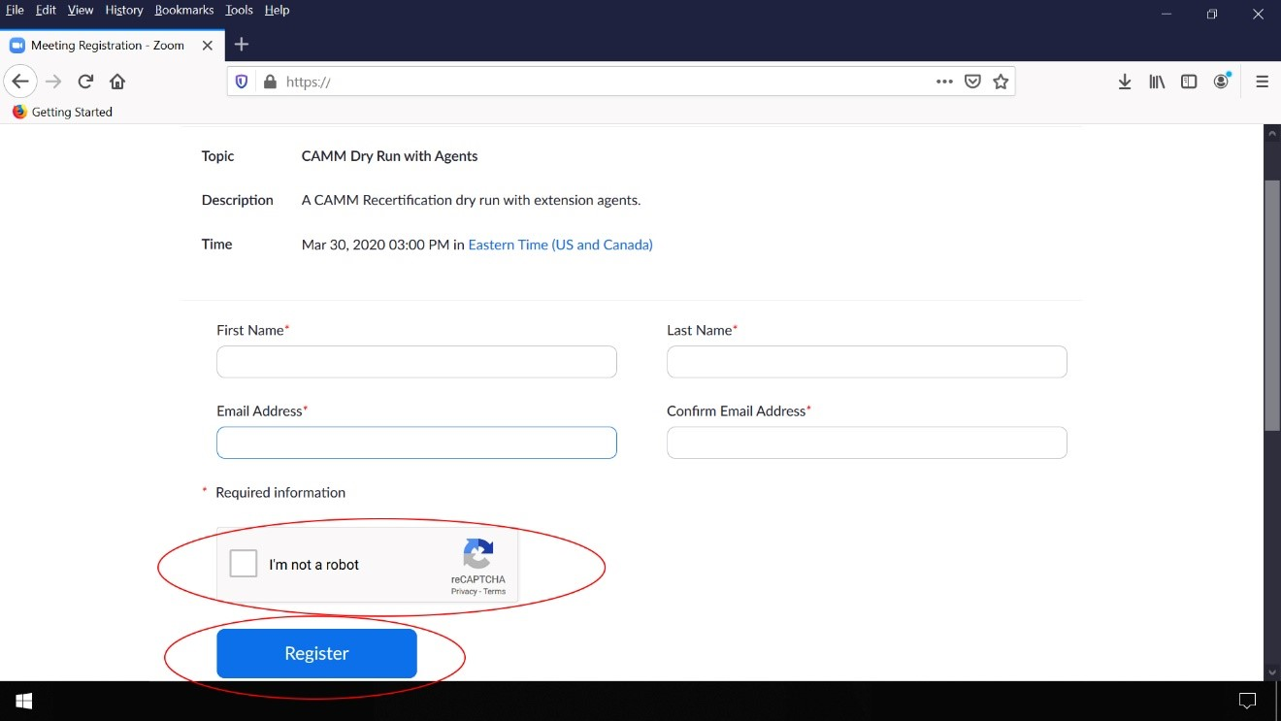

- A screen will now appear noting that you have completed registration. Click on the link provided to enter the meeting:

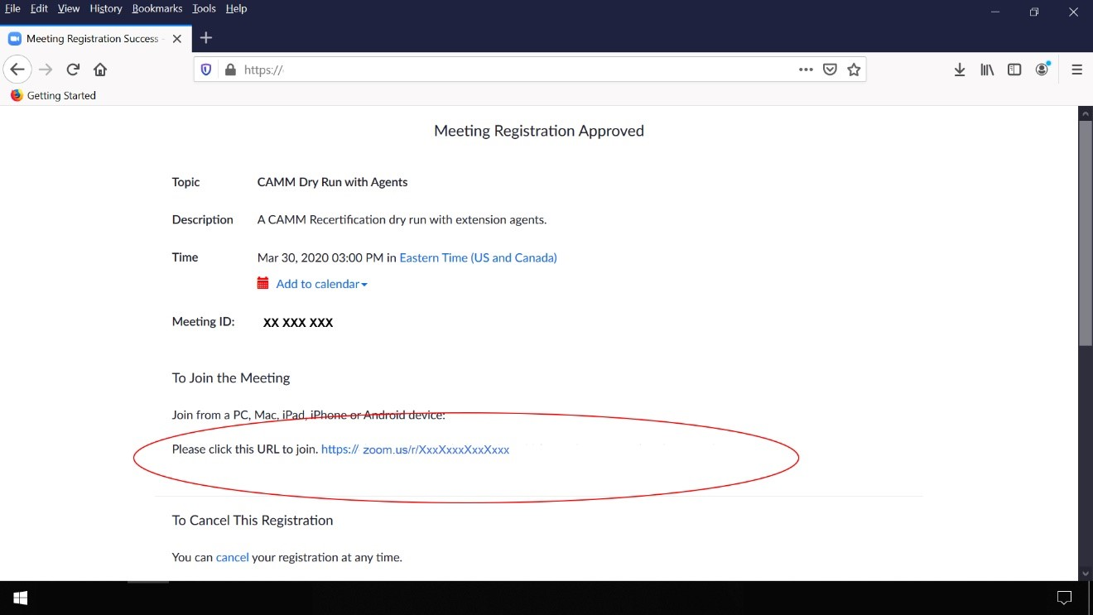

- Another screen now asks you to select the Zoom application – click on the “Open Link” button:

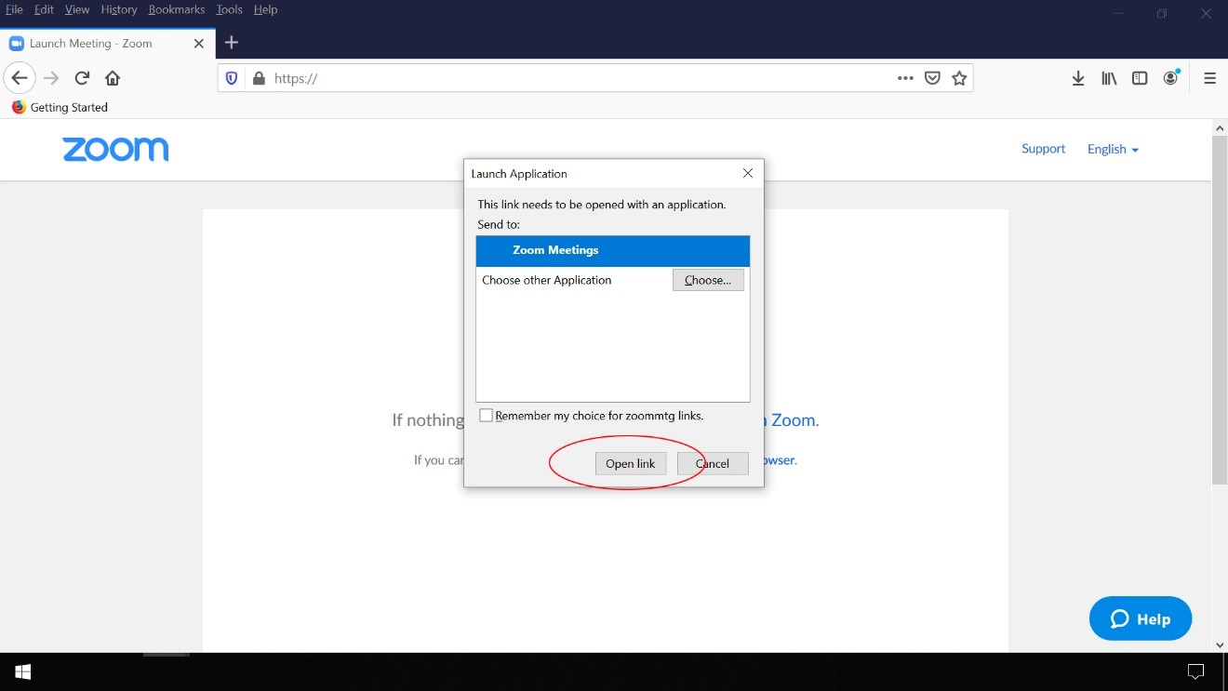
- The next question may ask you to join with video (or may skip this step depending on how the meeting was set up):

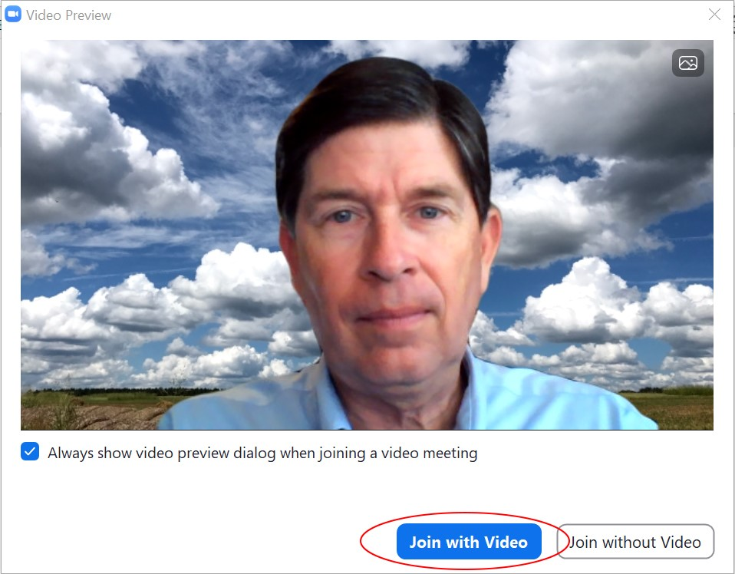

- The last question will ask about audio connections – choose “Join with Computer Audio”:

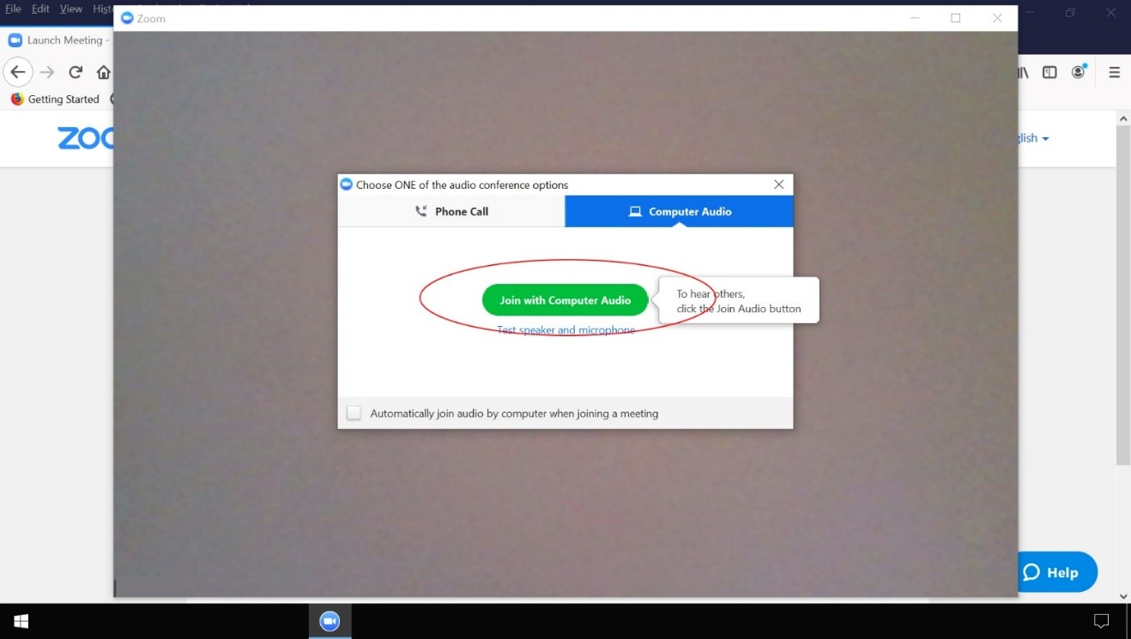

- You are now connected to the meeting, and your screen will look like this:

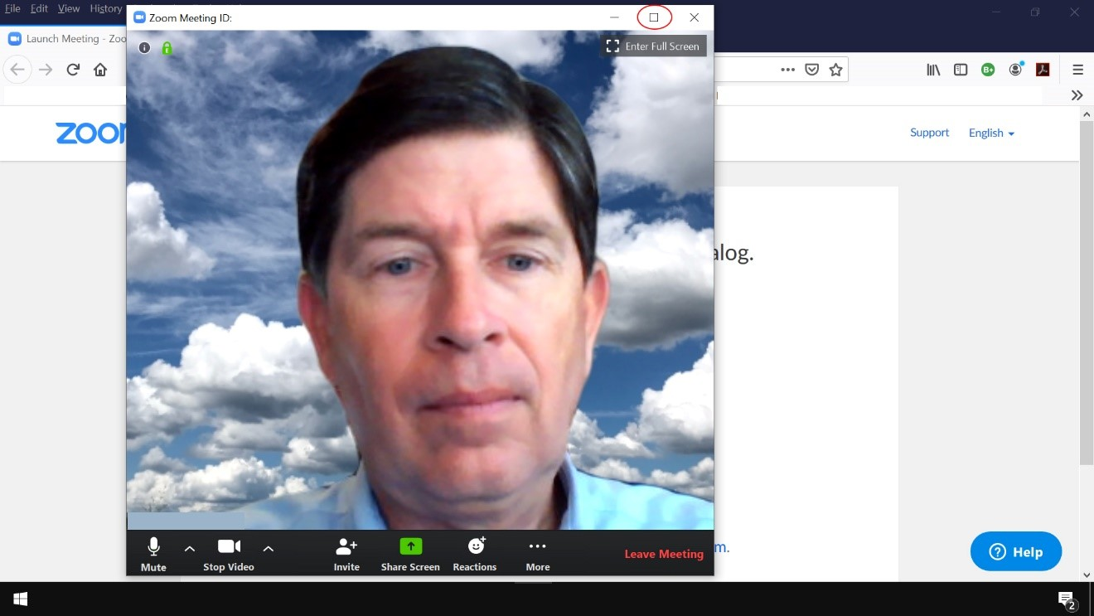

Click on the “Maximize” button in the top right to make the video full screen.

- Note the “Mute” button at the lower left. Click on that to mute your mic (if there is a red slash through it the mic is already muted); to prevent feedback we will mute all mics for these meetings. You may ask questions using the “Chat” function - click once on the “Chat” button so you can see the chat dialog box – it will look like this:

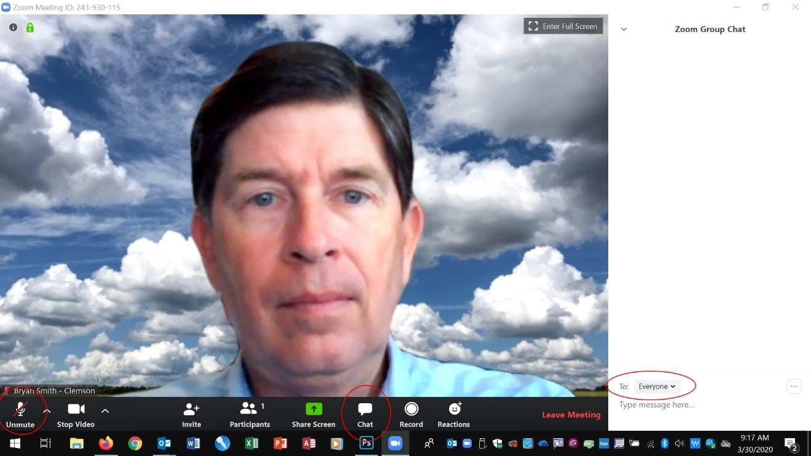

Note the “Everyone” list in the “To” field – anything you type is seen by everyone on the meeting. Please be aware that these chats are recorded (and the meeting will be also) and hosts and co-hosts can see the chat text when the meeting has ended. Note also the controls at the bottom of the screen will disappear after a few seconds – you will need to move your mouse over the screen to have them reappear.

- To leave the meeting when it has ended, simply click the “Leave Meeting” button in the lower right corner. The hosts will be notified when you leave the meeting.

That’s a brief overview of getting connected.

