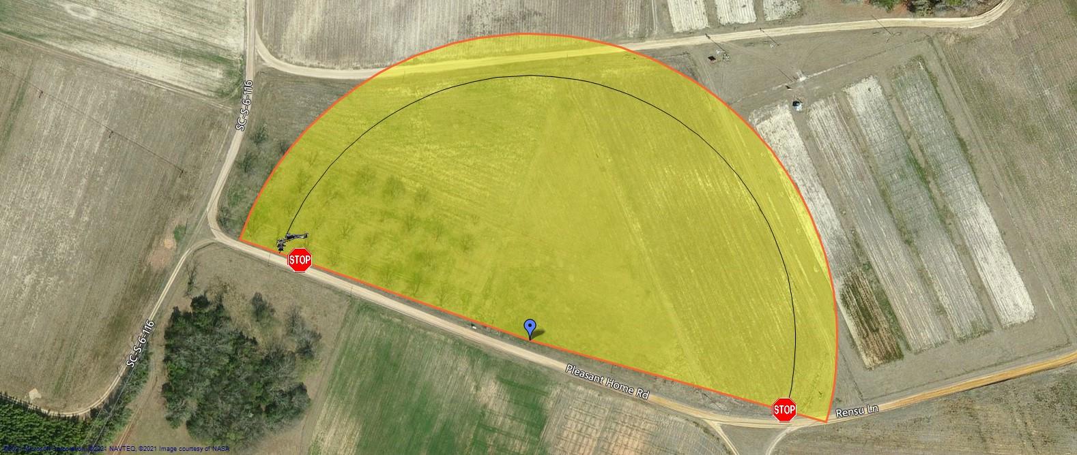
Report generated using Center Pivot Mapper Software (v.1.1.1.1)

User Inputs

Pivot center position: 33.3460650108345°, -81.3173085451126°
End/Endgun position: 33.346658774533°, -81.319270581007°
Forward stop position: 33.3456045611035°, -81.3153076171875°
Reverse stop position: 33.3465909960514°, -81.3191156834364° Endgun or last sprinkler radius: 100.0 ft

Calculated Outputs
Machine length: 636.7 ft
Wetted radius: 736.7 ft
Angle between stops: 176.2°
Machine travel between stops (at end): 1957.9 ft
Area inside end/endgun position: 14.31 ac
Area outside end/endgun position: 4.85 ac
Total wetted area: 19.16 ac
24/7 flow required for 1 in. per week: 52 gpm
24/7 flow required for 2 in. per week: 103 gpm
Date of report generation: February 10, 2021
Software developed by:

