South Carolina FFA State Officers

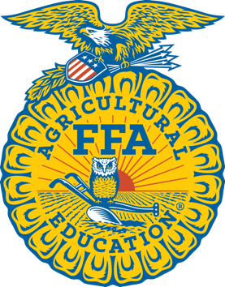

Gift of Blue

Application is due at the Spring Region Teachers Meeting

The South Carolina FFA State Officers are providing a gift of blue corduroy to the six specifically selected members of the SC FFA Association. They all have seen the power of these blue jackets to inspire positive change and would like to present jackets to deserving students that have not had the opportunity to purchase a jacket. Six students will receive a free FFA jacket embroidered with their name. If you know of a student that would be honored to have a jacket purchased by the State FFA Officers, please fill out the form below with basic information about the student for consideration.

Member name: __________________________________________________

Chapter Name as it appears on your Jacket: ______________________________

Chapter Number: ________________

Grade: _________

Jacket Size: _____________
Scarf or Tie? ______________________

In 150 words or less, please give a brief description of the student and his/her desire to have a Gift of Blue.

