Faculty Representative to the Board of Trustees

February 2018 Report

Thompson Mefford

January 19, 2018

**Summary:**

In this report I provide some brief updates since the last report, I do a deep dive into one of the key factors that contributes to our academic *reputation*, and discuss some opportunity to enhance our *recruitment* and *retention* of faculty.

**Brief Updates:**

Appendix A of the Faculty Manual, which defines the role of the faculty representative to the Board of Trustees, was revised and the new version was passed and approved for immediate inclusion at the November 14th Faculty Senate Meeting. I have included the revised version at the end of this report.

At the December 12th Faculty Senate Meeting, I made a presentation that was an overview of the Board of Trustees. Key talking points were the structure of the Board, a typical quarterly meeting, faculty representation at these meetings, and my personal objectives as the Faculty Representative. I ended my presentation encouraging senators to apply for the representative position in the Spring. During the question and answer section, I received several queries about opportunity for faculty to interact with the Board. As always, I am happy to facilitate any additional interactions that are of interest.

I am extremely excited that this quarter’s Board Meeting marks the return of awards ceremony for excellence in faculty and staff. I strongly encourage members of the Board to seize this opportunity to learn from these great individuals on how we can create a greater Clemson. It is through their hard work that we are succeeding.

I am also excited to report that through the help of Senior Associate Provost Ellen Granberg, we are launching our series of lunches with Provost Jones where we have identified individuals with outstanding scholarship, but have yet to be recognized with national level awards. We have also identified those with outstanding teaching credentials. These lunches will be a great opportunity to learn more about how we can better facilitate the faculty at Clemson.

**Academic Reputation:**

In my previous report, I highlighted key metrics of Clemson’s performance that highly influence academic reputation. Using the National Science Foundation (NSF) Survey of Research and Development Expenditures at Universities and Colleges/Higher Education Research and Development Survey (HERD), Clemson ranks 109 nationally (up from 114 in 2015) with a total $183,965,000 in expenditures, while removing medical school expenditures we are ranked 77. Increasing the amount of external funding is a key measure in the *ClemsonForward* plan. Nonetheless, the required resources to achieve this goal will require a long-term commitment by the University.

In discussing research expenditures several items must be discussed. First and formost, research expenditures are only one metric in describing the scholarship of an institution. That is, *dollarship does not equal scholarship*. Nonetheless, it is important to remember that federally funded research support is the number one indicator for Association of American Universities (AAU) membership. Moreover, it is these funds that largely are used to support graduate students, post-docs, and the overall research structure of the University. The first two are key metrics for Carnegie classification. For Clemson to maintain our current R1 status, we need to increase the number of PhD graduates as well as the number of postdoctoral appointees. Using the 2016 IPES data, Clemson ranked 93rd in the country (conferring 233 doctoral degrees) and ranked 134th (with 77 postdoctoral appointees). Therefore, we need to ensure that we are making progress in our research expenditures.



Table 1: Research expenditures over the past 5 years by unit.

For this quarter’s report, I did an analysis of research expenditures over the past 5 years. Special thanks to Vice President for Research Tanju Karanfil for his assistance. This amounted to over $387,644,867 or an average of $77,528,973 per year. Table 1 provides a breakdown by unit. The distribution of expenditures matches well with the typical scholastic endeavors of each college, and emphasizes that this is just one metric to judge the academic quality of an institution. It is also important to note the high contribution of non-academic units. The 5-year grand total is the result of the hard work of 1,087 individuals who each contributed an average of $71,323 per year. It is also important to note that many of these expenditures are the result of a low yield grant proposal process, that can take multiple years of preparation, feedback, and relationship building, resulting in grants that will be spent out over months to years. Keeping the productivity of our 876 tenure-track faculty (Fall 2016) constant, one can calculate that it would require roughly 254 additional tenure track faculty to reach the *ClemsonForward* goal of $100,000,000 in federally funded research expenditures per year.

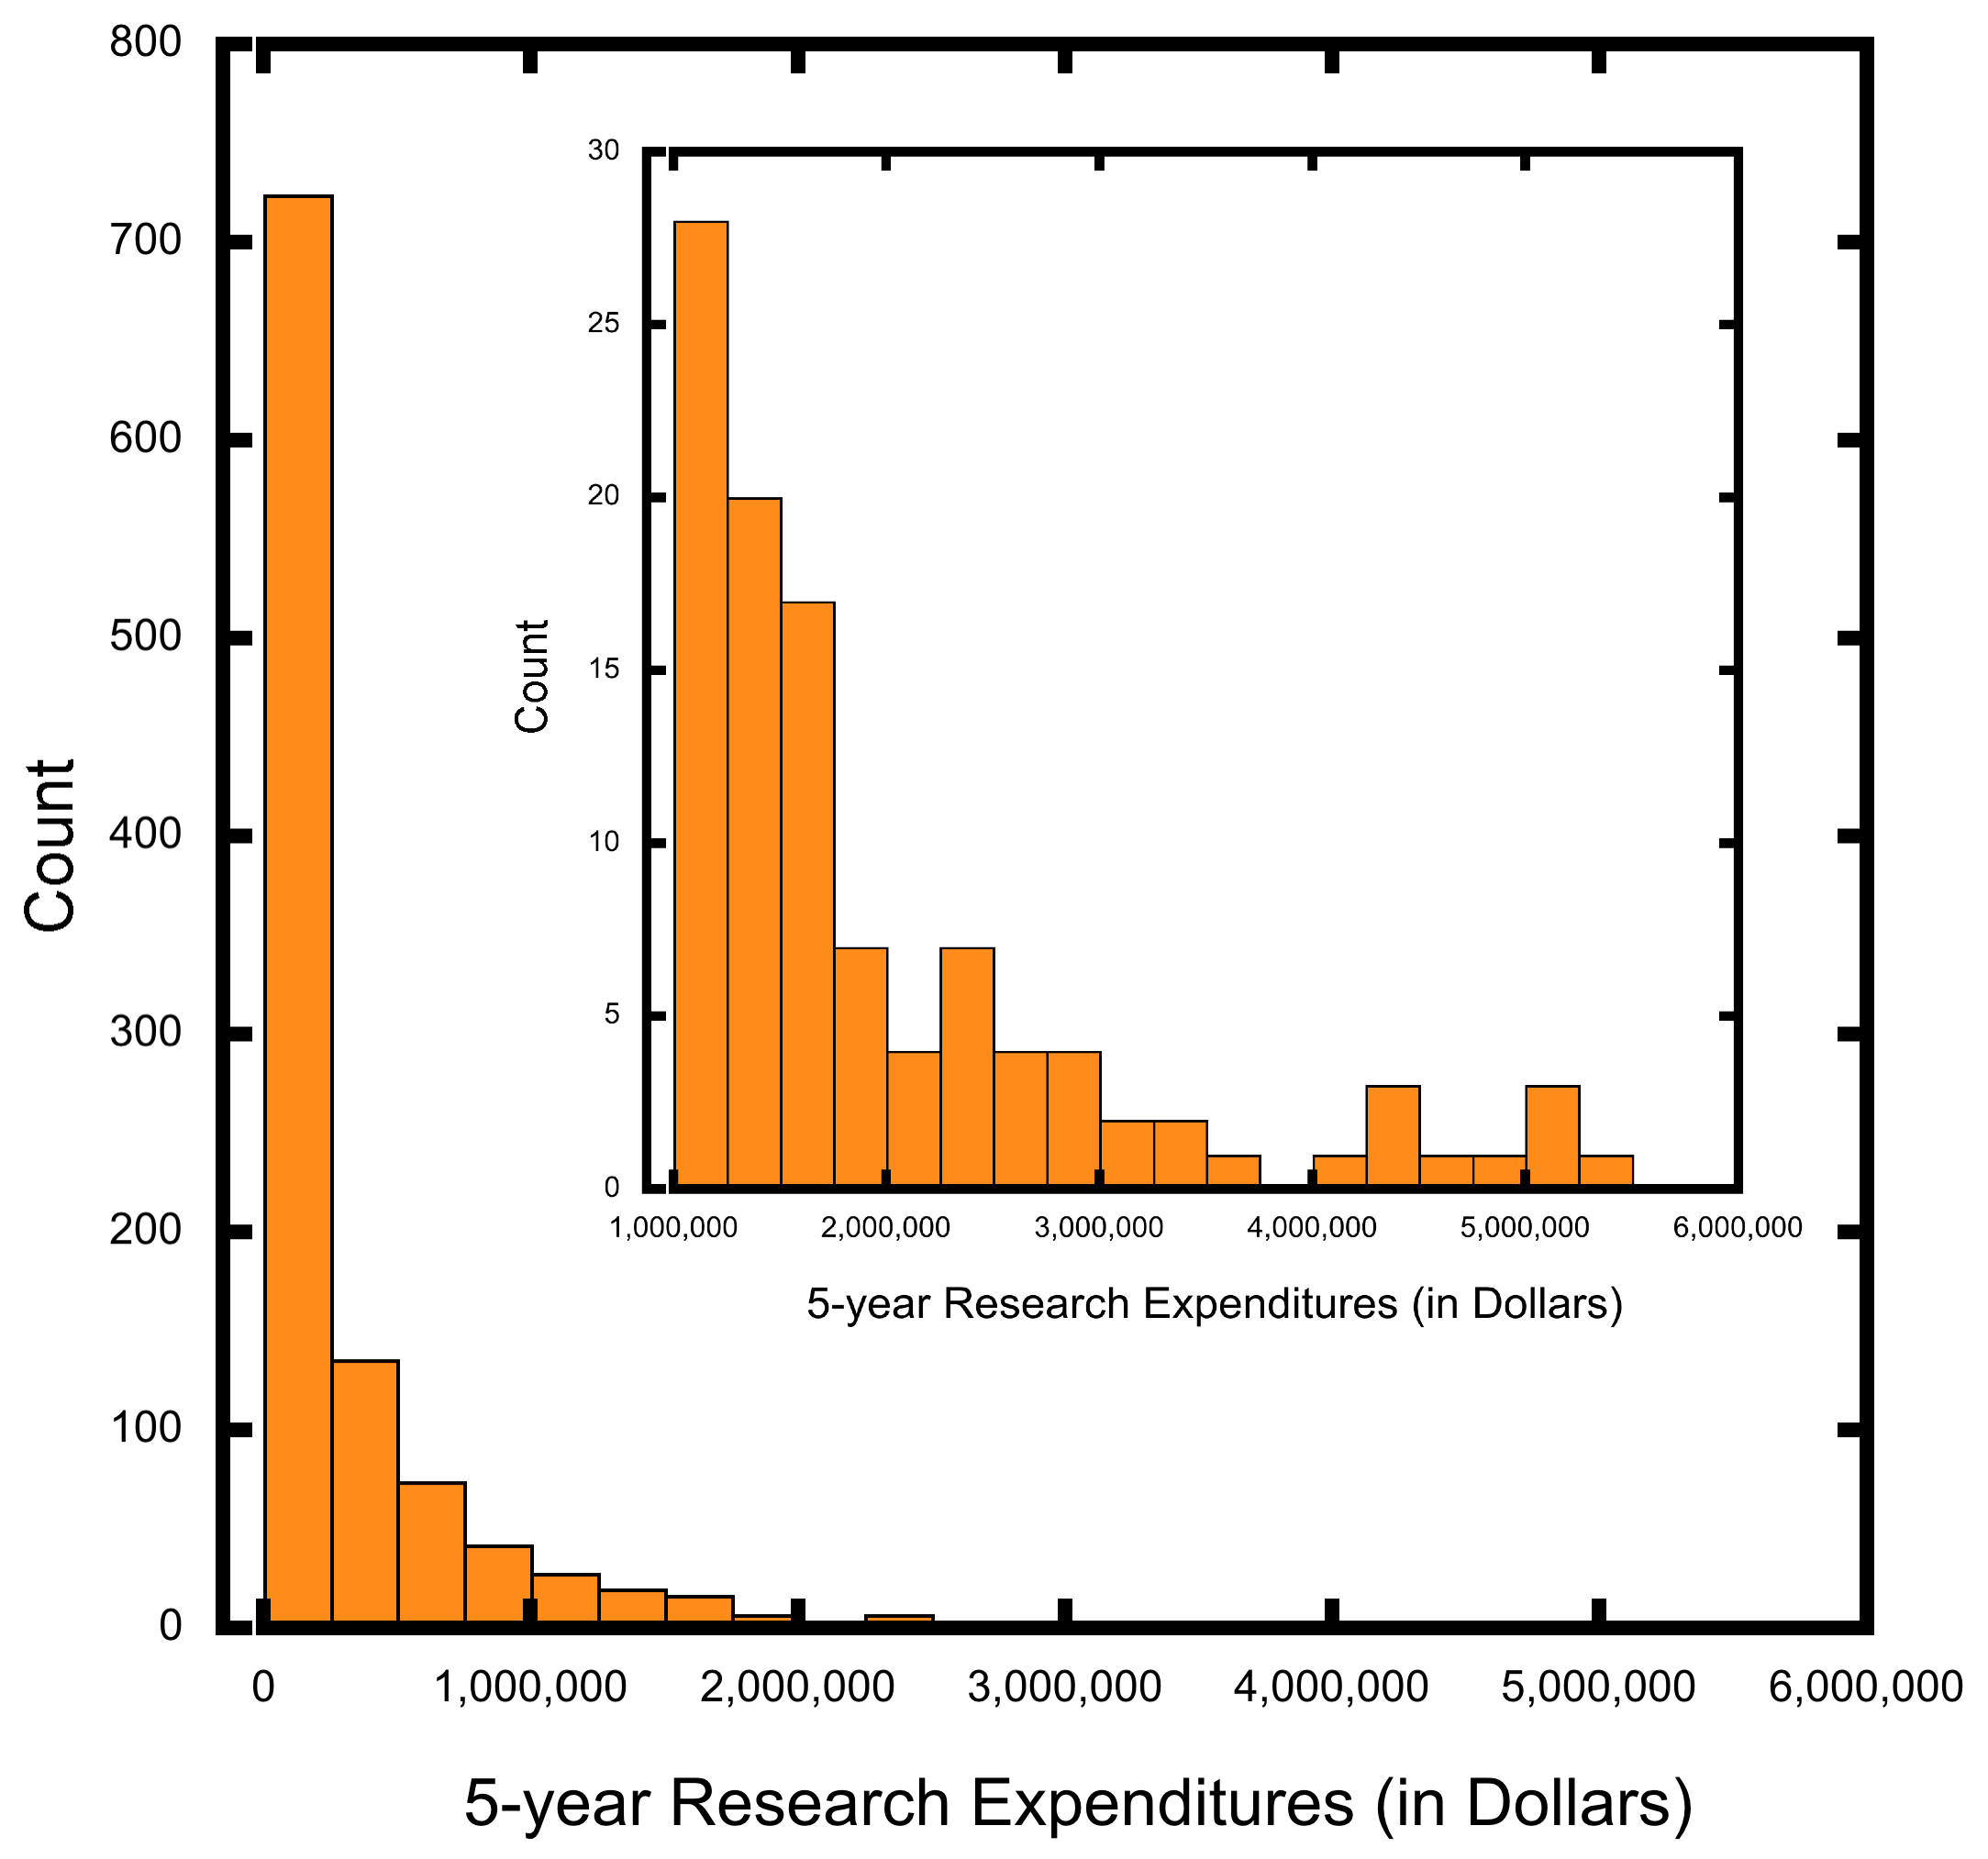

Figure 1: Histogram of 5-year research expenditures by individuals insert added to show higher values of expenditures.

While the average for 5-year research expenditures per individual is $359,350, the median is $103,238. Seeing this major difference, I plotted the research expenditures based on dollar amount (Figure 1). The resulting plot is a highly skewed distribution where a select group of individuals have values significantly higher than their peers. This begs the question “Who are these stars?”



Table 2: Number of individuals contributing to varying percentiles of the research expenditures.

As seen in Table 2, a mere 7 individuals contributed to 10% of our research expenditures over the past 5 years. The efforts of 20 (or the top 2%) contributed 20% to our expenditures. So, who makes up the top 20? What makes them special? What can we learn from them?

The top 20 is composed of 1 member of staff, 2 associate professors, 5 professors, 8 title/endowed professors, 3 extension agents, and 1 research professor. Of these, 3 individuals that are no longer associated with Clemson. The majority are associated with an academic center or institute. There are 3 women and 17 men. The median year of their terminal degree is 1992. The average adjusted 9-month salary was $140,887. Using their expenditures, this works out to an average return on investment of 6.8. (Please note these individuals do much more than just generate research expenditures).

Conclusions from this analysis:

* A major investment in faculty is needed to reach our *ClemsonForward* goals.
* The work of a very few makes a significant contribution to our research expenditures
  + The corollary to this is that the retention of these substantial players is critical to reaching our long-term goals (see below).
* Centers and institutes provide the research infrastructure necessary to support the work of these individuals.
* Many of these are later in their careers and have a knowledge base that could be used to set a culture of research excellence for the next generation. Developing a research program at this high level takes a great deal of time. We need to provide to the support to facilitate this development.

**Recruitment and Retention:**

*Dual Career Hiring.* Over the past few years the University has developed policies that work well for trailing spouses who are also academics. This system equally shares the costs associated with the additional hire with the asking department (or the asking department’s college), the receiving department (or its college), and the office of provost. This system appears to be working well and is a valuable tool in getting and keeping the best and brightest here at Clemson.

While a step in the right direction, this program focuses on couples where both are academics. Clemson’s Office of Human Resources currently provides some support for couples seeking non-faculty positions inside or outside of the University. We can improve our recruiting efforts by providing assistance to the trailing spouse in identifying appropriate employers and helping make connections with key contacts, while serving as a liaison between potential new hires and hiring managers. Such a position would maintain a network of business contacts in the community and surrounding area to assist the partners and spouses of recruited faculty.

*Faculty success center.* As discussed above we have some outstanding faculty making a meaningful contribution to the scholastic culture on campus. Also important is to provide an environment to retain and grown the next generation of stars. In thinking about a space to incubate a shared culture of scholarship, one could image a centralized location to enhance our productivity. *A faculty success center*. Such a facility could contain:

* The office of teaching effectiveness and innovation
* Support for grant and scholastic outputs including specialists with graphic communication skills to better tell the research story.



Figure 2: Mockup of interaction space in proposed faculty success center

* Space for writing groups, journal clubs, and professional development
* Interaction space to promote excellence and networking among the faculty.
* Offices for the Faculty Senate and grievance dispute resolution
* Location for faculty to have HR questions answered

Such a center would be an invaluable tool in recruiting faculty to campus, ensuring they feel included in the Clemson community, and providing resources to help them reach their full potential. Moreover, Clemson would likely gain national attention among academia for making such a bold move.

APPENDIX A FACULTY REPRESENTATIVE TO THE BOARD OF TRUSTEES

1. Overview
   1. The Clemson University Board of Trustees has approved the concept of a Faculty Representative to the Board of Trustees using the process outlined below. This person is recognized as the official representative of the Faculty and is granted privileges beyond those accorded to Board meeting visitors. This includes receipt of minutes, agendas, and attachments of all Board and Committee meetings and the opportunity to be included on the agenda upon the request being approved.
   2. The Representative is charged with (a) communicating the faculty experience to the Board and (b) facilitating formal and informal interactions between Board members and the faculty through activities such as visits to faculty offices, labs, classrooms, and other research and teaching facilities.
   3. The Representative also serves as a non-voting ex officio member to the Faculty Senate and the Faculty Senate Executive and Advisory Committees, as well as a member of other committees as appointed. In addition, the representative will submit written and oral reports to the Faculty Senate at the next Faculty Senate meeting following a Board of Trustees meeting.
2. Selection Procedures
   1. Selection Committee
      1. The selection committee will solicit nominations for the Faculty Representative to the Board of Trustees at least three months prior to the expiration of the term of the incumbent Representative.
   2. Selection Committee Membership
      1. Two previous Board Representatives, selected by all previous Representatives;
      2. Two Distinguished Alumni Professors, selected by the Alumni Professors;
      3. President-Elect of the Faculty Senate;
      4. President of the Faculty Senate (Chair);
      5. Lead Faculty Senators from all colleges not otherwise represented.
   3. Nominations
      1. Any tenured regular faculty member (as defined by the Faculty Manual) at Clemson University is eligible to be nominated and hold the position.
      2. Self-nominations will be accepted.
      3. The nomination period will run for 30 calendar days from the date of the Call for Nominations.
      4. Each nomination must include:
         1. Curriculum vitae
         2. A statement of interest from the nominee
         3. A statement from the nominee detailing experience in faculty governance (including areas such curriculum, promotion and tenure policies, faculty/administration relations, Faculty Senate or academic policies)
      5. The Faculty Manual Editorial Consultant will examine all nominations to verify the faculty status of each nominee.
      6. The names of all eligible nominees will be distributed to the members of the Selection Committee. The Committee will consider the eligible nominations and make the final selection. i. The committee may, at its discretion, conduct personal interviews of nominees.
   4. The Faculty Representative will serve a three-year term commencing with the first Board meeting following selection.
      1. If the Faculty Representative cannot serve a full term, a replacement will be selected using the above procedures.
      2. The newly selected Faculty Representative will serve a full three-year term.
   5. The Faculty Representative may not serve successive terms in the office.