Cash Transfer Reconciliation:

This report is found in Data Warehouse, go to: (System Run Reports for Budget Centers Choose desired budget centerDaily ReportsCash Transfer Reconciliation)

This report shows chart-field-strings where the current budget and the actuals do not balance.

Step 1: Select the Cash Transfer Reconciliation report and go to tab labeled “All Transfers”
Step 2: Check to ensure the report is for the current FY and current date. If not, then click refresh and enter the current FY.
Step 3: Export the data to excel by selecting file type “Excel (.xlxs) and selecting “Prioritize the formatting of documents” then click on.
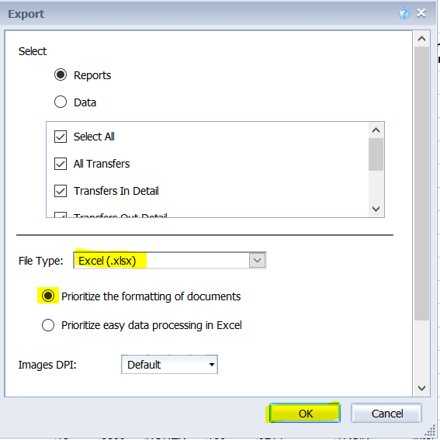
Step 4: The only tab you should need to review is “All Transfers” all other can be deleted if desired. Filter the data in the “All Transfers” tab by the Budget Centers you are responsible for.
Step 5: Evaluate which lines are errors that need to be cleared and which are acceptable.
When it is ok for Budget to not match actuals:
- Chart-field-strings involving class code 530 and the corresponding 130 line are acceptable and will not have actuals to match the budget
- If actuals are greater than current budget this should be investigated to ensure a transfer did not occur in error and to ensure all transfers entered for budgets are posted for actuals. If the discrepancy is from revenue or a different type of actuals journal that would require the budget center to increase the overall Approp the discrepancy is acceptable.

Step 6: Once discrepancies in error are identified run the LJ_CASHTRF_ACTUAL and LJ_CASHTRF_BUDGETS queries for all projects with identified errors. These queries will pull all data for all journals where either a budget or actuals was entered for the projects identified in the query criteria.
Step 7: It is easiest if you filter these query data reports by a specific project and evaluate 1 discrepancy at a time. Compare the actuals journal to the budget journal to see which lines do not equal. You can use the data in the column labeled “USER” to reach out to who is responsible for making the budgets or actuals journal to let them know there is a discrepancy. Generally, it is best to reach out to the user who entered the budget side first then to the user who entered cash. If there is no budget, then reach out to the user who entered the actuals.

In accordance with the Budget Office’s Reconciliation policy; beginning FY22 Budget Centers should complete the Cash Transfer Reconciliation and the Mismatched BVA Transfers Reconciliation processes on a weekly or bi-weekly basis to ensure that any issues are promptly remediated. Any issues found in these reports should be remediated by the date marked “Deadline to Clearing Errors and Posting All Journals” per the Controller’s close calendar: (https://www.clemson.edu/finance/controller/schedules/fy_21_monthly_closing_schedule.xls)
This is consistent with current accounting restrictions and enables the budget fix process to be aligned more closely to those expectations thereby improving reporting on a monthly basis.

Please reach out to your CBO with any questions on how to resolve discrepancies found during the Budget Balance Recon process.

Additional information about budget amendments and their rules can be found in the Budget Office Training Manual: https://media.clemson.edu/cfo/budgets/PeopleSoft-Budget-Training.pdf

