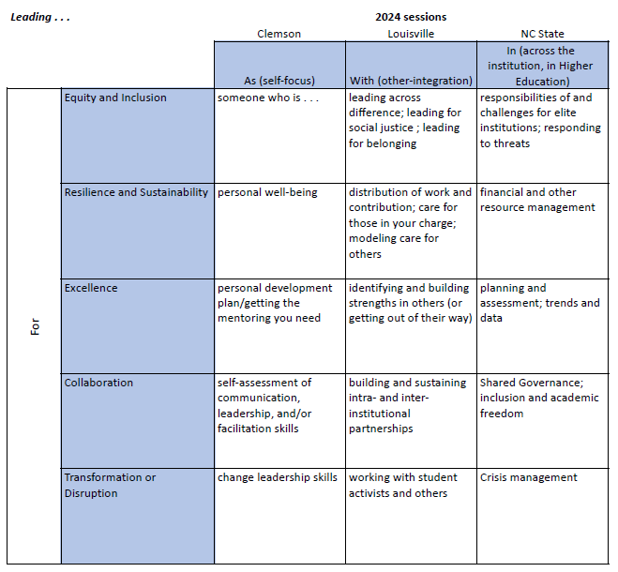
ACC-ALN Academic Leaders Network
2024 Cohort

Session 1: ‘Leading yourself’
Clemson, South Carolina
March 20-22, 2024
Wednesday lunch – Friday lunch

Note-taking file: Leading yourself

Wednesday, March 20 topics:

Welcome
Expectations, Logistics, and Group Norms

Communities of Practice: Q&A and sign-ups

Leading from the middle: a conversation with seasoned deans
Dean Anand Gramopadhye (Engineering, Computing, and Applied Sciences)
Interim Dean George Petersen (Architecture, Arts and Humanities; former founding Dean of Education)

Leading yourself 1: Intentional career mapping and leading change
Dean Cynthia Young (College of Science)

Leadership, with Provost Bob Jones

===================================================
Thursday, March 21 topics:

Leading yourself #2: “5 Paths to Leadership” with Academic Impressions

Leading yourself #3: Neuro design thinking and your leadership perspective
Elysse Newman
(2023 ACC-ALN cohort graduate and Associate Dean for Faculty Affairs and Research)

Leading yourself #4: Leading change
Beth Rotach, Chief Strategy Officer, Academic Impressions
Yianna Kappas, Account Manager, Academic Impressions

Cross-institutional communities of practice, group meeting #1

President’s Leadership Institute: introduction and panel discussion @ the Master’s Club
Julio Hernandez (Assistant to the President for Community Outreach & Engagement, and PLI graduate)

===================================================
Friday, March 22 topics:

ACC Overview and trends
Billy Soo (Vice Provost for Faculties, Boston College)

Cross-institutional communities of practice, group meeting #2

Closing session: Integration and goal setting, conference wrap-up

