# **Resource Guide for Clemson University’s DigitalMeasures-TPRworkflow System**

# **Types of Reviews for Clemson University’s DigitalMeasures-TPR workflow**

**Reappointment** – Stops at the Provost. Does not include the external reviewers category.

**Promotion to Senior Lecturer** – Continues to the President. Does not include the external reviewers category.

**Promotion Speical Faculty** – Continues to the President. Promotions other than senior lecturer that do not include the external reviewers.

**Tenure and Promotion to Associate Professor** – Continues to the President. Includes external reviewers.

**Promotion to Full Professor** – Continues to the President. Includes external reviewers.

In addition, each review type may include variances. Examples include:

* Faculty who work in the University Libraries have different submission categories.
* Faculty who work in the School of Mathematics and Statistical Sciences and the School of Computing have a division structure for their submission flow.
* The College of Engineering, Computing and Applied Sciences has a college-wide TPR committee that consults with the Dean. This is the only college where a formal college committee is included.

# **FACULTY STEP**

# **File Upload Procedures – DigitalMeasures-TPR workflow**

## **Please save often as you upload materials.**

It is possible to leave Workflow and return later to continue uploading documents. Before you leave Workflow, though, please choose **Actions** and **Save**. Do **NOT** leave the browser open for a long period without saving the uploads you have already added.

Each time you save, you will automatically return back to your inbox. To return to the TPRworkflowjust click the task to open it again.

**The MAXIMUM file upload size is 1 GB (Gigabyte).**

## **Each Section is Shown Separately**

Name your files logically. You will not be able to rename them once uploaded, so name them before.

If you are uploading more than one file to a section, upload them in the order you want them to appear, because you will not be able to rearrange them. (You will be able to delete and reload, but not rearrange.) Use descriptive titles that will make sense to the reviewer.

In the picture below, it shows the order uploaded (based on the number) and how it appears to you and the review team.

**How it appears to you in the upload screen:**

(The “section” name is on the left – each section is a separate upload area.)

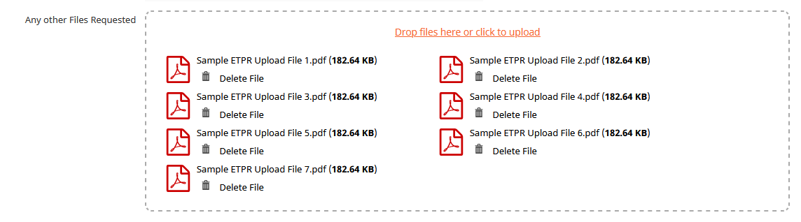

## **How it appears to reviewers:**

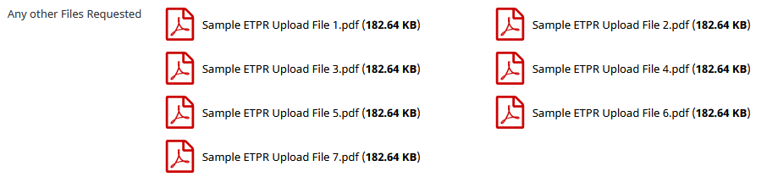

If you have longer file names, you may have to experiment to see how it looks to you, depending on how the longer names wrap. (As mentioned earlier, to change the name, you will have to delete and upload it again). Keep in mind that the way you see it is exactly how the reviewers will see it on the screen.

## **Snapshot**

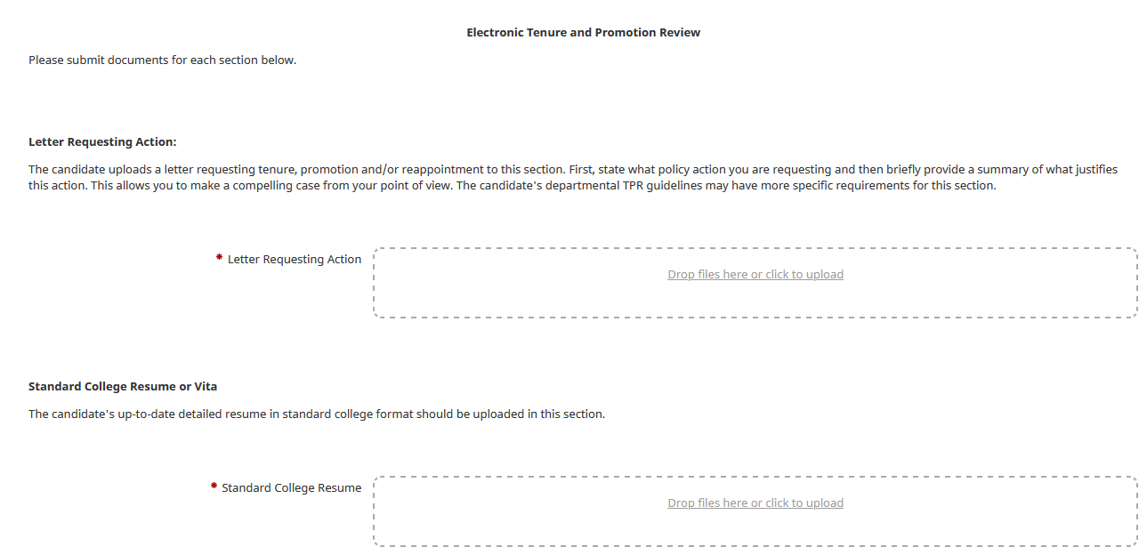Each upload area looks like this, with text above (describing what is to be uploaded) and an upload box where multiple files can be added for each. Since the entire form is difficult to read in snapshots, the text of each section follows.

## **Actions**

The actions box is in the upper right and corner. Actions available are Save for Later and Submit to Document Review. The submit action releases the documents to your TPR chair and department chair. An example (with a different submission option) is below. Save often as you are loading files and do NOT leave the browser unattended for any length of time.

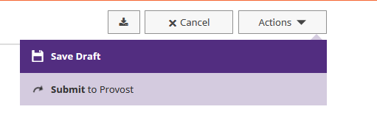

# **Faculty Form/Text Shown**

**Electronic Tenure and Promotion Review**

**Step 1: Document Preparation and Upload** – To launch the TPRworkflow review, faculty must prepare segments of a faculty dossier, a portfolio of their work since their first year as a faculty member. The following sections detail the dossier sections in DigitalMeasures and the recommended materials needed for each section. Faculty should always consult with their TPR chair for departmental specific guidelines unique to each section.

Please submit documents for each section below.

**Letter Requesting Action:**

The candidate uploads a letter requesting tenure, promotion and/or reappointment to this section. First, state what policy action you are requesting and then briefly provide a summary of what justifies this action. This allows you to make a compelling case from your point of view. Your departmental TPR guidelines may have more specific requirements for this section.

Letter Requesting Action

Drop files here or click to upload

**Standard College Resume or Vita**

The candidate's up-to-date detailed resume in standard college format should be uploaded in this section.

Standard College Resume

Drop files here or click to upload

**Top Achievements**

The candidate provides evidence to support the case made in the Letter Requesting Action. The candidate's departmental TPR guidelines may have more specific requirements for this section. If you want to upload top achievements from prior years (previously stored in etpr), it is suggested to combine them into one document and label it with the year range, such as Top Achievements 2017 - 2019. This would result in two documents being uploaded here, one for the current year, and one for prior years. **Include the Candidate Workload Report in this section.**

Top Achievements

Drop files here or click to upload

**Teaching Statement**

The candidate's statement on teaching including their teaching philosophy, methods used, materials developed, evidence of effectiveness, challenges and responses to challenges, how student feedback was used to improve teaching and other relevant information is uploaded into this section. The candidate's departmental TPR guidelines may have more specific requirements for this section. If you want to upload teaching statements from prior years (previously stored in etpr), it is suggested to combine them into one document and label it with the year range, such as Teaching Statement 2017 - 2019. This would result in two documents being uploaded here, one for the current year, and one for prior years.

Teaching Statement

Drop files here or click to upload

**Student Feedback Forms**

The candidate has the option to upload appropriate student feedback forms in this section. TYour departmental TPR guidelines may have more specific requirements for this section.

Student Feedback Forms

Drop files here or click to upload

**Other Evidence of Teaching Effectiveness**

The candidate shares any other evidence of teaching effectiveness not provided in the prior two sections. This can include evidence such as senior exit surveys, alumni surveys, in-class peer visitation reports, recordings, student pre- and post-tests, student work samples documenting course learning outcomes and other relevant information. Your departmental TPR guidelines may have more specific requirements for this section.

Teaching Effectiveness

Drop files here or click to upload

**Research/Scholarship Activities**

The candidate provides information about research and scholarship activities not addressed in the standard college resume such as literature citations, patents, awards, research proposals, etc. Your departmental TPR guidelines may have more specific requirements for this section.

Research

Drop files here or click to upload

**Service Activity**

The candidate provides information about service activity that was not addressed in the standard college resume. Your departmental TPR guidelines may have more specific requirements for this section.

Service Activity

Drop files here or click to upload

**Extension Activity**

Candidates who have extension appointment or funding will complete this section. The candidate provides information about extension activity that was not addressed in the standard college resume. Your departmental TPR guidelines may have more specific requirements for this section.

Extension Activity

Drop files here or click to upload

**Goals Statement**

The candidate provides a statement of short-term (1-year) and long-term (5-year) goals in this section. Your departmental TPR guidelines may have more specific requirements for this section.

Goals (Include 1 yr and 5 yr)

Drop files here or click to upload

**External Evaluator List from Candidate - (Uploaded by Candidate)**

**This section is only necessary for faculty seeking promotion to associate or full professor and/or seeking tenure.** The candidate lists their recommendations for external evaluator(s) that could provide independent evaluative comments as part of the candidate review, if applicable. Candidates provided this same information during the TPR-precheck step and are to report it here to promote transparency. Your departmental TPR guidelines may have more specific requirements for this section. Please also check for any updates from your TPR chair at the Precheck step.

Candidate's External Evaluators List

Drop files here or click to upload

**Activity Reports**

Candidate uploads DigitalMeasures Activity Reports here as well as prior FAS reports if applicable. Candidate should confirm with TPR chair for expectations here.

Activity Reports

Drop files here or click to upload

**Supplementary Information**

The candidate provides any clarifying statements or additional information not covered by their standard college resume or any other section. The candidate's departmental TPR guidelines may have more specific requirements for this section.

Supplementary Information (Optional)

Drop files here or click to upload

**Step 2: Document Review** – This step lasts one day. It notifies everyone in the review process (department chairs, TPR chair and committee) that the package is ready. You do not have to do anything for this step. It will auto-advance on its own. **When you see a deadline giving you one day to do something it is a document review step.**

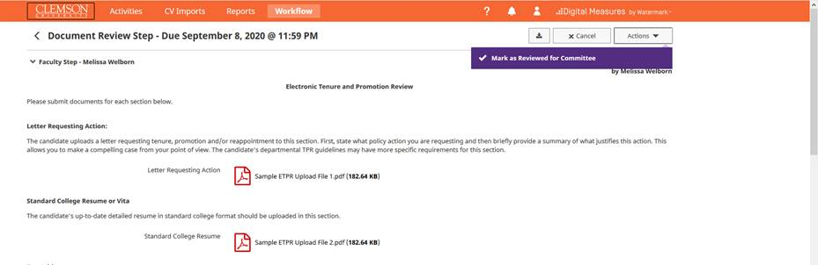

**Step 3: External Reviewers –** *(Except for reappointments and promotion to senior lecturer)*This step was set up to last ten days as a placeholder, but it can take as long as it takes. The department chair and TPR committee have access to the files without it. The TPR chair is the default to load external letters. The faculty member will never be able to see this section.

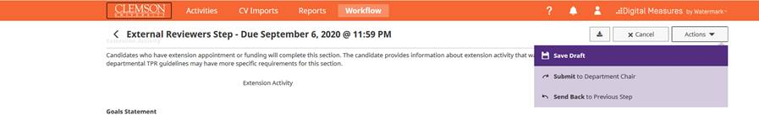

**Step 4: Department Chair** – The department chair makes his or her recommendations and loads a formal letter. This was set up as a group review, which allows the DM Administrator to add a staff assistant if requested. If the department chair wants staff assistance for this part, email [DMAdmin@clemson.edu](mailto:DMAdmin@clemson.edu).

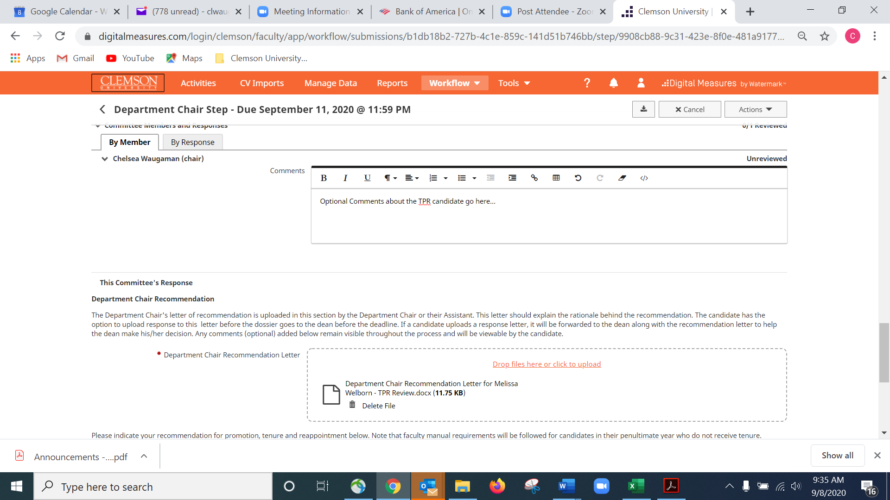

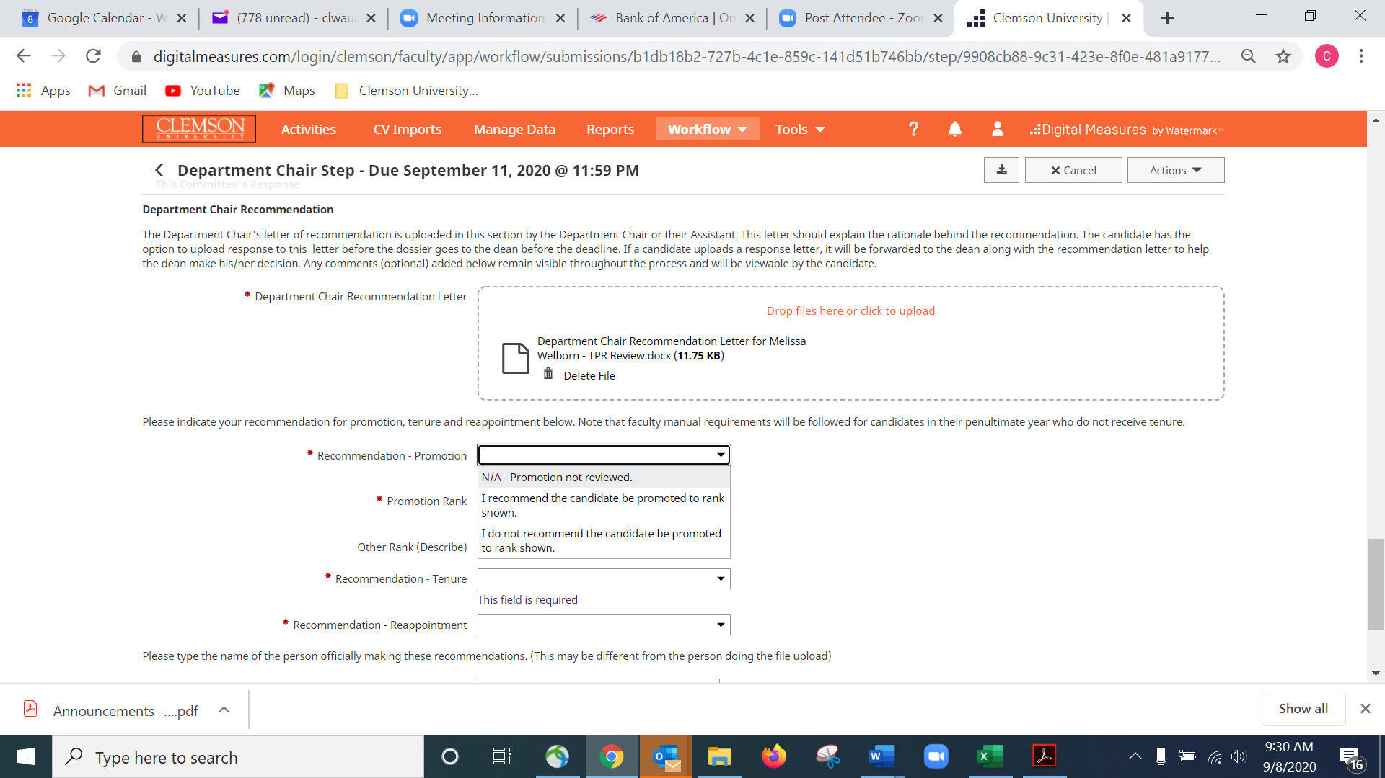

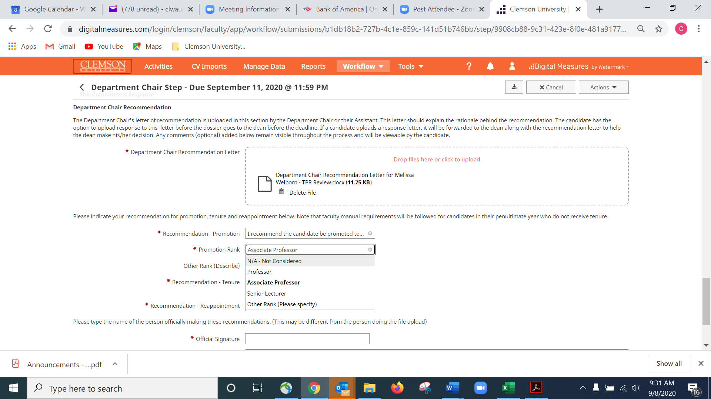

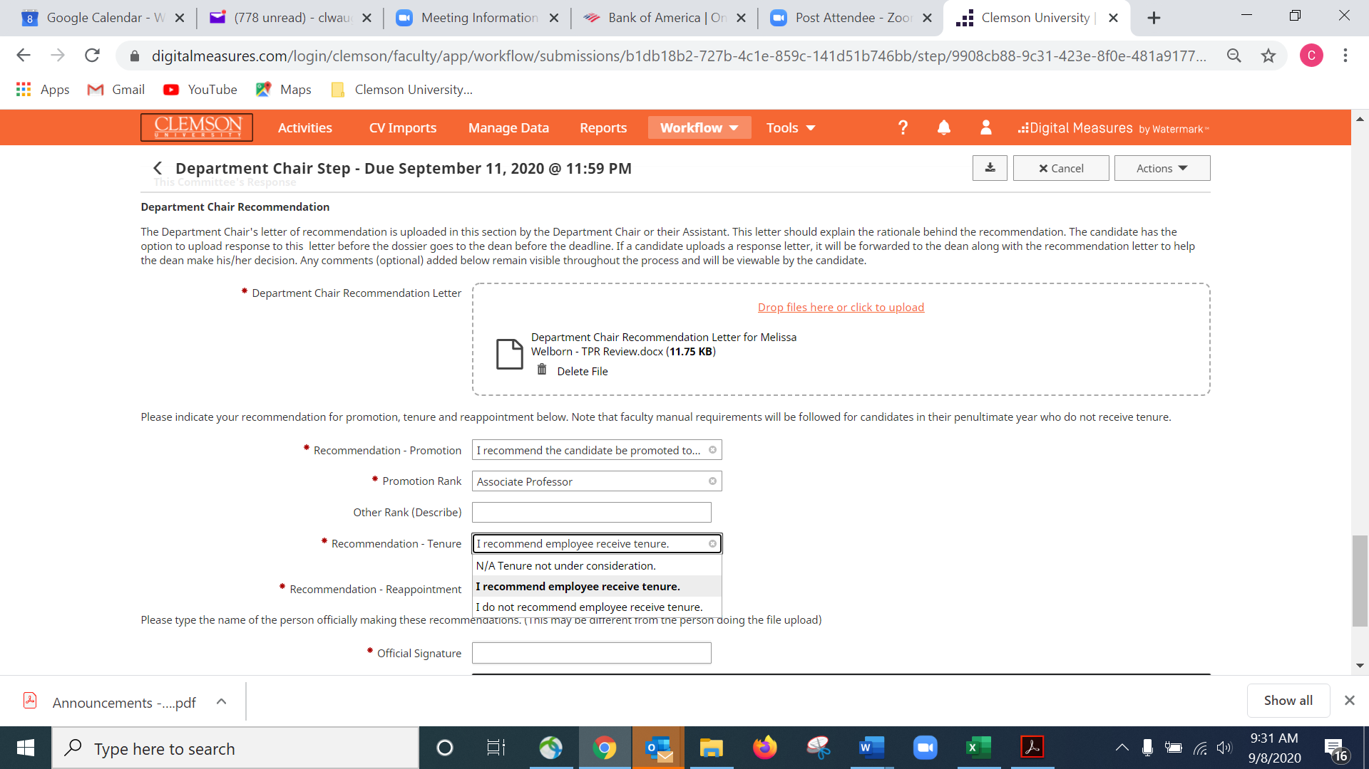

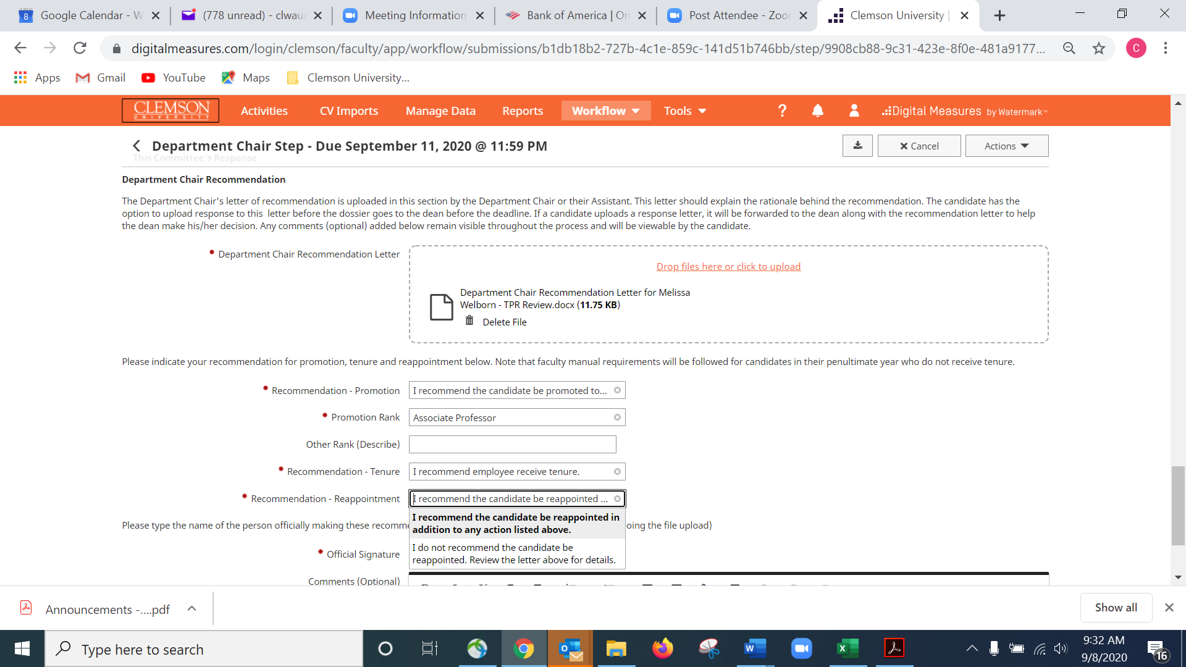

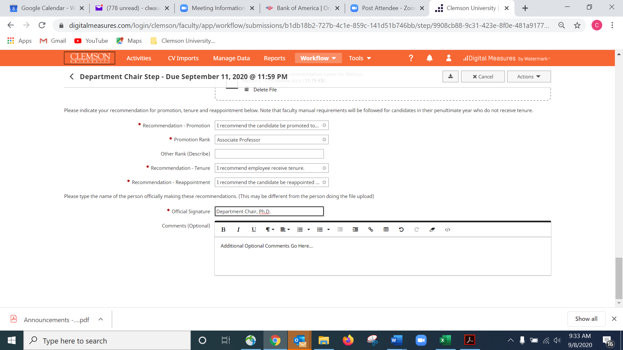

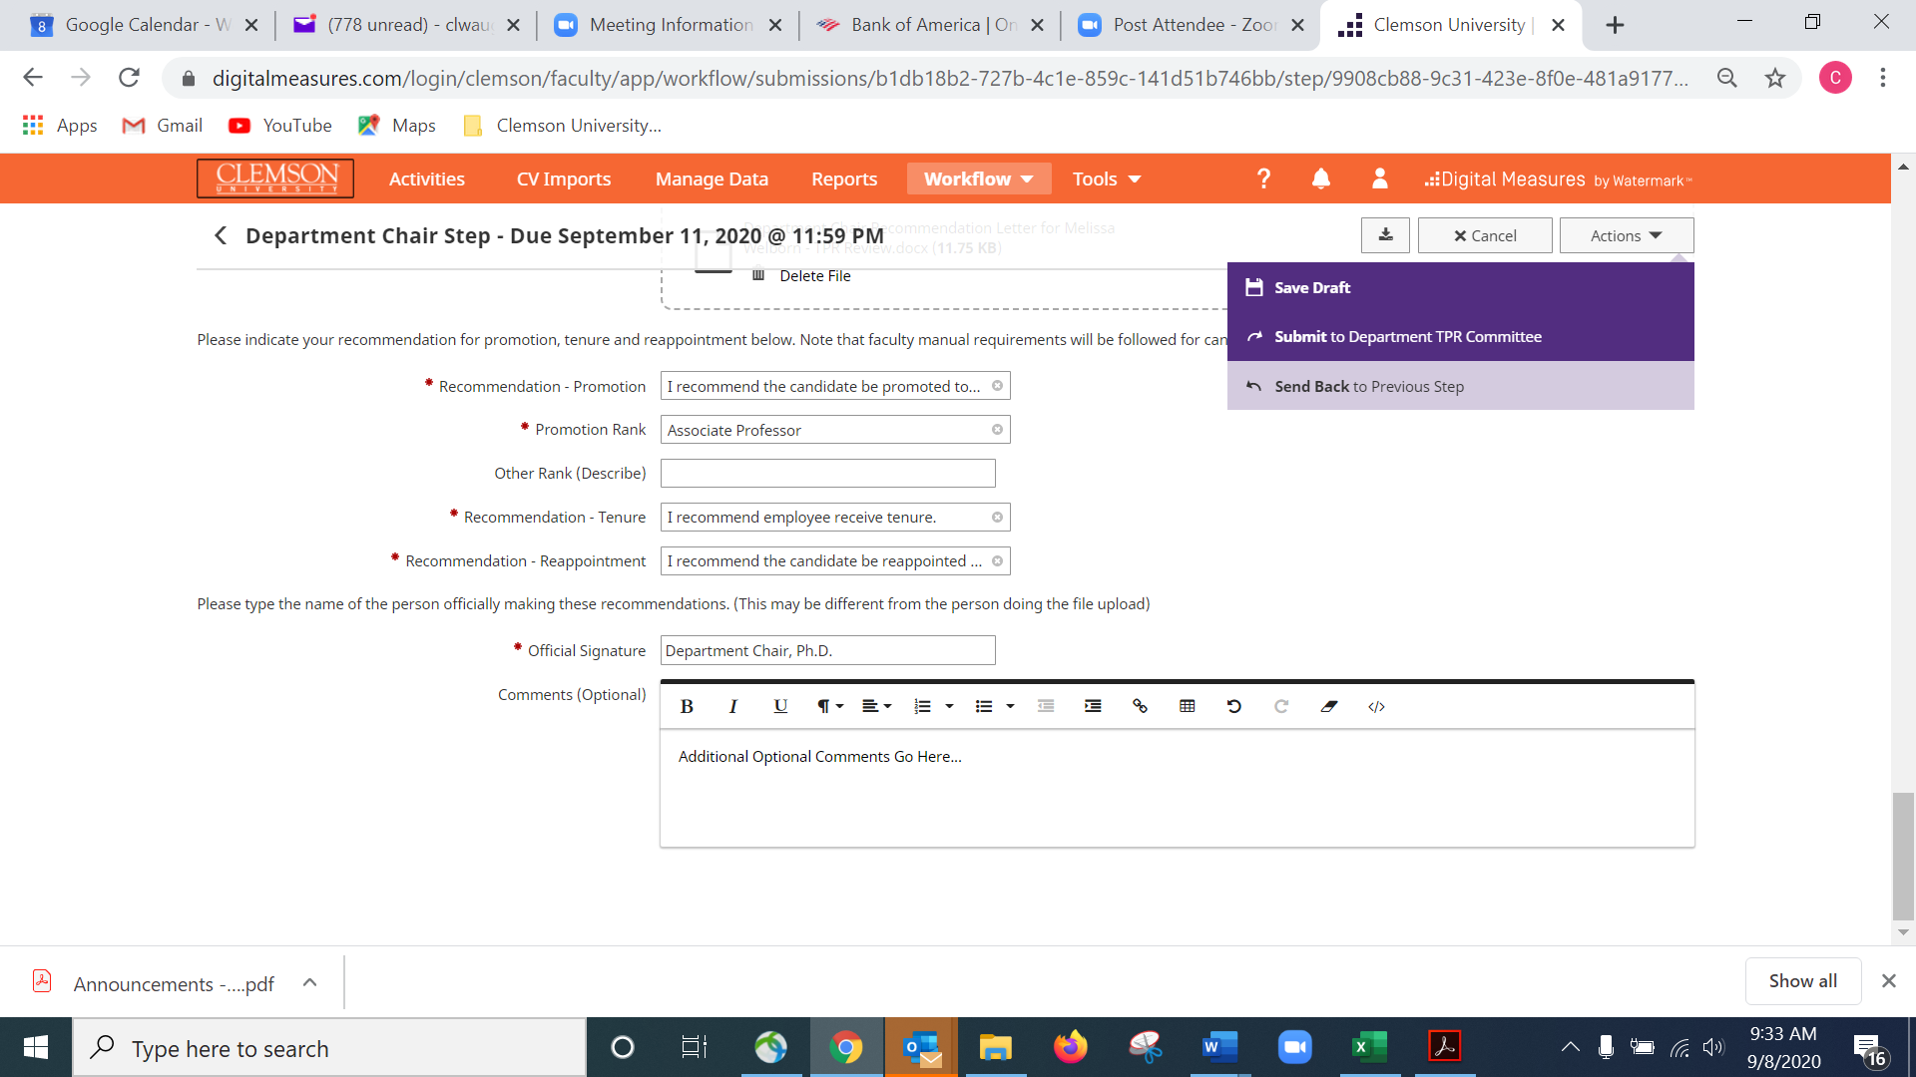

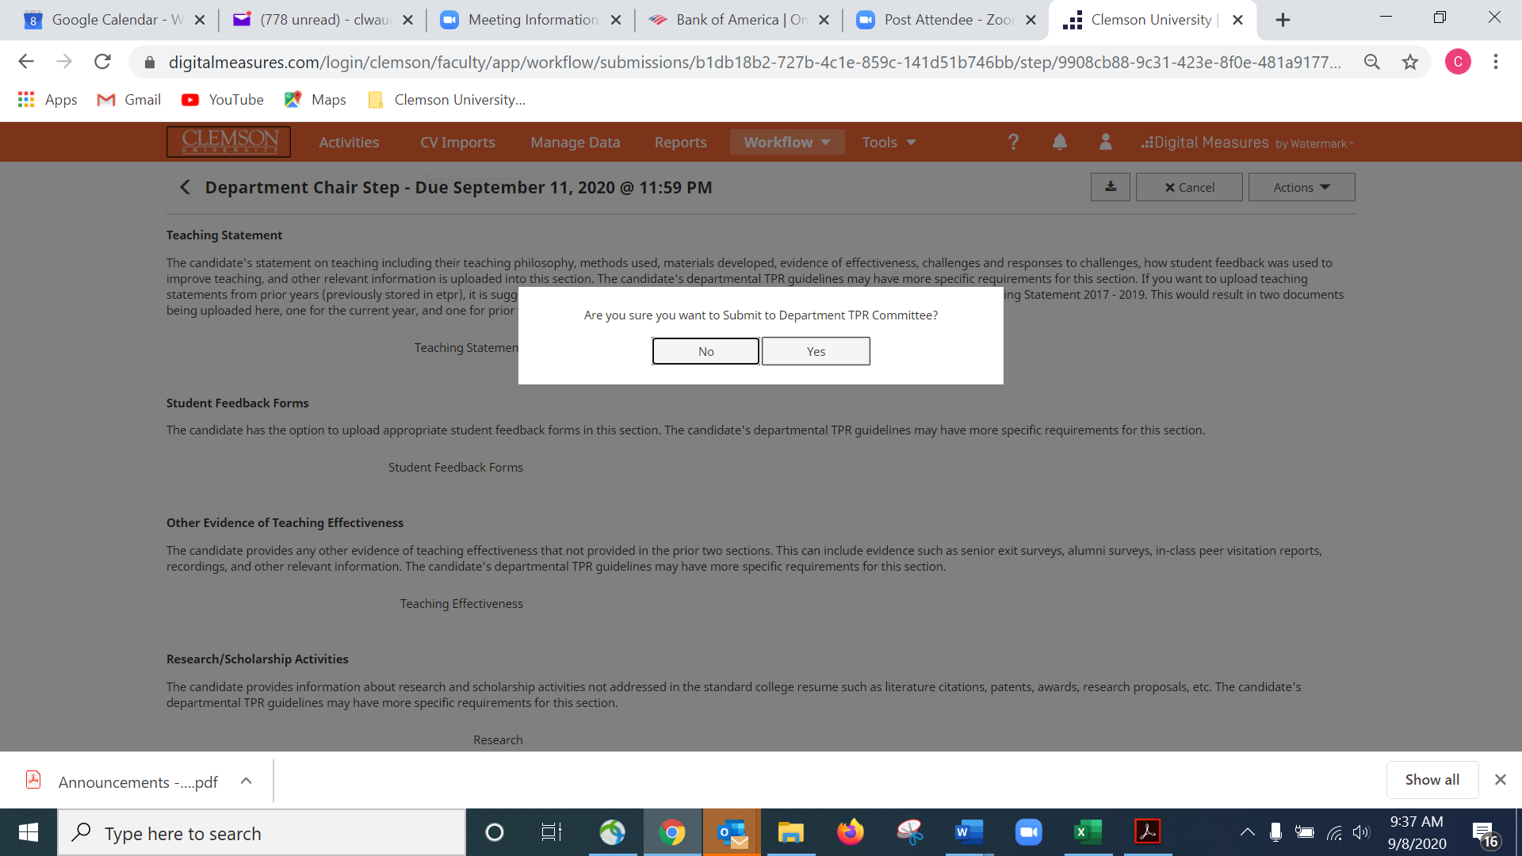

**Step 5: Department TPR Committee** – The TPR Committee reviews the files. The TPR Committee chair uploads a letter and makes the formal recommendations.

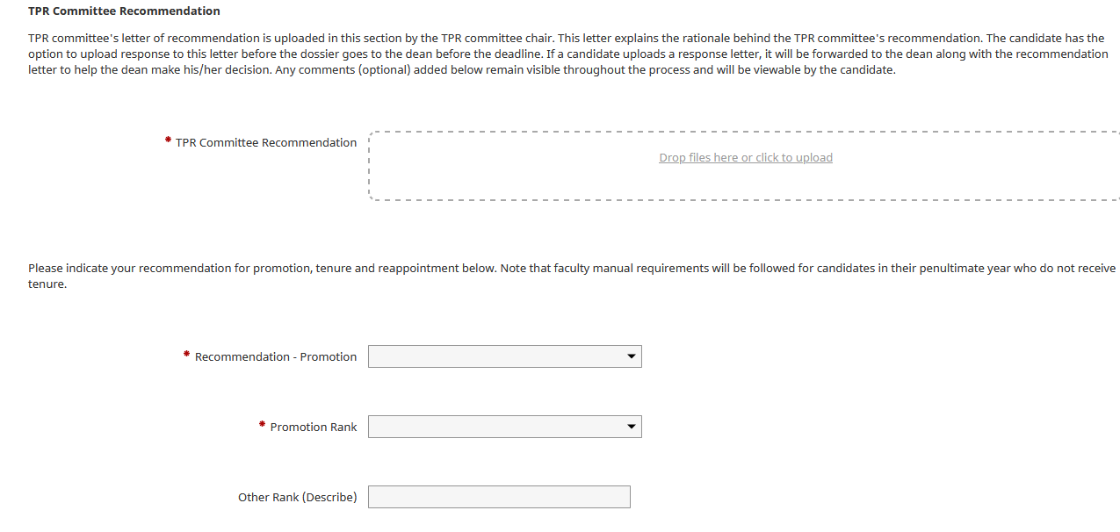

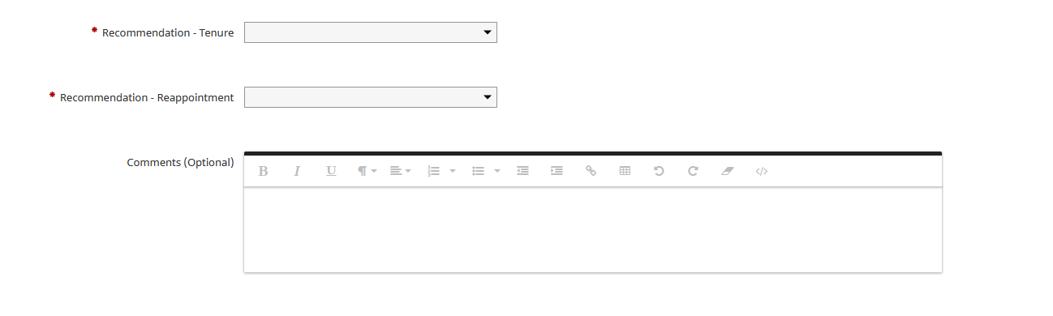

**Step 6: Recommendations Review** – This step allows the TPR committee to review the department chair recommendations and vice versa. It’s a one day step before the faculty has access.

**Step 7: Faculty Response Department** – This step gives access to the faculty member to review recommendations. He or she has ten days to add a response letter. If he or she chooses not to, after ten days the faculty dossier goes forward to the Dean’s Office.

**Step 8: Dean** – This is a one day step where the Dean gains access before it goes to the college TPR committee. If there is no college committee, Step 8 and 9 are omitted and the next step is Dean Recommendation.

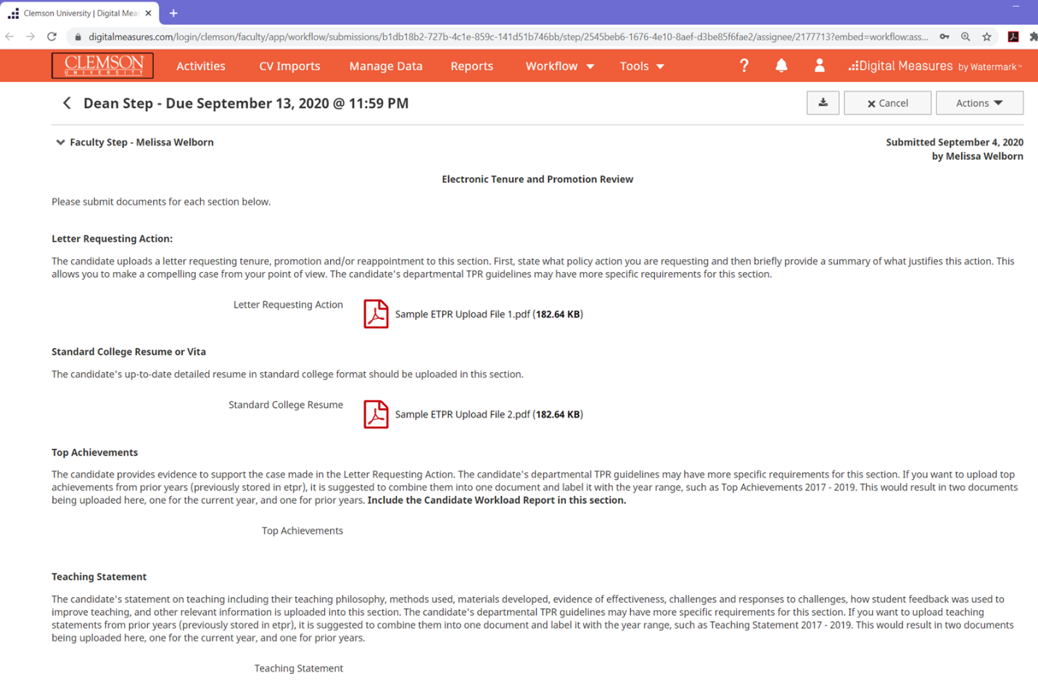

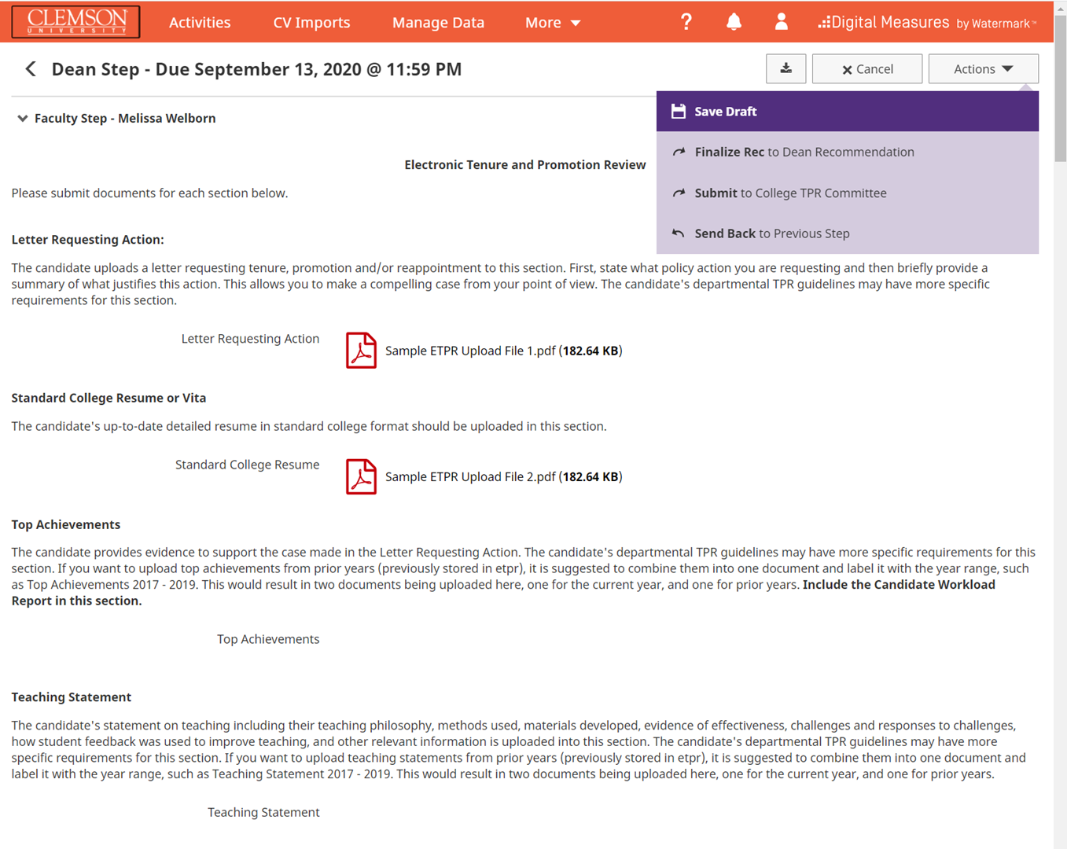

**Step 9: College TPR Committee** – This step allows the College TPR Committee to review the faculty dossier for 10 years. That timeframe can be adjusted, depending on where the process is relative to the other deadlines.

**Step 10: Dean Recommendations –** The Dean puts forth his or her recommendations.

**Step 11: Faculty Response Dean** – At this step the faculty member has access to the dean and College TPR Committee (if applicable) recommendations.. He or she has ten days to add a response letter. If he or she chooses not to, after ten days the dossier goes forward to the Provost’s Office.

**Step 12: Provost** – The Provost makes his recommendation.

**Step 13: President** – The President makes his recommendation.

**Step 14: Faculty Confirmation** – This is the final step and it returns back to the faculty member to view results. After one day, the process will complete.

# Recalling a Package

Faculty who have submitted a package and realize that there is something missing can request that the dossier be returned to them, if the dossier is still in the document review step.

If the dossier is at the department chair step, the department chair must send it back to the document review step, and then may send it back again to the faculty. (After he or she sends it back from the department chair step, it will appear in everyone’s inbox again for the document review step, and then the chair can send it back to the faculty). Faculty can also recall it once it is in the document review step.

A package may be sent back one step or recalled one step, but this may take multiple iterations if it has gone past that first step.

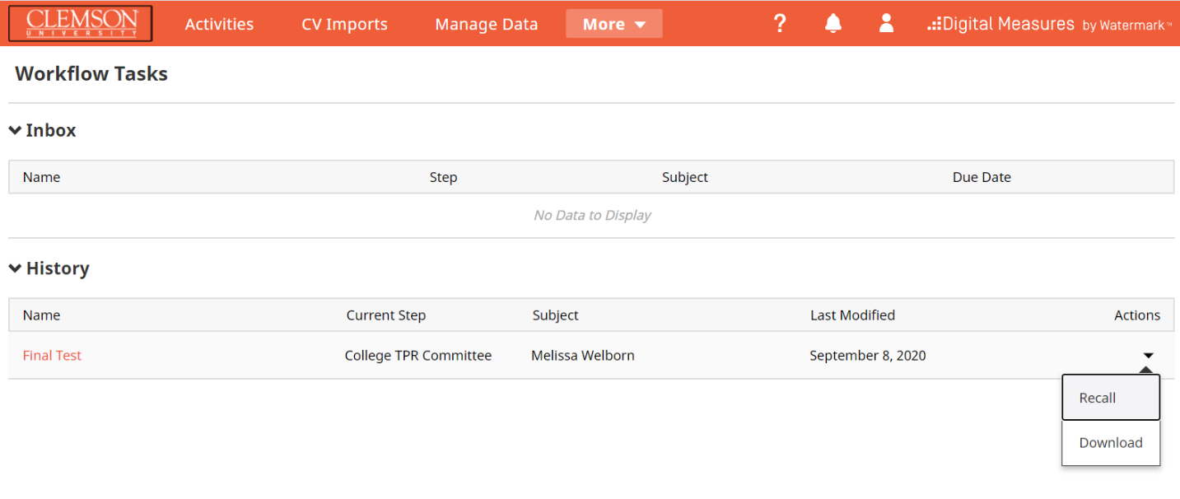

# Downloading Files – College TPR Committee Step

Files that Download when ‘download’ action is selected from College TPR committee step

