CEPSCI Online Exam Primer

- The online certification exam will be composed of 50 multiple choice questions.

- The exam period will be 2 hours maximum and will occur the afternoon following the online training course.

- Exam check-in will be through the Canvas Platform. Login information will be provided in advance of the class date. A pretest will be available to evaluate the capabilities of the computer being used and demonstrate exam questions layout. Please attempt to login and take the pretest prior to the exam date. The exam will begin promptly at 1:00 PM.

- The test questions will cover the general subject matter areas shown below with the potential number of questions in each subject matter area also listed.

- Regulatory (6-8 questions)
- Runoff BMPs (12-16 questions)
- Erosion BMPs (12-16 questions)
- Sediment BMPs (12-16 questions)
- Interpretation of construction plans (8-12 questions)

- Each examinee shall bring the following to the examination site:
  - Exam access directions
  - Canvas username and password
  - Valid State Driver’s License or other government issued ID
  - scratch paper and pencil or pen
  - battery / solar powered calculator (use of mobile phone prohibited)
  - Hand lens or magnifying glass (optional)

*This is a closed book exam, there should be nothing other than the above materials on your table or desk

*The use of cell phones at any time are prohibited

- The following draft questions, along with the Construction Plan and Topo Map Review questions illustrate the types and formats of questions that may be asked.

CEPSCI Exam
Sample Questions

Directions: Select the best answer for each question.

- Sediment control structures such as silt fence most commonly trap sediment by the following means.
  - Slowing water to allow sediment particles to settle out.
  - Serving as a filter that traps sediment particles in the small openings.
  - Preventing on-site erosion.
  - Serving as obstacles for vehicular traffic to slow movement.

- PAM is a chemical that is added to turbulent runoff primarily to achieve the following.
  - Change the turbulent flow to laminar flow.
  - Cause flocculation that reduces sediment transport.
  - Make the water potable immediately.
  - Provide binding of seed to mulch so that vegetation can be established.

- Energy dissipation is an important function for each of the following BMPs except
  - ECBs
  - Mulches
  - Riprap
  - Construction entrance

- Filter fabric inlet protection is the most appropriate BMP of choice in situations where the flow rate is
  - High (> 0.5 cfs)
  - Medium (~ 0.5 cfs)
  - Low (< 0.5 cfs)
  - Frequent

- Which of the following would not file a Notice of Intent (NOI) prior to any land disturbing activities?
  - Secondary Permittee
  - Utility Provider
  - Compliance Inspector
  - Primary Permittee

- Final site stabilization is achieved when percent vegetative cover on all disturbed areas is at least the following.
  - 65 percent
  - 70 percent
  - 80 percent
  - 90 percent

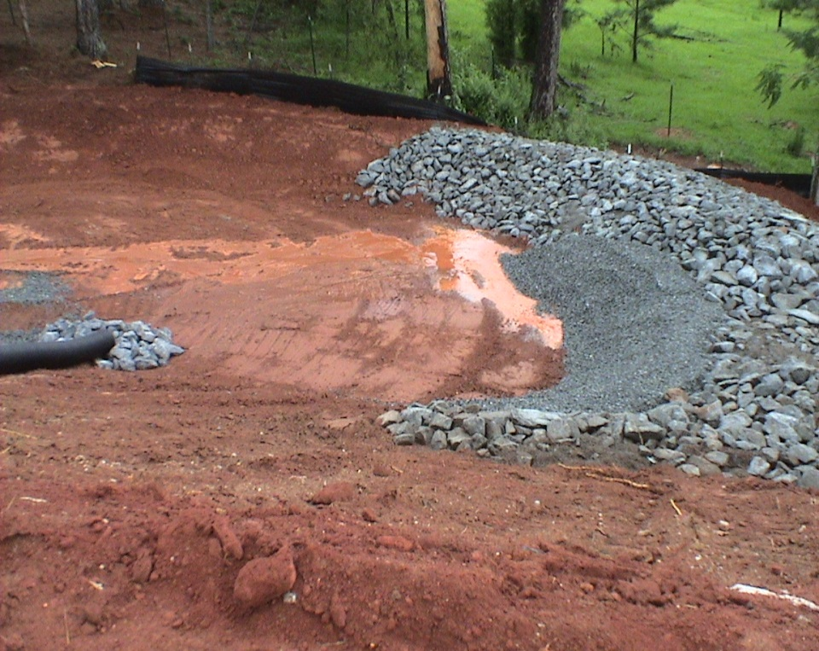
- The sediment control structure in the center right side of the photo above is a
  - Rock-filter fabric inlet.
  - Rock construction entrance
  - Rock ditch check
  - Rock spillway for a sediment trap

- Consider the following situation: You observe bulldozer tracks with dozer traveling parallel to the contour. The statement that you would use in an inspection report about the situation shown is most nearly.

  - The bulldozer tracks indicate that the tracking was done in the incorrect direction.
  - The bulldozer tracks indicate that the tracking was done in the correct direction.
  - The situation is an improper application of tracking and should be replaced immediately with sod.
  - ECB would not be appropriate on the site because the slope is too flat.

- The main benefit of using mulches and ECBs is that they

  - Are not living like vegetation
  - Provide instant cover
  - Do not have to be anchored
  - Last 4-6 years which is longer than the life of most construction projects

10. Sediment and erosion control measures shall not be removed until all construction is complete and a temporary ground cover is established.

- True
- False

