In response to the rapidly evolving New World Screwworm (NWS) outbreak in the Southwest United States, South Carolina has changed its import requirements for states affected by NWS infested and adjacent surveillance zones. Animals originating from states not affected by NWS infested and adjacent surveillance zones follow normal importation requirements.

All animals arriving from a state affected by an infested zone must be inspected within 24 hours of arrival for fly strike at the destination site. The USDA Best Practices for Evaluation of Animals for NWS are recommended for guidance in completing the inspection. If an infestation is found, the owner will contact Clemson University Livestock -Poultry Health at (803) 788-2260 to speak with an animal health program manager for further instructions.

Click on the following for updated importation requirements for states affected by an infested and adjacent surveillance zones:
- Commercial swine imported to South Carolina
- Companion animals imported to South Carolina
- Equine imported to South Carolina
- Livestock animals imported to South Carolina
- Livestock animals shipped directly to slaughter in South Carolina
- Poultry imported to South Carolina

Commercial swine imported to South Carolina from a state affected by an infested and adjacent surveillance zones
- Commercial swine housed in an indoor, commercial facility that is not experiencing NWS myiasis within an infested or adjacent surveillance zone:
- Completes and submits a South Carolina NWS permit request form and the Swine Production Health Plan (SPHP) at least 48 hours prior to movement.
- Inspects animals at loading for myiasis.

Companion animals imported to South Carolina from a state affected by an infested or adjacent surveillance zone
- For animals within an infested zone:
  - In addition to meeting the normal importation requirements, an accredited veterinarian:
    - Completes an inspection following the USDA NWS pre-movement animal inspection checklist as guidance, noting that the animal(s) is free of wounds harboring NWS myiasis before shipping.
    - Completes and submits a South Carolina NWS permit request form at least 48 hours prior to movement (this permit number is placed on the ICVI).
    - Completes and submits an ICVI within five (5) days of an inspection. The ICVI must have the statement “All animals were inspected and found free of evidence of NWS infestation.”
      - The ICVI expires within seven (7) days of inspection.
    - Treats the animal(s) with a species-appropriate, FDA-approved, or EPA-approved product prior to entry and records it on the South Carolina NWS permit and ICVI.
      - All small mammals and exotic birds that are bred, born, and housed indoors are exempt from required treatment.
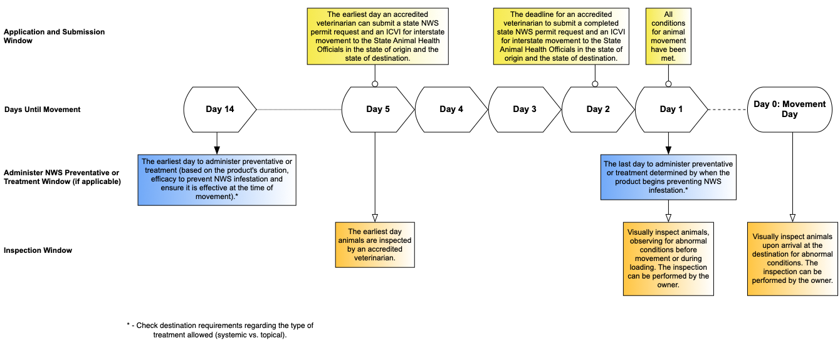

- For animals within an adjacent surveillance zone:
- Normal importation requirements and inspection completed by an accredited veterinarian.
- The ICVI must have the statement “All animals were inspected and found free of evidence of NWS infestation.”
      - The ICVI expires within seven (7) days of inspection.

- For animals outside of NWS infested and adjacent surveillance zones:
- Normal importation requirements completed by an accredited veterinarian.
    - The ICVI must have the statement “All animals were inspected and found free of evidence of NWS infestation.”

Equine imported to South Carolina from a state affected by infested or adjacent surveillance zones
- For animals within an infested zone:
  - Extended equine certificates of veterinary inspection (EECVI) are not accepted for importation into South Carolina. Only interstate certificates of veterinary inspections (ICVIs) are accepted.
  - In addition to meeting the normal importation requirements, an accredited veterinarian:
    - Completes an inspection following the USDA NWS pre-movement animal inspection checklist as guidance, noting that the animal(s) is free of wounds harboring NWS myiasis before shipping.
    - Completes and submits a South Carolina NWS permit request form at least 48 hours prior to movement (this permit number is placed on the ICVI). The ICVI must have the statement “All animals were inspected and found free of evidence of NWS infestation.”
      - ICVI expires within seven (7) days of inspection
    - Completes and submits an ICVI within five (5) days of an inspection.
    - Treats the animal(s) with a species-appropriate, FDA-approved, or EPA-approved product prior to entry and records it on the South Carolina NWS permit and ICVI.
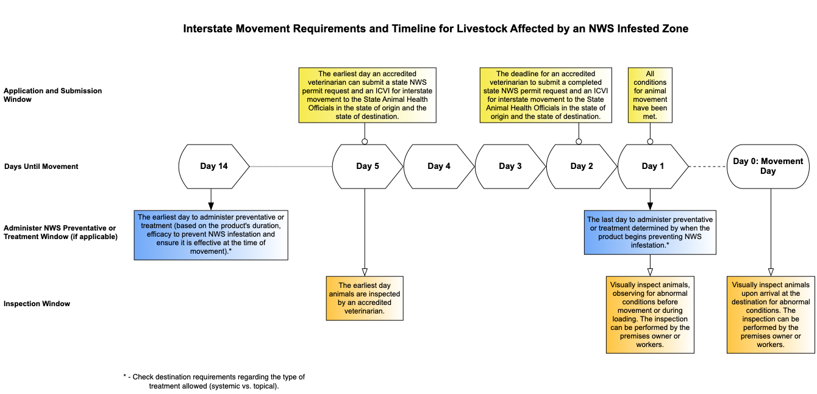

- For animals within an adjacent surveillance zone:
- Extended equine certificates of veterinary inspection (EECVI) are not accepted for importation into South Carolina. Only interstate certificates of veterinary inspections (ICVI) are accepted.
- Normal importation requirements and inspection completed by an accredited veterinarian.
- The ICVI must have the statement “All animals were inspected and found free of evidence of NWS infestation.”
      - The ICVI expires within seven (7) days of inspection.

- For animals outside of the NWS infested and surveillance zones:
- Extended equine certificates of veterinary inspection (EECVI) are not accepted for importation into South Carolina. Only interstate certificates of veterinary inspections (ICVI) are accepted.
- Normal importation requirements and an inspection completed by an accredited veterinarian.
    - The ICVI must have the statement “All animals were inspected and found free of evidence of NWS infestation.”

Livestock animals (including non-commercial and transitional swine) imported to South Carolina from a state affected by an infested or surveillance zone
- For animals within an infested zone:
  - In addition to meeting the normal importation requirements, an accredited veterinarian:
    - Ensure the animal has appropriate official identification.
    - Completes an inspection following the USDA NWS pre-movement animal inspection checklist as guidance, noting that the animal(s) is free of wounds harboring NWS myiasis before shipping.
    - Complete a South Carolina NWS permit request form at least 48 hours prior to movement (this permit number is placed on the ICVI).
    - Completes and submits an ICVI within five (5) days of an inspection. The ICVI must have the statement “All animals were inspected and found free of evidence of NWS infestation.”
      - ICVI expires within seven (7) days of inspection
    - Treats the animal(s) with a species-appropriate, FDA-approved, or EPA-approved product prior to entry and records it on the South Carolina NWS permit and ICVI, including product name, administered date, route of administration (oral, injectable, pour on, spray, ointment/paste, dip), and withdrawal period end date.

- For animals within an adjacent surveillance zone:
- Normal importation requirements and inspection completed by an accredited veterinarian.
- The ICVI must have the statement “All animals were inspected and found free of evidence of NWS infestation.”
      - The ICVI expires within seven (7) days of inspection.

- For animals outside of the NWS infested and adjacent surveillance zones:
- Normal importation requirements completed by an accredited veterinarian.
    - The ICVI must have the statement “All animals were inspected and found free of evidence of NWS infestation.”

- For dairy calves within an infested zone:
  - All calves have their navels dipped.
  - An accredited veterinarian completes an inspection following the USDA NWS pre-movement animal inspection checklist as guidance, noting the calves are free of NWS larvae, and any open wounds are treated with an EPA-approved NWS preventative topical pesticide and or an FDA-approved injectable product administered, and have official identification.
  - Completes and submits a South Carolina NWS permit request form at least 24 hours prior to movement (this permit number is placed on the ICVI) with an ICVI.
    - The ICVI must have the statement “All animals were inspected and found free of evidence of NWS infestation.”
  - The movement may be initiated immediately after the animals have been inspected and their navels have been dipped.

- For dairy calves within an adjacent surveillance zone:
  - All calves have their navels dipped.
  - Ensure the animal has appropriate official identification.
  - An accredited veterinarian completes an inspection following the USDA NWS pre-movement animal inspection checklist as guidance, noting the calves are free of NWS larvae, and any open wounds are treated with an EPA-approved NWS preventative topical pesticide and or an FDA-approved injectable product administered, and have official identification.
  - Completes and submits an ICVI.
    - The ICVI must have the statement “All animals were inspected and found free of evidence of NWS infestation.”
  - The movement may be initiated immediately after the animals have been inspected and their navels have been dipped.

- For dairy calves outside of the NWS infested and adjacent surveillance zones:
- Normal importation requirements completed by an accredited veterinarian.
    - The ICVI must have the statement “All animals were inspected and found free of evidence of NWS infestation.”

Livestock animals shipped directly to slaughter in South Carolina from a state affected by an infested or adjacent surveillance zone
- For livestock animals within an infested surveillance zone:
  - Animals shipped to South Carolina from an infested zone must be shipped direct-to-slaughter. These shipments may pick up and add animals to the load during the movement, but are not allowed to drop animals off at any location other than the designated slaughter location within the defined movement period.
    - An accredited veterinarian or an authorized inspector completes an inspection following the USDA NWS pre-movement animal inspection checklist as guidance, noting that the animal(s) is free of wounds harboring NWS myiasis before shipping and has appropriate official identification.
    - An accredited veterinarian completes a South Carolina NWS permit request form (this permit number is placed on the ICVI) and an ICVI at least 48 hours prior to movement.
    - The ICVI must have the statement “All animals were inspected and found free of evidence of NWS infestation.”
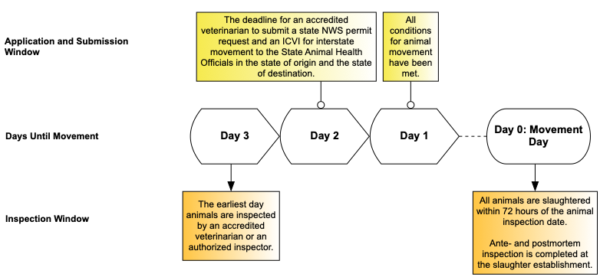

- For livestock animals within an adjacent surveillance zone or outside of the NWS infested and adjacent surveillance zones:
- Normal importation requirements.

Poultry imported to South Carolina from a state with infested and adjacent surveillance zones
- For commercial poultry within an infested or adjacent surveillance zone:
- The following poultry are exempt from movement requirements:
  - Hatching and table eggs and chicks under five (5) days of age.
  - NPIP subparts B, C, D, and J.

- For non-commercial poultry within an infested zone:
  - In addition to meeting the normal importation requirements, an accredited veterinarian:
    - Completes an inspection noting that the animal(s) is free of wounds harboring NWS myiasis before shipping.
    - Completes and submits a South Carolina NWS permit request form at least 48 hours prior to movement (this permit number is placed on the ICVI).
    - Completes and submits an ICVI within five (5) days of an inspection. The ICVI must have the statement “All animals were inspected and found free of evidence of NWS infestation.”
      - ICVI expires within seven days of inspection
    - Treats the animal(s) with a species-appropriate, FDA-approved, or EPA-approved product prior to entry and records it on the South Carolina NWS permit and ICVI.
      - All exotic birds that are bred, born, and housed indoors are exempt from required treatment.

- For non-commercial poultry within an adjacent surveillance zone:
- Normal importation requirements and inspection completed by an accredited veterinarian.
- Completes and submits a South Carolina NWS permit request form at least 48 hours prior to movement (this permit number is placed on the ICVI).
- The ICVI must have the statement “All animals were inspected and found free of evidence of NWS infestation.”

- For non-commercial poultry outside of the NWS infested and adjacent surveillance zones:
- Normal importation requirements completed by an accredited veterinarian.
    - The ICVI must have the statement “All animals were inspected and found free of evidence of NWS infestation.”

