|  |
| --- |
|  |
| Water-Demand Projection Methods for Off-stream Water Use in South Carolina |
|  |
|  |
| C. Alex Pellett |
| **5/20/2019** |

|  |
| --- |
|  |

Contents

1. Introduction 2

2. Thermo-electric Power 8

3. Public Water Supply 12

4. Manufacturing 16

5. Agricultural Irrigation 17

7. Other Categories 20

Appendices 22

# 1. Introduction

This report documents methods to project future off-stream water demand in South Carolina (SC). Data from State water withdrawal, discharge, and distribution permits are used to calibrate models of water demand. Future water demand scenarios are developed using projections of driver variables including economic growth, population, and electricity demand.

The SC Department of Natural Resources (SCDNR) is responsible for formulating the SC Water Plan. To develop the plan, possible water shortages are identified through comparisons of surface and groundwater resources to current and projected water demand. This report is an outcome of the United States Army Corps of Engineers (USACE) Planning Assistance to the States (PAS) agreement signed by representatives of USACE and SCDNR on May 23, 2018. The SC Water Resources Center (SCWRC) of Clemson University collaborated in the completion of this PAS agreement.

The water demand projections methods were developed in an inclusive process with a water demand technical advisory committee (TAC). The water demand TAC involved water use sector experts and stakeholders who met in a series of six Webex™ online teleconference water demand meetings which began in August 2018 and concluded in November 2018. A total of 110 stakeholders attended at least one of the water demand methodology meetings, with diverse backgrounds in public water supply, government, golf, higher education, power, consultant firms, agriculture, industry, legal firms, and environmental or conservation interests.

An initial draft report will be available to the public for review and comment for 30 days. Water users in each planning basin of SC, beginning with the Edisto, will be contacted to solicit additional feedback on the projection methods and draft results. Subsequent reports will summarize the water-user vetted results by sector and by watershed. Those reports will be distributed to stakeholder planning groups in each designated river basin of SC. The planning groups may recommend further adjustments to the projection scenarios. Projected water demands will then be input to the Simplified Water Allocation Model (SWAM) developed by CDM Smith Incorporated, and the Coastal Plain Groundwater Model developed by USGS, SCDNR, and the SC Department of Health and Environmental Control (SCDHEC).

This introduction chapter specifies the scope of the report and some general methods. Subsequent chapters document specific methods for different categories of water demand in SC: thermo-electric power, public supply, manufacturing, agriculture, golf, and other minor uses. As these methods are applied to project water demand across SC, modifications may be made as determined necessary to suit specific water uses.

## Scope

The subject of this report is water demand for off-stream use – actual or desired flows of water for uses outside of a water body. Off-stream uses of water begin with a withdrawal from a river, stream, reservoir, or groundwater aquifer. Consumptive water use results in evaporation or transpiration of water to the atmosphere. Non-consumptive water use results in a return flow to surface or groundwater. Throughout this report, the term “use” refers to off-stream water use.

Projecting future scenarios is a planning practice in which hypothetical scenarios of future conditions are described and relevant outcomes are estimated. Projections are based on explicit assumptions combined into scenarios spanning a 50-year planning horizon, from 2020 to 2070. Two scenarios will be defined by these methods: business-as-usual and high-demand.

This report does not include variable water use dependent on reservoir storage and release policies. Reservoir operations in SC are represented using distinct methods for modeling surface water, which are beyond the scope of this report. Specific effects of climate change are outside the scope of this report, but can be evaluated using the weather factors described below.

Surface water and groundwater resources in SC support fisheries and other wildlife, recreation, hydro-power plants, maintenance of minimum flows downstream of reservoirs, assimilative capacity for wastewater, aquifer inflows necessary to prevent saltwater intrusion, subsidence, and sinkhole formation. These are not considered off-stream demands and are beyond the scope of the study.

There could be regional, national, and global dynamics which may have effects on the future of water use in SC but which have not been represented in the methods presented here. Increased water demands or water shortages elsewhere could impact water demands in SC.

Portions of the water resources of SC come from neighboring states: Georgia, North Carolina, and even a portion of Virginia which drains to North Carolina as part of the Yadkin-Pee Dee basin. While water demands in those states can certainly affect SC’s water resources, those demands are beyond the scope of this study.

The number of permit-holders can change over time as some enterprises cease to operate or are acquired by other permit-holders. Enterprises which have not previously operated in SC or have not previously needed a permit for water use may begin reporting water use in the future. These dynamics are generally not explicitly included in the methods described in this report.

## General Concepts

Key terms used in this study are described in this section. The significance of these terms may vary from other literature. The statistical methods are described in more detail in Appendix 1 of this report.

### Source Water

A source water body is any stream, reservoir, or aquifer from which water is removed via an intake structure. Water which is removed from a source water body through an intake structure is termed a withdrawal. For the purposes of this study, water sources will be classified as either surface water, groundwater, or reuse of reclaimed wastewater. Rainfall and soil moisture are not considered source water bodies for off-stream water demand.

### Water Withdrawals

In SC, water withdrawals from rivers, in-stream reservoirs, and groundwater totaling more than 3 million gallons per month are subject to regulations which require annual reporting of monthly withdrawal volume. Reported withdrawal data are stored in a database maintained by SCDHEC. Intake locations are available from the SCDHEC GIS Data Clearinghouse.[1]

Each intake in the water withdrawal database is associated with one of the following categories of water use: Hydro-electric Power, Nuclear Power, Thermo-electric Power, Water Suppliers, Industry, Agriculture, Golf Courses, Mining, Aquaculture, and Other. The categories used in this study are based on these withdrawal permit categories, with some modifications. Nuclear power is considered a kind of thermo-electric power. Industry is referred to as manufacturing.

Records of monthly withdrawal volume extend back to the early 1980’s for some intakes. There have been changes in the regulatory reporting requirements over this time period, and the reports from 2013-present are generally more consistent. In earlier years, reports included some purchased water and water removed from off-stream storage ponds.

Some return flows to groundwater for Aquifer Storage and Recovery are documented in the water withdrawal database. Minor gaps and inconsistencies in the withdrawal data have been identified and corrected when possible.

### Water Use

Not all water that is withdrawn is put to immediate use, and not all water that is used in a given month comes directly from a withdrawal intake. Water uses can be supplied with purchases, reuse, and off-stream storage. Some water may be lost, for example through a leaky pipe.

The following mass balance is used to quantify water use in this study:

*Use = Withdrawal + Purchase + Reuse – Sales – Loss - ∆Storage* Equation 1

Where:

Use : Off-stream water use

Withdrawal : Total water withdrawal from source water bodies

Purchase : Total purchases of water from distributors

Reuse : Total reuse of water previously used for a different purpose

Sales : Total wholesale transfers of water to another user or distributor

Loss : Total losses of water preventing it from being put to use

∆Storage : Net change in off-stream water storage

In this study, reuse *refers to water which has been put to one use and is subsequently applied to a different use (typically by a different user).* Recirculation of water multiple times to the same use within a single enterprise is not considered as an addition to use.

The storage term refers to *off-stream water storage for water availability and does not include in-stream storage reservoirs, aquifer storage and recovery, or water pumped to an upstream reservoir for hydro-electric power*. Any flow of water from off-stream storage is a use, sale, or loss.

While withdrawals are recorded in the withdrawal database, there is much less information available to quantify purchases, sales, reuse, loss, and changes in off-stream storage for water users across SC. Some relevant information has been collected through survey responses and telephone interviews. Where information is not available, these terms are assumed to be negligible.

### Water Demand

Water demand estimated in terms of water volume per month, independent of availability of source water. Unmet demands are represented by the shortage term in the following equation:

*Demand = Use + Shortage* Equation 2

Where:

Demand : Water required, and normally used, to meet the objectives of water users

Use : Water actually used to meet the objectives of water users

Shortage : Water required but not available to meet the objectives of water users

### Water Consumption

Water use can be classified as either consumptive or non-consumptive according to the flow of water resulting from the use. Water that is evaporated or transpired to the atmosphere is considered to be consumed. Water that becomes part of an economic product is also considered consumed.

### Return Flows

Water that is not consumed is returned immediately to a surface water body or groundwater aquifer, or may be re-used to meet another demand. Piped discharges to surface water are subject to National Pollutant Discharge Elimination System (NPDES) regulations which require monthly reports of discharge volume. The discharges in the NPDES database often include inflow and infiltration from the environment to the waste-water system in addition to the return flows resulting from non-consumptive water use. Water withdrawals are not always connected to discharges in a simple 1:1 relationship. In some cases, complex water supply systems are interconnected with multiple suppliers and multiple discharge locations. Inflow and infiltration, and complex interconnections complicate the estimation of a mass balance for non-consumptive return flows.

*Discharge = Return Flow + Inflow & Infiltration* Equation 3

Where:

Discharge : Concentrated discharges to surface water bodies (NPDES data)

Return Flow : Water returned to the environment after non-consumptive uses

Inflow & Infiltration : Waste-water resulting from inflow and infiltration

Quantitative information is not available to reliably separate return flows from inflow and infiltration. If reported monthly discharge volume is not commensurate with monthly withdrawal volumes for a water user, then the annual minimum monthly discharge will be used as an estimate of return flow. Return flows to groundwater and dispersed return flows to surface water are assumed to be zero unless otherwise noted.

### Permit Systems

Related permits are often filed using different names and identification codes in these distinct databases. Together, the withdrawal, discharge, and distribution permits and reports can be used to estimate per capita consumptive and non-consumptive use.

### Drivers of Water Demand

Each major category of water use is associated with a primary driver, as outlined table 2. Projections of the drivers are available in other literature, and those projections will be used to ‘drive’ the projections developed in this study. Linear interpolation will be used to convert baseline driver data and projections to a monthly time step. In some cases, driver data is available for each permit-holder, in other cases, the driver variable is represented by a local or national average.

Table: Drivers of Water Demand



### Baseline Time Range

A baseline time period is defined for each water use. The baseline should represent a stable period of record with little or no significant changes affecting that user’s water demand. The average rate of use, seasonality, and efficiency of each permit-holder are assumed not to change over the baseline period. Weather variability over the baseline time period is necessary to estimate the impacts of drought on water demand. Generally, the period of time from years 2013-2017 will be used as the baseline, because water withdrawal reporting practices have been relatively stable over this range. Longer or shorter baseline time periods may be used on a case-by-case basis for different water users.

### Kinds of Water Use

The major categories of water demand can be subdivided into specific kinds of use: a water supplier may have sales to residential, commercial, and industrial customers; a thermo-electric utility may use different cooling systems for different generators; irrigation practices vary for different kinds of crops and soils. When such details are found to have significant effects in water demand models, baseline water demand will be calculated for each kind of water use.

### Weather and Climate

Weather and climate impact water demand in multiple ways. Temperature impacts electricity demand, which tends to peak when temperatures are most extreme. Temperature and humidity impact the efficiency of evaporative cooling and transpiration rates of crops. Insolation and precipitation also impact crop growth and irrigation requirements.

The Global Historical Climate Network (GHCN)is the most comprehensive station-based weather dataset available (Menne et al, 2012). Station records vary over time and there tend to be fewer records in rural areas. The Gridmet dataset includes daily weather variables on a 4 km grid, including estimates of precipitation and reference crop evapotranspiration (Abatzoglou, 2013). Gridmet is produced using GHCN station data. The uniform spatial grid with interpolated values simplifies the use of Gridmet as an input for further analyses. SCDNR has recently collaborated with researchers at the College of Charleston and the US Forest Service to evaluate different methods to calculate potential evapotranspiration using data from the GHCN (Amatya et al, 2018).

Any of these weather datasets can be used to calculate weather indices which may be correlated with water demand for a given use. The specific weather index applied to different kinds of water use vary. If weather indices are found to correlate with a kind of water use, then a weather coefficient will be included for that kind of water use in the baseline model.

### Projection Scenarios

The business-as-usual scenario assumes moderate weather conditions and no changes to water use efficiency. Driver values for the business-as-usual scenario will be taken from projections published from various sources and extrapolated to the 50-year period used in this study.

The high-demand scenario applies higher driver growth rates within the range of growth rates in the various source reports. The high-demand scenario also assumes a high impact of weather conditions on water use. These scenarios are applied uniformly across all permit-holders and kinds of water demand. Many additional scenarios can be explored by varying the scenario factors for different kinds of water demand or for different permit-holders.

### Works Cited

Abatzoglou, J. T. (2013), [Development of gridded surface meteorological data for ecological applications and modelling](http://onlinelibrary.wiley.com/doi/10.1002/joc.3413/full). Int. J. Climatol., 33: 121–131. For more information, see: <http://www.climatologylab.org/gridmet.html>

Amatya, Devendra M., Augustine Muwamba, Sudhanshu Panda, Timothy Callahan, Scott Harder, and C. Alex Pellett (2018) “Assessment of Spatial and Temporal Variation of Potential Evapotranspiration Estimated by Four Methods for South Carolina" Journal of South Carolina Water Resources: Vol. 5 : Iss. 1 , Article 1. Available at: <https://tigerprints.clemson.edu/jscwr/vol5/iss1/7>

Menne, M.J., I. Durre, R.S. Vose, B.E. Gleason, and T.G. Houston, 2012:  An overview of the Global Historical Climatology Network-Daily Database.  Journal of Atmospheric and Oceanic Technology, **29**, 897-910, [doi.10.1175/JTECH-D-11-00103.1](http://dx.doi.org/10.1175/JTECH-D-11-00103.1). For more information, see: <https://www.ncdc.noaa.gov/data-access/land-based-station-data/land-based-datasets/global-historical-climatology-network-ghcn>

# 2. Thermo-electric Power

Water is used to cool thermo-electric generators throughout SC. Water withdrawal and consumption at a given thermo-electric power plant is related to the type of fuel, prime mover, and cooling system used. Fuel types used for thermoelectric generation include coal, oil, natural gas, nuclear, and biomass. Recently, there has been a shift away from coal, with increased use of natural gas to fuel generators.

*The Water-Energy Nexus in Georgia: A Detailed Examination of Consumptive Water Use in the Power Sector* (Faeth et al., 2018) describes projections of thermo-electric water demand under multiple scenarios. That level of detailed analysis is beyond the scope of this study, but the report has informed the development of the methods presented here.

### Prime Movers

Prime movers used in thermo-electric generation can be placed in three classes: gas turbines, steam turbines, and combined cycle. Gas turbines are fueled with natural gas. Combustion heats air which drives the turbines, using relatively little water per kilowatt hour (kWh).

A variety of fuels can be used to power steam turbines, in which combustion heats water to create steam which drives the turbines. Compared to gas turbines, much more water is used running steam turbines, mostly to cool and condense the steam exhaust so that it can be recycled back through the turbine. Water used to generate the steam is often a small fraction compared with the cooling water used to condense the steam.

Combined-cycle generators direct excess heat from gas turbines to steam turbines, enabling more efficient fuel use. Water consumption rates of combined-cycle generators are typically intermediate between gas turbines and steam turbines. (NETL, 2010)

### Cooling Systems

Cooling systems used in thermoelectric generation can be placed in four classes: once-through, recirculating wet tower, recirculating pond, and dry tower cooling.

In once-through cooling systems, water is passed through a condenser and then discharged back to the environment, warmer but otherwise unchanged. Once-through cooling systems tend to have high withdrawal rates and low consumption rates within the plant boundaries. The discharged water can increase evaporation rates downstream, but this effect is more difficult to quantify compared to evaporation within the power plant.

The most common type of recirculating cooling system at thermo-electric power plants in the U.S. is wet tower cooling. After passing through the steam condenser, the cooling water is directed to a tower where ambient air is used to reduce the temperature of the cooling water so that the majority of it can be reused in the steam condenser. A portion of the cooling water is lost to evaporation, forming a water vapor plume above the tower. To prevent the build-up of minerals and sediment, another portion of the cooling water is discharged as ‘blowdown’. Recirculating pond cooling replaces the wet cooling tower with a cooling pond. Recirculating systems tend to have lower withdrawal rates and higher water consumption rates compared to once-through cooling systems. However, they are considered more ecologically friendly overall (Denooyer et al., 2016). The use of recirculating cooling systems has increased as once-through cooling systems have been retired, and this trend is expected to continue (Davies, Kyle, and Edmonds, 2013; Bijl et al., 2016). In SC, recirculating cooling systems are common.

Dry cooling systems operate a closed system without evaporative losses. Dry cooling systems are typically used where water is scarce, and are uncommon or nonexistent in the US Southeast.

### Peak and Base Load Generation

Some generators can efficiently produce a relatively constant output of electric energy, but cannot efficiently adjust output to meet short term fluctuations in demand. Peaker generators can more efficiently vary their output, and are used to match energy production to daily changes in demand. Natural gas is commonly used to fuel peaker generators which are designed to turn on and off quickly and efficiently. (NETL, 2010)

### Carbon Capture

Commercially available carbon capture technologies have been found to increase water consumption 50-90% or more, depending on the power generation platform. While water withdrawals for thermoelectric power generation are expected to remain relatively constant or decline slightly, water consumption is expected to increase nationally by 14-26% as recirculating cooling and carbon capture systems are brought online from 2005-2030. That scenario does not reflect the impact of potential changes in greenhouse gas mitigation regulations. (NETL, 2018)

### Energy Information

The United States Energy Information Agency (US EIA) publishes reports of monthly electricity generation and water use, nameplate capacities, capacity factors, and planned actions for each electricity generator and cooling system. Each generator is assumed to operate at the product of its nameplate capacity times the capacity factor. Planned actions include uprates and derates of plant capacity, and decommissioning. No planned actions affecting the generators in this study were found. For thermo-electric water demand projections presented in *The Water-Energy Nexus in Georgia*, coal plants were assumed to retire after 65 years of operation. Thermo-electric plants are not assumed to retire in this study. Projected retirement dates may be provided by stakeholders. River basin councils may assess long-term potential retirements.

### Water Consumption Rates

Average water consumption rates for different kinds of thermo-electric generators are available from several sources, providing a range of estimates. Estimates from a US Army Corps of Engineers study by Stuart Norvell correspond closely with estimates provided by Duke Energy. Faeth et al. (2018) provide similar numbers for Georgia, and the EIA dataset includes monthly water consumption rates for cooling systems in each power plant.

### Electricity-Demand Projections

There are three major power companies operating in SC: Duke Energy Carolinas, Santee Cooper, and Dominion Energy South Carolina (formerly known as SCE&G). Each of these utilities publishes annual or bi-annual Integrated Resource Plans (IRPs) with projections of electricity demand in their service areas. In the plots below, the average monthly energy demand is represented with a black line. The red and blue lines represent the summer and winter peaks in demand, which may only occur for a few hours each day during the hottest and coldest portions of the year.

The IRP projections from 2028 onwards are used to fit linear models for each utility and season to extend the projections to year 2070. These extended projections are considered the driver of water demand for thermo-electric power generation.

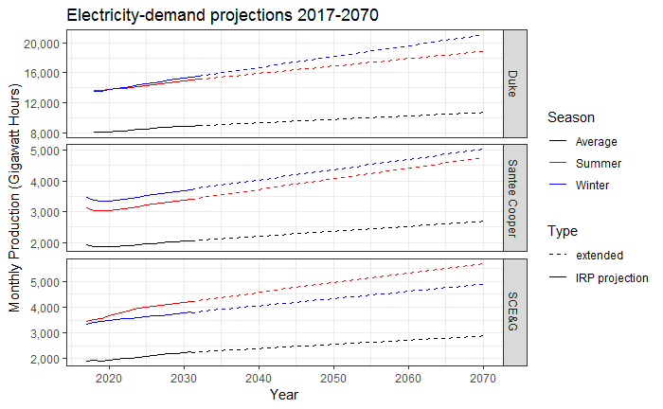

### Water-Demand Scenarios

The business-as-usual scenario assumes that increasing average demands are spread evenly across the electricity generation portfolio of each utility. Increases in summer and winter peak demands are assigned preferentially to peaker generators.

For the high-demand scenario, water consumption rates are increased by 15%. This represents the national average expected impact of carbon capture and recirculating cooling technologies.

### Alternative Sources of Electricity

The fastest growing source of electricity in SC in recent years is solar, which requires no water. Solar power generation is still minor compared with thermo-electric and hydro-power, and its continued growth may rely on continued support from the government. Faeth et al. (2018) projected continued growth in solar and other renewable sources of electricity, to as much as 30% of electric power generation by 2060. The costs of energy storage, necessary to buffer variable solar and wind power, is coming down. In this study, increases in solar, wind, and hydro-power relative to thermo-electric generation will not be considered in either the business-as-usual or high-demand scenarios.

### Works Cited

Bijl, David L. & Bogaart, Patrick W. & Kram, Tom & de Vries, Bert J.M. & van Vuuren, Detlef P., *Long-term water demand for electricity, industry and households*, Environmental Science and Policy, 55 (2016) pp 75-86

Davies, Evan, Page Kyle, and James Edmonds, *An integrated assessment of global and regional demands for electricity generation to 2095*, Advance in Water Resources, 52 (2013) pp 296-313

Denooyer, Tyler, Joshua Peschel, Zhenxing, Zheng, and Ashlynn Stillwell, *Integrating water resources and power generation: The energy-water nexus in Illinois*, Applied Energy, 162 (2016) pp 363-371

Dieter, C.A., Maupin, M.A., Caldwell, R.R., Harris, M.A., Ivahnenko, T.I., Lovelace, J.K., Barber, N.L., and Linsey, K.S., 2018, Estimated use of water in the United States in 2015: U.S. Geological Survey Circular 1441, 65 p., https://doi.org/10.3133/cir1441.

EPRI, *Water and Sustainability Vol 3: Water Consumption for Power Production – The Next Half Century*, Topical Report Number 1006786 (2002)

Faeth, Paul, Lars Hanson, Kevin Kelly, and Ana Rosner (2018). *The Water-Energy Nexus in Georgia: A Detailed Examination of Consumptive Water Use in the Power Sector*.

Maupin, Molly A., Joan F. Kenny, Susan S. Hutson, John K. Lovelace, Nancy L. Barber, and Kristin S. Linsey (2014). Estimated Use of Water in the United States in 2010. USGS Circular 1405.

NETL, 2010. *Estimating Freshwater Needs to Meet Future Thermoelectric Generation Requirements: 2010 Update*. DOE/NETL-400/2010/1339. National Energy Technology Laboratory

NETL, 2018. <https://www.netl.doe.gov/research/coal/crosscutting/environmentalcontrol/water-and-energy-interface>. Website accessed 8/15/18

# 3. Public Water Supply

Public water supplies include water distributors providing raw or treated water wholesale or retail to other water users. Users purchasing water can include residential, commercial, industrial, irrigation users, and other public supply distributors. Public supply is the broadest and most diverse category of water use described in this study.

### Public supply permits

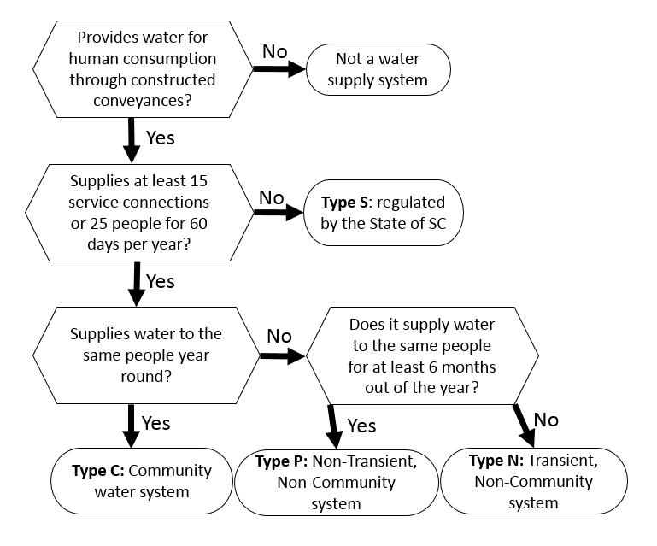

Figure: Water Supply System Classification

The Environmental Protection Agency (EPA) defines a public water system as *a system which provides water for human consumption through pipes or other constructed conveyances to at least 15 service connections or serves an average of at least 25 people for at least 60 days a year*.  Public water systems are divided into three categories for permitting purposes. Type C community water systems supply water to the same population year-round. Type P non-transient non-community water systems supply water to at least 25 of the same people at least six months per year. Some examples are schools, factories, office buildings, and hospitals which have their own water systems. Type N transient non-community water systems provide water in a place such as a gas station or campground where people do not remain for long periods of time. In addition to the public water systems regulated by the EPA, the SCDHEC regulates and issues permits for type S water supply systems which do not meet the EPA definition of public water systems. In this study, water demand of type P, N, and S systems is assumed to remain constant. Projection methods described here apply to Type C, Community Water Systems.

The State Drinking Water Database, part of the Environmental Facilities Information System (EFIS), contains information from all of the water supply permits in SC, including the number of commercial and residential taps, wholesale connections, and populations served. Populations served directly are counted as primary populations, and populations served indirectly (through sales of water to another distributor) are counted as secondary populations. This information is updated as permits are renewed every 3 to 5 years, depending on the size of the system.

### Wholesales

The drinking water database includes some information on system interconnections. Connections are listed, but wholesale volumes are not included. The primary population, served directly by a given distributor, is included along with the secondary service population served through a wholesale connection. The secondary population information may represent the total of several wholesale connections. In some cases, water from multiple distributors mixes within a single distribution system. Where sufficient information is available, wholesale volumes over the baseline period are subtracted from the seller and added to the buyer to calculate baseline water demand. Where wholesale volumes are not available, multiple interconnected distribution systems are lumped together and considered in aggregate.

Similarly, large industrial purchases of water can skew estimates of per capita water demand for a distribution system. Where sufficient information is available, industrial purchases will be projected using the methods developed for manufacturing self-supply.

### Septic Systems

SCDHEC maintains a database of permitted septic system drain fields including the water source as either purchased or from a domestic well. Older septic system drain fields may have been installed without a permit, but permit compliance is expected to be near 100% in recent years. The permits often have some geographic information, but exact address information is not always reliable. In many cases, septic systems are installed prior to home construction, and street names and address numbers may not have been finalized when the permit is granted. The permits, however, do indicate the county where the drain field is located. When sewer collection systems expand, residents may choose to continue to use their pre-existing septic systems instead of joining the sewer network. However, if their septic system fails or faces maintenance issues, homeowners typically join the sewer system. The septic system drain field permit database is not updated when a septic system is decommissioned. Assuming a life-span of 20 years for a drain field, the number of households purchasing water and on septic is subtracted from the number of residential customers to calculate per capita return flows and per capita consumptive use.

### Service Areas

Some water utilities have provided service area maps. Where such maps are not available, municipal boundaries can be used.[2] Service areas allow for an analysis of geographic data including land cover and demographic survey information. This information will be considered on a case-by-case basis if it has implications for future water demand.

### Population projections

The SC Office of Revenue and Fiscal Affairs (SC-ORFA) has developedpopulation projectionsfor each county based on birth, death, and migration rates. The SC-ORFA projections are developed using the cohort component method. Birth, death, and migration rates are estimated for age cohorts within the population of each county. This is based on the assumption that recent birth, death, and migration rates are representative of future rates for each age cohort of the population. The most recent projection available spans the years 2013 to 2035.

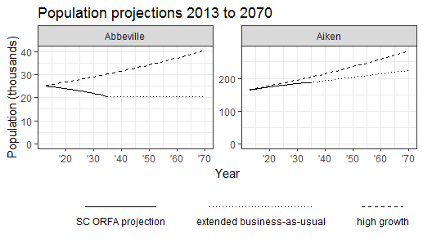

### Business-as-usual

The SC-ORFA projections represent the business-as-usual scenario, and the projections are extended here to 2070. The average annual change in the population of each county is calculated as the difference between the 2013 and 2035 populations, divided by 22 (2035 minus 2013) increments in the SC-ORFA projection. If the average annual change is positive, then the business-as-usual scenario is extended to 2070 at the same average annual rate of change. If the average annual rate of change is negative, then the business-as-usual scenario is extended as a flat line to 2070 (no change in population after 2035). Seasonal per capita water use rates of each distribution system remain constant.

### High-demand

The high-demand scenario assumes exponential growth. The average growth rate in the population of each county over the SC-ORFA projections is calculated as follows:

$$growth rate= {\left(\frac{population 2035}{population 2013}\right)}^{1/23}-1$$

For counties with a calculated growth rate less than the state average (0.83%), the state average is used. To represent a high-demand scenario, growth rates are further increased by 10% (for a minimum county growth rate of 0.00829 * 1.1 = 0.00912).

The high-demand scenario also includes drought impacts on irrigation demand. Drought impacts for each distribution system are estimated using the 90th percentile monthly per capita water demand in each 3-month season over the baseline period.

### Local Planning

Local (municipal, county, or regional) plans may not coincide exactly with the SC ORFA population projections. The SC Code of Laws requires that *local comprehensive plans must consider water supply, treatment, distribution, sewage system and wastewater treatment* (*Title 6: Chapter 29 Article 3 – Local Planning — The Comprehensive Planning Process)*. These local planning documents have been collected and reviewed as part of this study, and relevant excerpts from the local plans will be included in the basin studies.

### Advanced Methods

Some water distributors have provided more detailed information regarding sales volumes for residential, commercial, industrial, and wholesale water use. Some distributors have provided information regarding indoor and outdoor water use, and some distributors have provided indoor and outdoor water use for the different sales categories. This information can be useful, but at least 3 years are needed to apply the seasonal and weather dependent statistical models used in this study. When detailed sales data is available, statistical models for the different kinds of water use may be developed on a case-by-case basis.

# 4. Manufacturing

For decades, manufacturing withdrawals have declined as water-use efficiency has increased. There is potential for further efficiency measures which could decrease total withdrawals while increasing consumptive use. A trend in US manufacturing is to increase economic output by producing higher quality products which often do not require substantially more water to manufacture.

Water use in the manufacturing sector can be evaluated in terms of gallons per dollar of value produced or gallons per employee. Neither of these metrics are expected to provide correlations as strong as the drivers of thermo-electric and public supply.

Using information available on permits and on publicly available online search results, manufacturers withdrawing or discharging more than 1 million gallons per month in SC are labelled with their primary economic subsector.

### Manufacturing Projections

The US Energy Information Administration (USEIA) provides national level projections of macroeconomic indicators out to 2050, including projected growth rates for each subsector of the economy.

Growth of individual businesses will inevitably vary from national projections for a subsector. Within SC over the coming 50 years, there will likely be openings, closings, and transitions of industrial plants from one sector to another. Those possibilities are not considered explicitly in the scenarios presented here, but such possibilities should be considered on a case-by-case basis when relevant information is available.

### Business-as-usual

The average baseline withdrawal and consumption volumes for each permitted use are increased by a growth rate from the USEIA. The USEIA projected growth will be adjusted to a minimum of zero.

### High-demand

The 90th percentile withdrawal and consumption volumes for each permitted use are increased by a growth rate from the USEIA. In this scenario, the USEIA projected growth for each subsector will be adjusted to a minimum equal to the SC average.

# 5. Agricultural Irrigation

U.S. farm net income in the last three years has decreased to half of what it was in 2013. Many farms in SC have been impacted by recent extreme weather events. Irrigation is used to mitigate risks from uneven rainfall and drought. Many irrigators in SC supply fertilizers through irrigation, and some apply pesticides through irrigation. While irrigated agricultural area is growing, most of SC farmland is not irrigated. Despite the economic hardships faced by farmers, irrigation is often considered a profitable investment by farmers, lenders, and investors. In this study, irrigated area is the primary driver of irrigation volume, but irrigation depth can vary by crop, soil, weather, irrigation method, crop growth stage, and cultivation practices specific to each irrigator. Energy prices, commodity prices, subsidies, and crop insurance policies are external factors which will not be considered in this study.

### Irrigated Areas

The USDA Census of Agriculture (COA)is considered the most authoritative source of information regarding irrigated acreage per county and crop. Results of the 2017 COA were released in April 2019.[3] These census results are the standard with which other estimates are evaluated.

The Farm Service Agency (FSA) provides an annual dataset of irrigated and un-irrigated acreage per county per crop. This information comes from farmers registered with the FSA (not all farms provide this data). It represents an incomplete sample, whereas the COA is statistically corrected with the aim of better representing the entire population of farms. Because the FSA data is not statistically corrected, the reported acreages can be interpreted as a minimum value. FSA estimates are drafted and updated over several iterations as the data is compiled from local to national offices. The FSA dataset also includes information regarding crop variety and intended uses.

Clemson University Extension has undertaken an ongoing irrigation survey. Results will be published by county and will likely be informative for agricultural water demand projections. Results from a separate Clemson survey of greenhouses and nurseries may also be informative.

Groundwater withdrawal permits in capacity use areas include the expected irrigated acreage for each withdrawal well. Permit information is directly associated with reported withdrawal volumes, enabling farm-scale water-demand models. Using intake locations as a guide, many irrigated areas have been distinguished from Google Earth imagery. County-wide extent of irrigation from the sources described above can also inform manual image interpretation.

Image-based estimates of irrigated area allow for analysis of spatial variables such as soil. The Soils Data Layer (SSURGO)includes parameters such as hydraulic conductivity and moisture retention capacity which are relevant for modeling irrigation depth.[4]

### Machine Learning

Imagery such as from Google Earth and the National Agricultural Imagery Project (NAIP) can be used to delineate center pivot irrigation, but the manual process is tedious and prone to error. With machine learning methods, the manual image interpretations are used to train an algorithm to identify irrigated areas more efficiently.

### Satellite Data

The Landsat program produces satellite images twice a month at a spatial resolution of about 30 meters (<https://landsat.usgs.gov>). The Moderate Resolution Imaging Spectro-radiometer (MODIS)program provides daily images at a spatial resolution of about 250 meters (<https://modis.gsfc.nasa.gov>). Both of these datasets include spectral bands beyond the range of the human eye, which can indicate variations in plant stress and surface moisture which may not be apparent otherwise. This information has been used to identify irrigation in other studies. Notably, the MODIS Irrigated Agriculture Dataset for the United States (MIrAD*-*US) provides estimates of irrigation extent for years 2002, 2007 and 2012 at a spatial resolution of 250 meters (<https://earlywarning.usgs.gov/USirrigation>). MIrAD-US has been developed with a focus on accuracy in areas where irrigation extent is greatest, and uncertainty is greater in the humid Southeast region of the U.S.

The National Land Cover Dataset (NLCD) is developed using Landsat data. The NLCD classifies the land in to various categories and includes estimates of impervious surface (<https://www.mrlc.gov/finddata.php>). The NLCD has been published in five-year intervals from 1997-2017. The annual Cropland Data Layer (CDL, a.k.a. Cropscape)is developed using methods adapted from the NLCD (<https://nassgeodata.gmu.edu/CropScape>). The CDL classifies agricultural lands by crop type.

### Irrigation Suitability

Some areas are not considered suitable for irrigation and are excluded from this analysis outright. Impervious surfaces such as roads and rooftops, as represented in the NLCD, are assumed to remain unirrigated. Public parks and other protected areas in the U.S. have been compiled in to an official inventory, the Protected Areas Database (PAD, <https://gapanalysis.usgs.gov/padus>). Natural areas in the PAD are assumed to remain unirrigated. Parcels smaller than 10 acres are assumed to be unsuitable for irrigation at the scale of mainstream agriculture. Open water and wetlands are also excluded. Slopes greater than 2% are considered unsuitable for center pivot irrigation.

### Agricultural Projections

The United States Department of Agriculture (USDA) publishes 10 year projections of national crop plantings. The land in each county under each crop is projected to grow at the national projected rate from 2017-2027. The relative crop acreages of each county will be held constant for the remainder of the projection horizon. Successfully changing crops on a farm often requires significant investments in additional equipment as well as knowledge and expertise.

Additional changes in the crop portfolio are likely. For example, the hemp industryis relatively new in SC and is anticipated to continue growing in the near future. Most current hemp production in SC is for CBD oil, and irrigation is needed for reliable yields. The projected growth and future demand of this crop in SC is unknown as it is in its infancy. While there could be impacts in the future, water use associated with alternative crops such as hemp is assumed to be negligible in this study.

### Business-as-usual

The baseline average annual increase in irrigated area per county is calculated from the FSA data. Irrigated areas are projected to continue expanding at the calculated rate until reaching the limit of irrigable land currently under cultivation. The baseline average weather conditions are assumed to remain constant.

### High-demand

The rate of expansion calculated from the FSA data is increased by 15% in the high-demand scenario. Irrigation is projected to continue expanding until all irrigable areas are irrigated (including currently forested areas). The impact of drought is represented with the baseline seasonal 90th percentile irrigation depth.

Irrigation systems in this region are often designed to supplement rainfall, not replace it. If crop failures are imminent, such as during times of drought, some irrigators cease irrigation. This study does not account for drought-related crop failure in irrigated areas.

### References

Wayne C. Palmer (1968) Keeping Track of Crop Moisture Conditions, Nationwide: The New Crop Moisture Index, Weatherwise, 21:4, 156-161, DOI: [10.1080/00431672.1968.9932814](https://doi.org/10.1080/00431672.1968.9932814)

# 7. Other Categories

## Golf Course Irrigation

Golf course managers have reported trends in the market which allow for lower water usage. There is now greater support among the golfing community for less manicured turf and more native plants and wildlife habitat in out-of-play areas within and adjacent to golf courses. There is also a growing preference among some golfers for ‘firm and fast’ turf conditions – closely cropped turf that typically has lower water needs. Turf varieties have been selected for drought tolerance in some areas. Golf course irrigation demand in the business-as-usual scenario is projected to remain stable at the baseline average. In the high-demand scenario, seasonal 90th percentile demands will be used, with no change over time.

## Mining

Mining water use is projected as the baseline average with no growth for the business-as-usual scenario, and as the 90th percentile with no growth for the high-demand scenario.

## Aquaculture

Aquaculture water use is projected as the baseline average with no growth for the business-as-usual scenario, and as the 90th percentile with no growth for the high-demand scenario.

## Reuse

By some measures, the effluent water discharged from a waste-water treatment facility can be cleaner than the water in the receiving stream. Effective treatment processes for the removal of well-known pollutants such as pathogens, excess nutrients, and heavy metals have been established for many years, and are continually improving with new technologies. Treated solids are commonly applied to turf or crops. Treated water is used for irrigation in some locations in SC, and also can be used for some manufacturing processes. Re-used water may not be appropriate for all uses.

## Livestock

Locations of permitted livestock facilities are available from DHEC.

<http://www.scdhec.gov/HomeAndEnvironment/maps/GIS/GISDataClearinghouse/default.aspx>

Livestock water use in SC is assumed to be negligible in this study.

## Domestic wells

The population on domestic supply is estimated by subtracting the populations served by public supply from the total population in each county. That estimate is compared with the number of households listed as domestic supply in the septic drain field database. A domestic water use rate of 80 gallons per capita per day is assumed. The population on domestic supply is projected to grow at the same rates as the populations on public supply, described in chapter 3.

## Data center cooling

Water demand for data center cooling is expected to remain constant.

## Lakefront irrigation

Lakefront irrigation is assumed to be negligible in this study.

## Emergency fire control

Emergency fire control is assumed to be negligible in this study.

## Aquifer recharge

Aquifer storage and recovery (ASR) is a strategy used by some public suppliers in SC to manage groundwater resources. The concept of ASR is to purposefully add water to an aquifer when water is available from other sources so that the water can be retrieved when supply is less plentiful. Groundwater composition varies by location and depth, but groundwater is typically cleaner (and cheaper to treat) than surface water. ASR could pose a risk of polluting aquifers with contaminants from surface water. To avoid this risk in SC, water is treated to drinking water standards before being used for ASR. Some have argued that drinking water standards should not be applied to ASR due to the impact on the economic viability of this otherwise very useful water management practice.

## Military bases

Water use related to military bases and other Federal institutions (including the Savannah River Nuclear Site) is assumed to remain constant.

## Prisons

Water use at prisons is assumed to remain constant.

# Appendices

## Formal Methods

Use, *u*, refers to a series of observations of off-stream water use of some kind, *k,* over a period of time (*t1, t2, t3, … , tn* ). A permittee, water user, or population of water users may direct water to multiple uses of different kinds over a period of time. The time step used in this study is the calendar month, and each observation is labelled by month, *m*, and year, *y*, to distinguish seasonal effects.

Table 1. Symbols used in this section

|  |  |
| --- | --- |
| **Symbol** | **Meaning** |
| *u* | An off-stream water use |
| *k* | Kind of water use |
| *t* | Time step |
| *y* | Year AD |
| *m* | Calendar month |

Missing data within the baseline period will be estimated. Daily data will be aggregated, and annual data will be disaggregated, to a uniform monthly time-step.

**Figure A.1** illustrates the calculation of a baseline water demand model for three different water uses (u1 , u2 , and u3) of the same kind. In this example, assume the kind of water demand is residential public supply. The driver values can be interpreted as population, and the rate can be interpreted in terms of gallons per capita per month. Plots A, B, and C present the baseline data used in the example. Plots D, E, F, and G illustrate the derivation of the terms in the baseline water demand model:

Equation A.1

$${Demand}_{u,t}=\frac{{{Driver}_{u,t}*Rate}_{k}*{Seasonality}_{k, m}*{Weather}_{u,t}}{{Efficiency}_{u}}$$

Where:

*Demandu* : Modeled water demand for use *u*, expressed in terms of volume per month.

*Driveru* : Primary driver value for use *u*, units vary by category.

*Ratek* : Normal rate for kind *k* of water demand, expressed per unit of the primary driver.

*Seasonalityk,m* : Normal seasonality coefficient for kind *k* and calendar month *m*, unitless.

*Efficiencyu* : Average efficiency coefficient for use *u*, unitless.

*Weatheru,t* : Weather coefficient for use *u*  at time *t*, unitless.

**Water Use Rate**

The *Ratek* variable is calculated for each kind of water demand, using data from all uses of that kind. It is calculated in a two-step process. The first step is to calculate an average rate for each use over the baseline period. Equation 5 provides the average rate over the baseline time period for a specific use, *Rateu*. In Plot D of Figure A.1, these average values are labelled within the box plots representing the monthly rates of each user over every month in the baseline. Those averages are then averaged again among all uses of each kind. *Ratek* (Equation 6) is the average rate of all uses of kind *k*, labelled at the dashed lined in Figure A.1.D.

Equation A.2

$${Rate}_{u}=\frac{\sum_{t=t_{1}}^{t_{n}}{\frac{{Demand}_{u,t}}{{Driver}_{u,t}}}}{n_{t}}$$

Where:

${Rate}_{u}$: Baseline average rate for use *u.*

*t1 , … , tn* : Baseline time steps for use *u*.

${Demand}_{u,t}$: Demand at time *t* for use *u.*

${Driver}_{u,t}$: Driver for use *u* at time *t.*

$n_{t}$: Number of baseline time steps for use *u*.

Equation A.3

$${Rate}_{k}=\frac{\sum_{u=u_{1}}^{u_{n}}{{Rate}_{u}}}{n_{u}}$$

Where:

${Rate}_{k}$: Average rate of demand over the baseline period for all uses of kind *k.*

*u1 , … , un* : Distinct uses of kind *k* in the baseline dataset*.*

*nu*  : Number of distinct uses of kind *k* in the baseline dataset.

**Seasonality**

*Seasonalityk,m* is meant to capture seasonal variation in water demand (separate from seasonal variation in the driver variable). Like *Ratek*, *Seasonalityk,m* is calculated in a two-step process. Baseline average seasonality for a given water use *u* and calendar month *m* is calculated as follows:

Equation A.4

$${Seasonality}_{u, m}=\frac{\sum_{y=y_{1}}^{y_{n}}{\frac{{Demand}_{u,y,m}}{{Driver}_{u,y,m}* {Rate}_{u}}}}{n_{y}}$$

Where:

${Seasonality}_{ u, m}$: Baseline average seasonality coefficient for use *u* during calendar month *m.*

*y1 , … , yn* : Gregorian calendar years AD in the baseline time period.

${Demand}_{u,y,m}$: Demand for water use *u* during month *m* of year *y.*

${Driver}_{u,y,m}$: Driver for water use *u* during month *m* of year *y.*

$n_{y}$: Number of years in the baseline period for use *u.*

The baseline seasonality term for kind *k* is calculated as the average of the baseline seasonality for all uses *u* of that kind (Equation 8). Baseline seasonality, *Seasonalityk,m*, is depicted with a dashed line in plot A.1.E. Point icons are used to represent the individual baseline observations for each use and each month.

Equation A.5

$${Seasonality}_{k, m}=\frac{\sum_{u=u_{1}}^{u_{n}}{{Seasonality}_{u, m}}}{n_{u}}$$

Where:

*Seasonalityk,m* : Baseline seasonality coefficient for kind *k* during month *m*, unitless.

**Efficiency**

The efficiency coefficient, as defined here, should not be interpreted as a literal measure of water use efficiency. It is a correction factor which adjusts the general water demand models of each kind to each specific use. Not all uses of the same kind are truly comparable using this general model, and error in either the demand or driver data for any use at any time step in the baseline period could affect the efficiency coefficients of all uses of that kind. Wide-ranging efficiency coefficient values could indicate variation among water uses of the same kind, but … take it with a grain of salt. Unlike the baseline rate and seasonality, which are calculated as averages across all of the users of each kind, the efficiency coefficient is calculated per use *u*:

Equation A.6

$${Efficiency}_{u}=\frac{\sum_{t=t_{1}}^{t_{n}}{\frac{{Driver}_{u,t}*{Rate}_{k}*{Seasonality}_{k, m}}{{Demand}_{u,t}}}}{n_{t}}$$

Where:

*Efficiencyu* : Baseline efficiency coefficient for use *u*.

Plot A.1.F shows boxplots labelled with the baseline average efficiency of each example use.

**Weather**

Each weather coefficient, *Weatheru,t*, will be estimated as a function of the weather index. The weather coefficient represents the deviation from normal expected demand (during normal/average weather conditions). Linear least squares is used to fit a line between the weather index as the independent variable, and the ratio of observed baseline demand to expected demand as the dependent variable.

Equation A.7

$${Expected Demand}_{u,t}=\frac{{{Driver}_{u,t}*Rate}_{k}*{Seasonality}_{k, m}}{{Efficiency}_{u}}$$

Plot A.1.G illustrates a linear model of the weather index (plot A1.C) and the deviation from normal expected demand for each example use. The linear model of weather effect is used to calculate the weather coefficient for each use at each time step of the baseline model.

The final modeled baseline flows are compared with the ‘observed’ baseline flows in plot A.1.F. Because Figure A.1 illustrates an example with contrived data, it is no surprise that the model fits quite well. The purpose of figure 1 is to help the reader understand the proposed method of fitting baseline models to water demand data for different kinds of uses. Similar figures will be produced for each significant water demand in the State to provide model validation and detailed results for interested stakeholders.

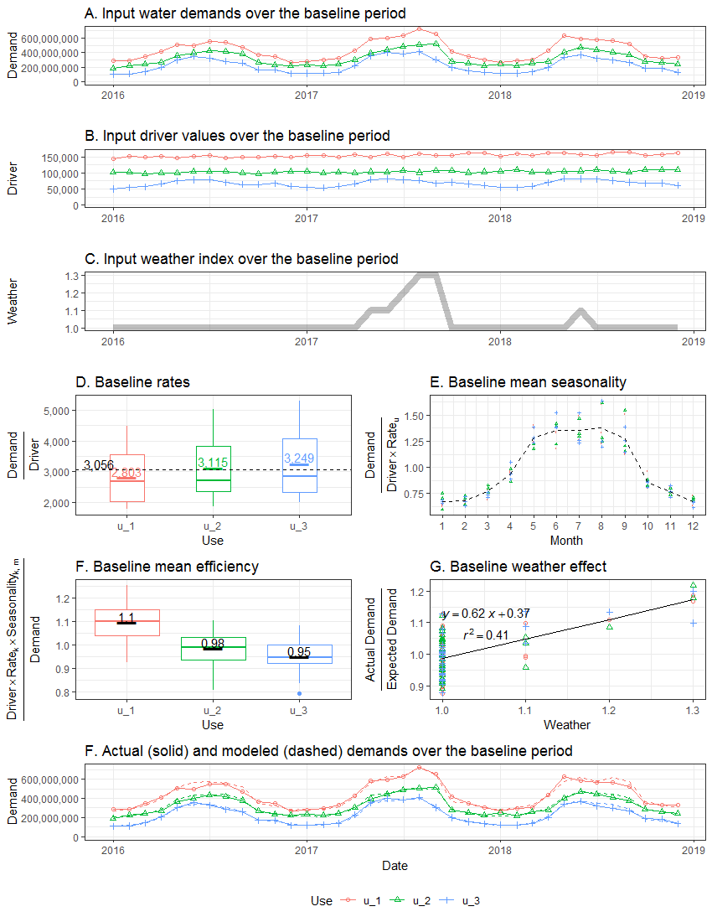

1. <https://apps.dhec.sc.gov/GIS/ClearingHouse/>
2. available at <http://gis.sc.gov/data.html>
3. Available at <https://www.agcensus.usda.gov>
4. Available at <https://websoilsurvey.nrcs.usda.gov/>